UNIT 1: LEISURE ACTIVITIES
I.Vocabulary:
Word | Meaning | Picture | Examples
Addicted(a)  /ə’diktid/ | Nghiện (thích cái gì) |  | Many teenagers are addicted to computer games nowadays
Adore(v)  /ə’d :r/ | Yêu thích, mê thích  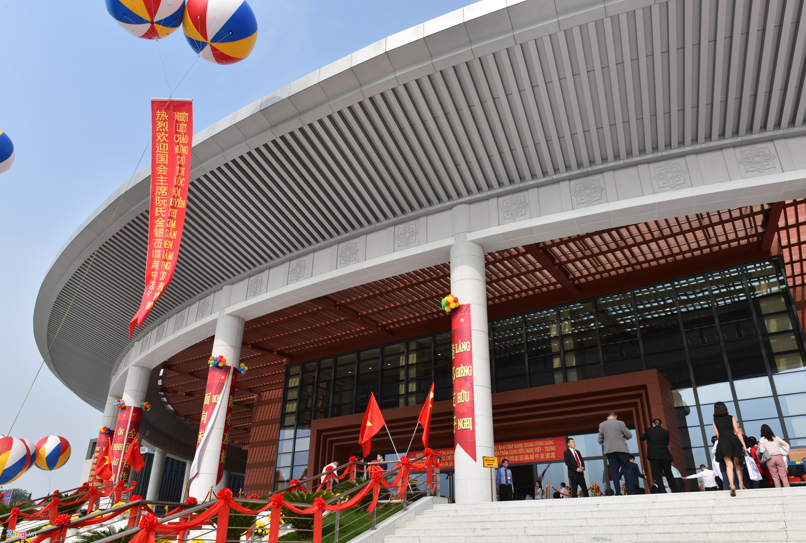 |  | Jane adores working with children
Community centre  /kəˈmjuːnəti ‘sentər/ | Trung tâm văn hóa cộng đồng |  | The locals go to the community centre every weekend
Craft(n)  /kra:ft/ | Đồ thủ công  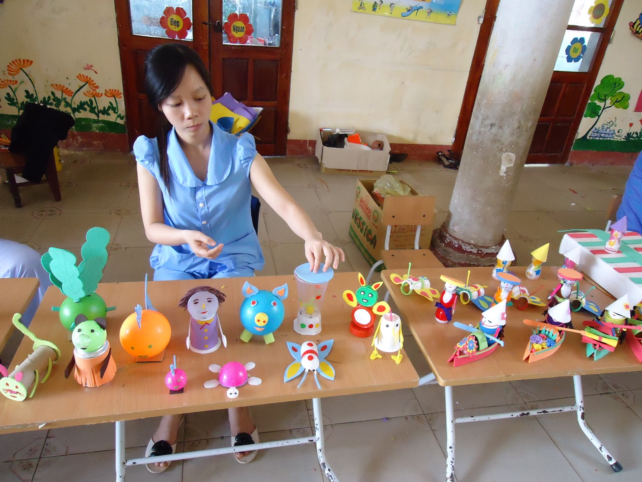  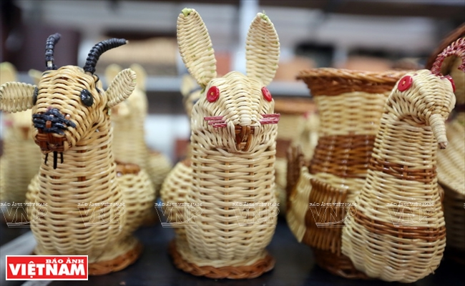 |  | He invited me to a craft work  shop lastweek
DIY  /di: ai wai/ | Đồ tự làm, tự sửa |  | My brother is a real DIY enthusiast
Hang out  /hæŋ aut/ | Đi chơi với bạn bè  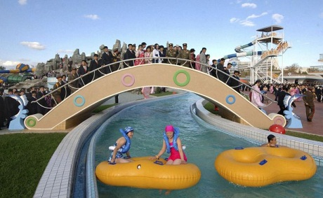 |  | I often hang out with friends in my freetime
Leisure (n)  /ˈleʒə(r)/ | Giải trí |  | These days we have more leisure activities than in the past
Mind(v) /maind/ | Chú ý, để ý  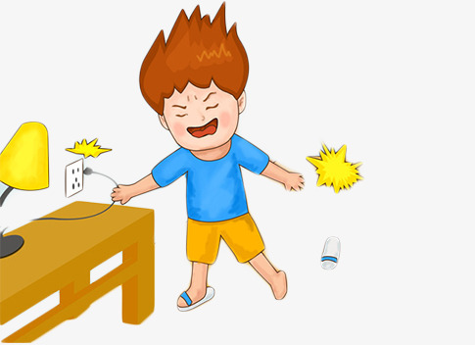 |  | I hope you don’t mind the noise
Rely on  /ri’lai on/ | Tin tưởng, tin cậy |  | You can rely on his judgement
Savings(n)  /seivi ŋ z/ | Tiền tiết kiệm |  | He spent all his saving on buying a new car
Socialise(v)  /’s əuʃəlaɪz/ | Giao tiếp để  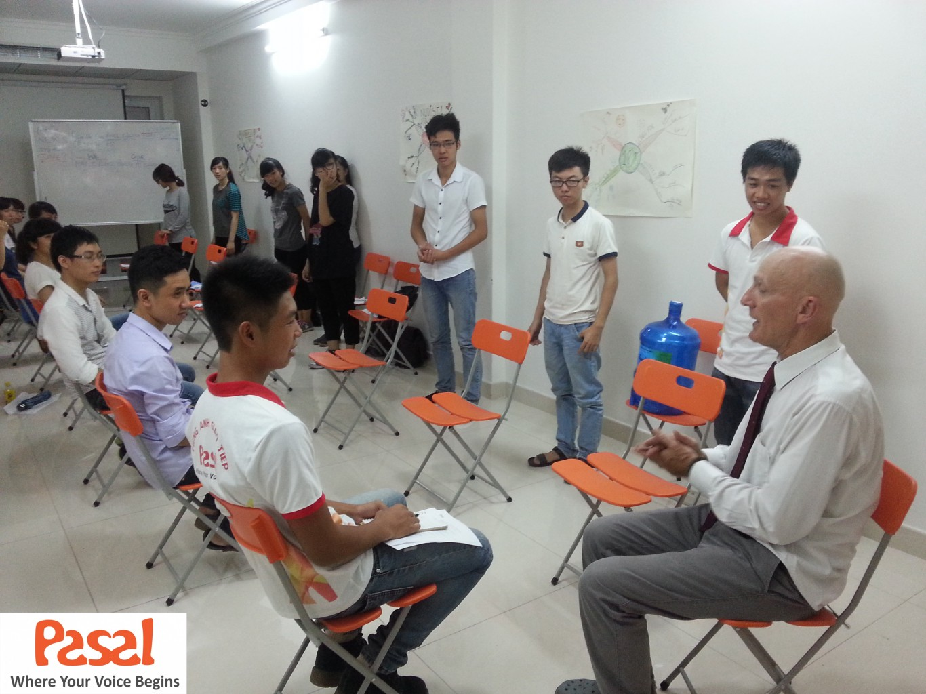  tạo mối quan  hệ  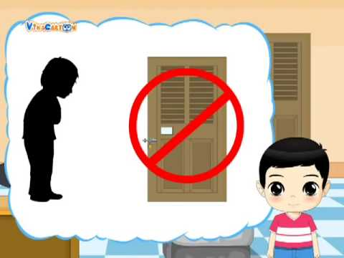 |  | He enjoys socialising with other students
Stranger(n) /ˈstreɪndʒə(r)/ | Người lạ |  | You shouldn’t reveal your personal information to strangers
Surf(v) /sɜːf/ | Lướt  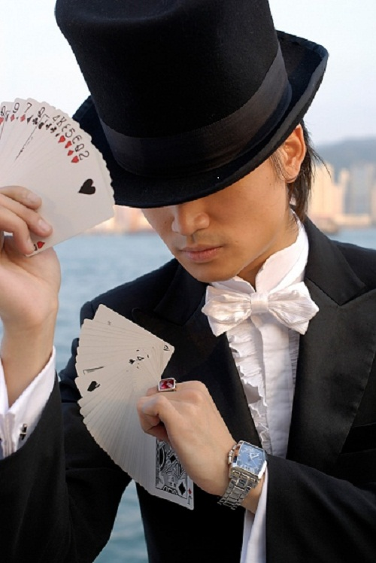 |  | I spent two hours a day surfing the web
Trick(n) /trik/ | Mẹo  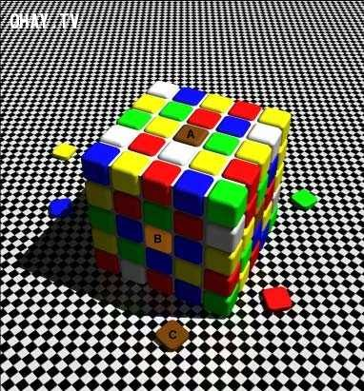 |  | He amazed everyone by a card trick
Virtual(a) /ˈvɜːtʃuəl/ | ảo (chỉ có ở  trên mạng) |  | The Internet has created a virtual world for its users

III. Grammar: CÁC ĐỘNG TỪ DIỄN ĐẠT SỰ YÊU THÍCH (VERBS OF LIKING)
1. VERBS OF LIKING:
Động từ | Nghĩa
adore | Yêu thích, mê mẩn
Love | Yêu
Like/ enjoy/ fancy | Thích
Don’t mind | Không phiền
Dislike/ don’t like | Không thích
Hate | Ghét
Detest | Căm ghét

2.VERBS OF LIKING + V_ING / TO V:
-Khi muốn dùng một động từ chỉ một hàng động khác ở sau động từ chỉ sự thích, ta phải sử dụng danh động từ (V_ing) hoặc động từ nguyên thể co “to” (toV)
1.Verbs + V-ing/ to V
Những động từ đi với cả danh động từ và động từ nguyên thể có “to” mà không đổi về nghĩa
Verbs | Verbs + V-ing | Verbs +to V
Like | I like skateboarding in my free time | I like to skateboard in my free time
Love | She loves training her dog | She loves to train her dog
Hate | He hates eating out | He hates to eat out
Prefer | My mother prefers going jogging | My mother prefers to go jogging
2. Verbs + V-ing
Những động từ chỉ đi với danh động từ
Verbs | Verbs + V-ing
Adore | They adore eating ice-cream
Enjoy | We enjoy playing basketball
Fancy | Do you fancy making crafts?
Don’t mind | I don’t mind cooking
Dislike | Does he dislike swimming?
Detest | I detest doing housework

BÀI TẬP VẬN DỤNG CƠ BẢN:
Bài 1: Hoàn thành những câu sau, sử dụng dạng nguyên thể có (to)(toV) của động từ trong ngoặc:
1.Everyone likes (eat)__TO EAT_______ice cream.
2.Do you prefer (read)____TO READ____books in your freetime?
3.I hate(watch)____TO WATCH____horror movies?
4.Many people prefer(go)__TO GO____travelling on holidays.
5.My father loves(play)____TO PLAY______golf with his friends.
6.I prefer (not stay)____NOT TO STAY______up too late.
7. What does your sister love(do)__TO DO_______in her spare time?
8.I used to prefer(hang out)___TO HANG OUT______with my friends at weekend.
9. I think not many people like(listen)__TO LISTEN______to her music.
10. Teenagers love (surf)___TO SURF______the web to while away their freetime.
Bài 2: Hoàn thành những câu sau, sử dụng dạng danh động từ (V-ing) của động từ trong ngoặc:
1.My mother dislikes(prepare)__PREPARING_____the meals.
2.Do you enjoy(do)__DOING______DIY in your freetime?
3. I detest (have) _____HAVING_____a conversation with John.
4.Do you think Jane prefers(not socialise)__NOT SOCIALISING_________with other students?
5.I don’t mind(explain)__EXPLAINING_____the problem again.
6.Ann fancies(listen)____LISTENING_______to songs of her favourite singer.
7.My friend adores(spend)___SPENDING____time with her cats.
8.I always love(try)___TRYING_____new things when I go travelling.
9.Mr.Smith hates(drive)___DRIVING______his old car.
10.Anne prefers(not go)___NOT GOING______out too late.
Bài 3:Điền dạng thích hợp của động từ trong ngoặc để hoàn thành các câu sau:
1.Did you enjoy(watch)__WATCHING____the comedy last night?
2.Many people prefer(do)_DOING/TO DO_____gardening after their retirement.
3.My cat dislikes(sleep)___SLEEPING_____on the floor.
4.My father doesn’t mind(work)___WORKING___hard.
5.My cousin doesn’t like(study)___STUDYING/ TO STUDY______Math and Chemistry.
6.They dislike(talk)____TALKING______with each other.
7.Jim and Jane don’t fancy(go)___GOING_______out tomorrow.
8.Did you hate(eat)__EATING/TO EAT____vegetables when you was small?
9.she didn’t prefer(tell)___TELLING/ TO TELL_____him about her plan.
10.James enjoys(have)_HAVING______dinner in a luxury restaurant.
11.I hope my mother will enjoy(spend)___SPENDING____time with her grandchildren.
12.Some people enjoy(take)___TAKING___a shower in the morning.
13.I think your brother won’t mind(lend)_LENDING_______you a helping hand.
14.My boyfriend dislike(wait)_____WAITING______.
15.What do you detest(do)___DOING_______the most?
Giaỉ thích:
Bài 4: Dựa vào các từ cho sẵn, viết thành câu hoàn chỉnh:
1.Peter / prefer/ play/ computer games/ in his free time.
PETER PREFERS PLAYING / TO PLAY COMPUTER GAMES IN HIS FREE TIME.
2.You/ hate/ do/ the washing?
DO YOU HATE DOING/ TO DO THE WASHING?
3.My father/ enjoy/ play/ sports/ and/ read/ books.
MY FATHER ENJOYS PLAYING SPORTS AND READING BOOKS
4.The teacher/ not mind/ help/ you/ with difficult exercises.
THE TEACHER DOESN’T MIND HELPING YOU WITH DIFFICULT EXERCISES.
5.Jane/ not fancy/ read/ science books.
JANE DOESN’T FANCY READING SCIENCE BOOKS.
6.Which kind of juice/ you/ dislike/ drink/ the most?
7. Ann/ fancy/ do /DIY/ in her free time.
WHICH KIND OF JUICE DO YOU DISLIKE DRINKING THE MOST?
8. My father/ prefer/ not eat/ out.
MY FATEHR PREFERS NOT EATING / NOT TO EAT OUT
9.Mr.Smith/ love/ go/ shopping/ at weekend.
MS.SMITH LOVES GOING/TO GO SHOPPING AT WEEKENDS
10.Everyone/ adore/ receive/ presents/ on their birthday.
EVERYONE ADORES RECEIVING PRESENTS ON THEIR BIRTHDAYS.
Giải thích: Viết câu ở thì hiện tại đơn để diễn tả sự yên thích, dung danh động từ(V-ing)sau những động từ chỉ sự yêu thích như: adore, enjoy, fancy, don’t mind, dislike, detest” dùng danh động từ(hoặc động từ nguyên thể có “to: sau các động từ :like, love, hate, prefer”
BÀI TẬP VẬN DỤNG NÂNG CAO
Bài 5: Đánh dấu(V) trước câu đúng, đánh dấu(X) trước câu sai và sửa lại cho đúng:
1. X My sister doesn’t mind to look after my cat.--> LOOKING(MIND-V-ING)
2. X Jim dislikes going to the library because he likes reading books. ->LIKES(SAI VỀ LOGIC)
3.X I prefer to not go out today. NOT TO GO(PHỦ ĐỊNH NOT ĐỨNG TRƯỚC TO)
4.I used to like watching cartoons on TV.
5X.Does Mrs.Smith enjoy to cook? COOKING( ENJOY-V-ING)
6.XMary hates doing the housework and take after her baby sister.--> TAKING(SAU HATE LÀ DOING RỒI NÊN PHẢI ĐỂ DOING SONG SONG CẤU TRÚC
7. In my freetime, I love to do DIY with my sister.
8.XJosh detests to socialise with his co-workers. SOCIALISING(DETEST+VING)
9.XWhich movie does he fancy to watch? WATCHING (FANCY+V-ING)
10.I prefer hanging out with friends to playing computer games.
Bài 6: Điền dạng đúng của các động từ chcho sẵn vào chỗ trống sao cho hợp lý:
socialize | detest | surf | write
rely | read | adore | Hang out
1.My brother likes____TO SURF/ SURFING______the Internet looking for new music.
2.I dislike____RELYING_____too much on other people. I want to be independent.
3.Josh enjoys____HANING OUT______with his classmates after school.
4.My sister and I fancy___READING____novels when we have free time.
5.He’s very artitic. He enjoys____WRITTING____poems in his free time.
6.James____DETESTS_____talking with his neighbors because he finds them annoying.
7.My uncles loves____TO SOCIALIZE/SOCIALIZING______with other people . he has many friends.
8.Ann______ADORES____working with children. She’s a teacher.
Bài 7: Khoanh tròn vào đáp án đúng:
Nowadays, leisure activities are totally different from the past. Many people no longer enjoy(1) in outdoor activities after school. In stead, they(2)playing computer games or (3) the web in their free time. Some people (4)too much on computer and the Internet. For example, they prefer(5) messages to having a face-to-face conversation with friends. Even when people (6)out with their friends, they rarely talk but they use their phones to surf web. However, many people dislike the Internet and the(7)world. They hate to waste time on the computer and(8)other activities such as reading, shopping or sporting.
1.A.participate B.to participate C. participating D. participates
2.A.fancy B.don’t mind C.dislike D.hate
3.A.sailing B. surfing C.swimming D.diving
4.A.play B.rely C.addict D.use
5.A.send B.to send C.to sending D. sends
6.A.play B.rely C.meet D.hang
7.A.virtual B.real C.fake D.new
8.A.dislike B.detest C.enjoy D.mind
Bài 8: Đọc doạn văn sau và điền (T-true)trước câu đúng với nội dung bài đọc , điền (F-false) trước câu không đúng với nội dung bài đọc:
LEISURE ACTIVITIES IN BRITAIN
The weekends area a time for many leisure activities in Britain. British people often have to work five days a week from Monday to Friday is the precious time for family and friends. People enjoy various indoor and outdoor activities in Britain. According to the EU’s statistical office, British people spend abot 45% of their free time watching television, 24% of their free time socialising , 22-23% on sport and hobbies, and 10% on other activities. Other popular leisure activities are listening to the radio, listening to pre-recorded music, reading, DIY, garedning, eating out and going to the cinema.
The most common leisure activity in the UK is watching television. The average viewing time is 25 hours per person per week. Almost all households have at least one television set. The second most popular activity in Britain is visiting or entertaining friends or relations. Another popular leisure activity is gardening. The British are known as a nation of gardeners. Most people have a garden on their property. Every town in Britain has one or more DIY centers and garden centres. These are like supermarkets for the home and garden. These places are very popular with British home-owners at the weekends.
___T____1.People enjoy various indoor activities Britain.
____F___2.British people spend more than half of their free time watching television.
_______3.The most common leisure activity in the UK is visiting or entertaining friends or relations.
___F____4. All house holds have at least one television set.
___F____5.British people are all gardeners.
____T___6. All towns in Britain have one or more DIY centers and garden centres.

UNIT 2: LIFE IN THE COUNTRYSIDE
I.Vocabulary:
Word | Meaning | Picture | Examples
Beehive(n)  /’bi:haiv/ | Tổ ong |  | Look! There is a beehive on the tree.
Cattle(n)  /ˈkætl/ | Gia súc |  | There is a herd of cattle over there.
Crop(n) /krop/ | Vụ mùa |  | We are looking forword to  a bumper crop
Dairy product /ˈdeəri ˈprɒdʌkt/ | Sản phẩm từ sữa |  | The doctor advised me to eat more dairy products.
Densely(adv) /densli/ | Dày đặc |  | I don’t want to live in a densely populated area.
Disturbing(adj) /dɪˈstɜːbɪŋ/ | Gây khó chịu |  | Don’t make such disturbing noise
Earthen(adj) /ˈɜːθn/ | Bằng đất nung |  | The locals used to live in earthen houses
Envious(adj) /ˈenviəs/ | Ghen tị |  | Everyone is envious of him
Harvest(n) /ˈhɑːvɪst/ | Vụ thu hoạch |  | Farmers often work very hard during  harvest time
Hay(n) /hei/ | Cỏ khô |  | These farm workers are making hay to feed the cattle in the winter
Herd(v) /hɜ:d/ | Chăn, dắt |  | I used to go herding buffaloes when I was  small.
Inconvenient  (adj)  /ˌɪnkənˈviːniənt/ | Bất tiện |  | This place is a bit inconvenient for  a formal meeting
Kite(n)  /kait/ | Con Diều |  | My brother wants to fly his new kite
Load(v)  /ləʊd/ | Chất, chở |  | They loaded the boxes into the trucks
Nomadic(adj)  /nəʊˈmædɪk/ | Thuộc về du mục |  | Many groups of people gave up their nomadic life to settle down
Pasture(n) /ˈpɑːstʃə(r)/ | Đồng cỏ |  | People often raise cattle in areas of rich pasture

B. GRAMMAR:
I.Ôn tập so sánh hơn với tính từ( comparative forms of adjectives)
Ta sử dụng so sánh hơn của tính từ để so sánh giữa người(hoặc vật) này với người(hoặc vật) khác. Trong câu so sánh hơn, tính từ sẽ được chia làm 2 loại là tính từ dài và tính từ ngắn, trong đó:
- Tính từ ngắn là tính từ có 1 âm tiết : Ví dụ : tall, high, big………..
- Tính từ dài là tính từ có từ 2 âm tiết trở lên : Ví dụ : expensive, intelligent……..
II. Cấu trúc câu so sánh hơn:
Đối với tính từ ngắn | Đối với tính từ dài
S1 + to be + adj +er + than + S2
Với tính từ ngắn, thêm đuôi “er” vào sau tính từ | Với tính từ dài, thêm đuôi “more” vào trước tính từ
Ví dụ:  China is bigger than India  Lan is shorter than Nam  My house is bigger than your house  His pen is newer than my pen | Ví dụ:  Gold is more valuable than silver  Hanh is more beautiful than Hoa  Your book is more expensive than my book  Exercise 1 is more difficult than exercise 2
Lưu ý: Để nhấn mạnh ý trong câu so sánh hơn, ta thêm “much” hoặc “far” trước hình thức so sánh
Ví dụ: Her boyfriend is much/ far older than her
III. Cách sử dụng tính từ trong câu so sánh hơn:
1.Cách thêm đuôi –er vào tính từ ngắn
Tính từ kết thúc bởi 1 phụ âm thêm đuôi -er | Old-older, near-nearer
Tính từ kết thúc bởi 1 nguyên âm “e” thêm đuôi -r | Nice-nicer
Tính từ kết thúc bởi 1 nguyên âm(ueoai) +1 phụ âm gấp đôi phụ âm cuối và thêm đuôi -er | Big-bigger, hot-hotter, fat-fatter
Tính từ kết thúc bởi “y” dù có 2 âm tiết vẫn là tính từ ngắn bỏ “y” và thêm đuôi “ier” | Happy-happier,  Pretty-prettier

Lưu ý: Một số tính từ có hai âm tiết kết thúc bằng “et, ow, er, y” thì áp dụng như quy tắc thêm er ở tính từ ngắn
Ví dụ: quiet quieter clever cleverer
Simple simpler narrow narower
2.Một vài tính từ đặc biệt:
Với một số tính từ sau, dạng so sánh hơn của chúng không theo quy tắc trên.
Tính từ | Dạng so sánh hơn
Good | Better
Bad | Worse
Far | Farther/ further
Much/ many | More
Little | Less
Old | Older/ elder
BÀI TẬP VẬN DỤNG CƠ BẢN:
Bài 1: Cho dạng so sánh hơn của các tính từ trong bảng sau:
Tính từ | So sánh hơn | Tính từ | So sánh hơn
Bad | WORSE | Modern | MORE WONDERFUL
Clever | CLEVERER | Old | OLDER
Convenient | MORE CONVENIENT | Peaceful | MORE PEACEFUL
Far | FURTHER/ FARTHER | pretty | PRETTIER
Fresh | FRESHER | Quiet | QUIETER
Friendly | FRIENDLIER | Smart | SMARTER
Generous | MORE GENEROUS | Soon | SOONER
Good | BETTER | Strong | STRONGER
Happy | HAPPIER | Ugly | UGLIER
High | HIGHER | Warm | WARMER
Little | LESS | Wonderful | MORE WONDERFUL
Long | LONGER | Young | YOUNGER

Bài 2:Khoanh tròn vào đáp án đúng:
1.Living in this small town is (more peaceful/ peaceful more) than I expected.
2.Nowadays people are (more anxious/ anxious more) about pollution than before.
3.Today you look ( happier/ more happy) than usual.
4.This year I will move to a (bigger/ biggest) city.
5.This experience is (more exciting/ most exciting) than I expected.
6. Who is (more intelligent/ most intelligent) between two of them.
7. This song is (catchier/ more catchy) than that song.
8. The new sofa is (costlier/ more costly) than the old one
9.Our family will move to a (more comfortable/ more comfortable than) place next year.
10. I hope you will get (best/ better) the next time I see you.
11.James has (many/ more) books than Paul.
12.She is (more independent/ most independent) than the last time I saw her.
13. Today my sister (is more quiet/ quieter) than usual.
14.Jane is(more pretty/ prettier) than Ann.
15.The weather is (hotter/ hottest) than yesterday.

Bài 3 :Hoàn thành các câu sau với dạng so sánh hơn của tính từ trong ngoặc:
1.Living in the city is______MORE CONVENIENT__than living in the country(convenient).
2.Mrs.Smith is____YOUNGER_____than I thought.(young).
3.Houses in big cities are much_________than those in my hometown(tall).
4.No one in my class is_________TALLER __than Jim (smart).
5. The senior prom would be_____MORE EXCITING____than any other proms(exciting).
6. I have______LESS____courage than my brother(little).
7. His health condition is getting____WORSE______(bad).
8.You are_____CLEVERER____than you think(clever).
9.This computer is much___MORE EXPENSIVE______than mine(expensive)
10.I always dream of a____MORE MODERN______house to live in(modern).
11.They are______MORE SKILLFUL____than they used to be(skillful).
12.Life in this village is__ MORE PEACEFUL __than anywhere else.(peaceful).
13.I think people in the countryside are_____FRIENDLIER___than city dwellers.(friendly)
14.This year, the prize for the winner is__MORE VALUABLE____than last year.(valuable)
15.Which dress is_______MORE SUITABLE___for me?(suitable)
16.You should be_____MORE CONFIDENT_____and show your best.(confident).
17.They said that the conference was_____MORE INTERESTING___than usual(interesting).
18.Jane is so pretty but her sister is even______PRETTIER____(pretty).
19.They work hard to have____BETTER____life(good).
20.John is____MORE INTELLIGENT______than the rest of the class.(intelligent)

Bài 4: Biết câu so sánh hơn dùng từ gợi ý:
0.Bob / strong /Jim. Bob is stronger than Jim.
1.My current job / demanding/ my last one.
MY CURRENT JOB IS MORE DEMANDING THAN MY LAST ONE
2.Today/ Jane/ beautiful/ usual.
TODAY JANE IS MORE BEAUTIFUL THAN USUAL
3.Yesterday / it/ cold/ today.
YESTERDAY IT WAS COLDER THAN TODAY
4.Fruits and vegetables / healthy / fast food.
FRUITS AND VEGETABLEA ARE HEALTHIER THAN FASTFOOD
5. Life in the countryside / peaceful/ life in the city.
LIFE IN THE COUNTRYSIDE IS MORE PEACEFUL THAN LIFE IN THE CITY.
6.Your sister/ good/ you think.
YOUR SISTER IS BETTER THAN YOU THINK
7.Who / intelligent/ you/ in your class?
WHO IS MORE INTELLIGENT THAN YOU IN YOUR CLASS?
8. Ann/ short / you?
IS ANN SHORTER THAN YOU?
9. Last year/ his salary / low/ this year.
LAST YEAR HIS SALARY WAS LOWER THAN THIS YEAR
10. Bob/ look / strong/ his brother.
BOB LOOKS STRONGER THAN HIS BROTHER

Bài 5: Sắp xếp các từ sau thành câu hoan chỉnh:
1.London /think/ is/ than/ more/ I/ New York/ expensive.
I THINK LONDON IS MORE EXPENSIVE THAN NEW YORK
2.Important/ is/ Health/ than/ money/ more.
HEALTH IS MORE IMPORTANT THAN MONEY
3.in / in/ city/ better/ the / is/ in /than / country/ convenient / than / is.
TRAVELLING IN THE CITY IS MORE CONVENIENT THAN IN THE COUNTRYSIDE
4.in / health care/ city/ better/ the / is/ in / than / countryside/ the service/ the.
THE HEALTH CARE SERVICE IN THE CITY IS BETTER THAN IN THE COUNTRYSIDE
5.living/ is/ than / in /rural/ more/ areas / living/ urban /in / comfortable/
LIVING IN RURAL AREAS IS MORE COMFORTABLE THAN LIVING IN URBAN AREAS
6.in/ pasture / this/ that/ area / richer / is / area.
PASTURE IN THIS AREAS IS RICHER THAN THAT AREA
7. Peter/ better / Math/ than / at/ is / Tom.
PETER IS BETTER AT MATH THAN JOHN
8.crowded/ cities/ often / than / more/ are/ the / countryside.
CITIES ARE OFTEN MORE CROWDED THAN THE COUNTRYSIDE
9.this /cake/ is /that/ more/ one/ delicious/ than?
IS THIS CAKE MORE DELICOUS THAN THAT ONE?
10.Who/ more/ than / Tom / can /in / intelligent / class/ his?
WHO CAN BE MORE INTELLIGENT THAN TOME IN HIS CLASS?
IV. SO SÁNH HƠN VỚI TRẠNG TỪ (COMPARATIVE FORMS OF ADVERBS)
Tương tự như với tính từ, trang từ chia thành 2 loại:
-.Trạng từ ngắn là những trạng từ có 1 âm tiết.
Ví dụ: hard, near, far, right, wrong…………
-Trạng từ dài là những từ có từ 2 âm tiết trở lên.
Ví dụ: slowly, responsibly, quickly, interestingly, tiredly……
1.Cấu trúc câu so sánh hơn với trạng từ:
Đối với trạng từ ngắn | Đối với trạng từ dài
S1 +V +adv +er +than+ S2 | S1 +V +more / less +adv +than+ S2
Với các trạng từ ngắn, thường là trạng từ chỉ cách thức có hình thức giống tính từ, ta thêm “er” vào sau trạng từ | -Với trạng từ dài, hầu hết là các trạng từ chỉ cách thức có đuôi “ly” ta thêm “mỏe”(nhiều hơn) hoặc “less”(ít hơn) vào các trước trang từ  -“Less” là từ phản nghĩa của “more” ,được dùng để diễn đạt sự không bằng nhau ở mức độ ít hơn.
Ví dụ:  They work harder than I do.  She runs faster than he does  My mother gets up earlier than me.  I go to school later than my friends do | Ví dụ:  My friend did the test more carefuly than I did.  My father talks more slowly than my mother does.  Hanh acts less resposibly than anyone

2.Một vài trạng từ có dạng từ đặc biệt:
Tính từ | Dạng so sánh hơn
well | Better
Badly | Worse
Far | Farther/ further
Early | Earlier

Ví dụ:
The little boy ran farther than his friends
You’re driving worse today than yesterday.

BÀI TẬP VẬN DỤNG CƠ BẢN:
Bài 6: Cho dạng so sánh hơn của các trạng từ trong bảng sau:

Trạng từ | So sánh hơn | Trạng từ | So sánh hơn
Badly | WORSE | Late | LATER
Conveniently | MORE CONVENIENTLY | Smartly | SMARTLY
Early | EARLIER | responsibly | MORE RESPONSIBLY
Far | FARTHER/FURTHER | Patiently | MORE PATIENTLY
Fast | FASTER | Generously | MORE GENEROUSLY
Fluently | MORE FLUENTLY | Cleverly | MORE CLEVERLY
Happily | MORE HAPPILY | Quickly | MORE QUICKLY
Hard | HADRER | Suitable | MORE SUITABLY
Slowly | SLOWER | Beautifully | MORE BEAUTIFULLY
well | BETTER | Strongly | MORE STRONGLY

Bài 7: Khoanh tròn vào đáp án đúng:

1.The teacher asked me to speak___________.
A.loud B.louder C.more loud
2.Today you looks________than usual.
A.more confident B.more confidently C. confidently
3.Your house is_______decorated than me.
A.more beautiful B.more beautifully C.beautifully.
4.No one in my class runs__________than Peter.
A.more fastly B.more better C.faster.
5.This time you did much________!
A.better B.more better C.more well
6.You have to work_________If you want to succeed.
A.more hardly B.hardlier C.harder
7.Today I come to class_________than usual
A.more early B.earlier C. early
8.You need to work___________, or you will make a lot of mistakes.
A.more careful B. more carefully C. carefully
9.She walks__________than other people.
A.slower B.slowlier C.more slowier
10.The blue skirt suits you_______than the black one.
A.better B.more better C.more well
Bài 8: Hoàn thành các câu sau với dạng so sánh hơn của các trạng từ trong ngoặc:
1.I speak English____ MORE FLUENTLY______now than last year.(fluently).
2.They smiled____ MORE HAPPILY____than before(happily).
3.Tom arrived___ EARLIER______than I expected(early).
4.We will meet __LATER______in the afternoon(late).
5.Mary dances____ MORE GRACEFULLY______than anyone else(gracefully)
6.Could you speak_____LOUDER____?(loud)
7.Jim could do the tast___BETTER___Jane(well).
8.We walked____ MORE SLOWLLY___than other people(slowly).
9.Planes can fly____HIGHER______than birds(high).
10.I can throw the ball______FARTHER____than anyone else in my team(far).
11.James drives___ MORE CAREFULLY____than his wife(carefully).
12.I visit my grandmother___ MORE OFTEN____than my brother.(often)
13.No one can run___FASTER____than John(fast).
14.My sister cooks____WORSE____than I(badly).
15. Everyone in the company is working____WORSE____than ever before(hard).

Bài 9:Hoàn thành các Câu sau với dạng so sánh hơn của các trang từ trong ngoặc:
1.I/ play/ tennis/ badly/ Tom.
I PLAY TENNIS WORSE THAN TOM
2.The Australian athlete/run/ slowly/ the Korean athlete.
THE AUSTRALIAN ATHELETIC RUNS MORE SLOWLY THAN THE KOREAN
3.Cats/ walk/ quiet/ dogs.
CATS WALK MORE QUIETLY THAN DOGS
4.James/ reply/ swiftly/ Peter.
JAMES REPLIED MORE SWIFTLY THAN PETER
5. The tiger/ hunt/ ferociously/ the wolf.
THE TIGER HUNTS MORE FEROCIOUSLY THAN THE WOLF
6.Your idea/ work/ well/ mine.
YOUR IDEA WORKS BETTER THAN MINE
7.I/ eat/ vegetables/ often/ I used / to.
I EAT VEGETABLES MORE OFTEN THAN I USED TO
8.Today/ you/ perform/ badly/ yesterday.
TODAY YOU PERFORM WORSE THAN YESTERDAY
Bài 10:Viết lại câu sau cho nghĩa không đổi, sử dụng cấu trúc so sánh hơn “more /less”
0.Ann speaks French more fluently than James.
James speaks French less fluently than Ann.
1.Today the sun shines more brightly than yesterday.
YETSERDAY THE SUN SHONE LESS BRIGHTLY THAN TODAY
2.This cake is more freshlt made than that one.
THAT CAKE IS LESS FRESHLY MADE THAN THIS ONE
3.Jim behaves more politely than his younger brother.
JIM’S YOUNGER BROTHER BEHAVES LESS POLITELY THAN JIM
4.Teenagers act more violently these days than in the past.
TEENAGERS ACTED MORE VIOLENTLY IN THE PAST THAN THESE DAYS
5.The doctor treats his patiently than he should.
THE DOCTOR SHOULD TREAT HIS PATIENTS MORE PATIENTLY THAN HE DOES
6.My sister speaks more quickly than I.
I SPEAK LESS QUICKLY THAN MY SISTER.
7.Now Mary drives more carefully than she used to.
MARY USED TO DRIVE LESS CAREFULLY THAN SHE DRIVES NOW
8.This summer I go to the beach more often than the last summer.
THE LAST SUMMER I WENT TO THE BEACH LESS OFTEN THAN THIS SUMMER
BÀI TẬP TỔNG HỢP NÂNG CAO
Bài 11:Hoàn thành câu, sử dụng dạng so sánh hơn của các tính từ hoặc trạng từ cho sẵn
Angrily | large | soft | Cleverly | Warm
comfortably | hard | rich | costly | beautifully

1.Her voice is_____SOFTER____than mine.
2.James can sing____MORE BEAUTIFULLY____than many singer.
3.We can live____MORE COMFORTABLY_____in the countryside than in the city.
4.We hoped we would own a _____LARGER____apartment.
5.This mordern computer is_____COSTLIER____than that old-fashioned one.
6.My new house is_____MORE CLEVERLY____designed than my old one.
7.My father reacted____MORE ANGRILY_____to my misbehaviors than my mother.
8.John studies_____HARDER_____than anyone else in the class.
9.It is getting____WARMER_____today so we can go out.
10. People in the city are___RICHER____than people in the countryside.
Bài 12; Gạch chân lỗi sai trong mỗi câu sau và sửa lại cho đúng:
1.Their life has been more comfortably since they moved to the city.--> COMFORTABLE
2.She looks more pretty in this white dress. PRETTIER
3.The manager wants us to work more hardly. HARDER
4.This week you looks more healthily than last week. HEALTHIER
5.Everyone in my town is looking for more better crop this year. BETTER
6.Jim runs more fastly than his friends. FASTER
7.I think a settle life is more better than a nomadic life. BETTER
8.Today Jim performs less confident than usual. CONFIDENTLY
9.The heavy rain makes it more difficultly to drive. DIFFICULT
10.Their team preformed much more well than our team. BETER
Bài 13; Viết lại câu bằng từ đã cho sao cho nghĩa câu không thay đổi theo mẫu:
0.This exercise is easier than that one.
That exercise is more difficult than that one.
1.Mr Smith is wealthier than Mr.Brown.
Mr Brown_IS POORER THAN MR.SMITH
2.My house is smaller than my parent’s house.
My parent’s house__IS BIGGER THAN MY HOUSE
3.The black dress is more expensive than the red one.
The red dress _IS CHEAPER THAN THE BLACK ONE
4.Today it is colder than yesterday.
Yesterday__IT WAS WARMER THAN TODAY
5.I don’t think you are taller than me.
I don’t think I___AM SHORTER THAN YOU
6.Is Jim worse at Math than John?
Is John____BETTER AT MATH THAN JIM?
7. Jim looks much younger than his classmates.
Jim’s classmates__LOOK MUCH OLDER THAN HIM
8.Your hair is longer than mine.
My hair__IS SHORTER THAN YOURS
Bài 14: Khoanh tròng vào đáp án đúng:
Benefit of living in the countryside.
While many people prefer city life, a lot of people want to send their life in a rural area. The countryside are often(1)_________than the city because there are not as many factories and traffic as in big cities. The country folk can be (2) _________and they often live(3) _________than city dwellers. Besides, life in the countryside is(4) _________and peaceful because the crime rate is much(5) _________. The rural areas are(6) _________populated than the urban area but the neighbors are(7) _________and more helpful. Life in the countryside is(8) _________for old people than the energetic youngsters.
1.A.less polluted B.more polluted C.less pollutedly D.more pollutedly
2.A.more healthy B.healthier C.more healthily D.helthily.
3.A.longly B.longer C.shortly D.shorter
4.A.more simple B.simpler C.simply D.more simply
5.A.higher B.highly C.lower D.lowly
6.A.more densely B.more dense C.less D.less dense
7.A.more friendly B.friendlier C.friendly D.less friendly
8.A.more suitable B.more suitbly C.less suitably D.suitably.
Bai15: Đọc đoạn văn sau và trả lời câu hỏi: The nomadic life of Mongolian
Mongololian people nowadays still maintain their tradition of a nomadic life. About half of mongolian population do not settle down but travel from place to place every season. When you think of Mongolian nomads, you think of animal farmers. Their most valuable possessions are their tents and cattle. Mongolian has severe weather. There are dramatic changed in weather condotions between seasons. That is the reason why Mongolian have to move location throughout the year to the most appropriate spots. In winter, they often move in front of a mountain for shelter. In spring, it’s closer to a river, in summer right next to a river for water supply, and in autumn up a hill to collect hay for winter time. Most nomads move at least four times a year but some might move up to 30 times in a year ,especially if they have a lot of animals that eat through the vaibable food quickly.
The number of namads has, however, significantly decreased over last years. More and more of its citizens move to Ulaanbaatar because they want to look for an education and a professional job.Mongolia is in a period of rapid change.
1.Is it true that about 50% of Mongolian population still lead a nomadic life?
YES IT IS
2.What are the most valuable possessions of Mongolian nomads?
TENTS AND CATTLE
3.Why do Mongolian have to move location throughout the year?
BECAUSE MONGOLIAN HAS SEVERE WEATHER AND THERE ARE DRAMATIC CHANGED IN WEATHER CONDITIONS BETWEEN SEASONS
4.Where do Mongolian nomads often move to in fall?
THEY MOVE UP A HILL
5.How often most nomads move their locations?
AT LEAST FOUR TIMES A YEAR
6.Why more and more Mongolian move to Ulaanbaatar?
MORE AND MORE OF ITS CITIZENS MOVE TO ULAANBAATAR BECAUSE THEY WANT TO LOOK FOR AN EDUCATION AND A PROFESSIONAL JOB.

END OF TERM TEST -ADVANCED
A.PHONETICS:
I.Find the word which has a different sound in the underlined part:
1.A.scientists B.bookworms C.deadlines D.flowers
2.A.nations B.speakers C.lessons D.students
3.A.continent B.alone C.combat D.control
4.A.delicate B.prefer C.reference D.schedule
5.A.southern B.courage C.encounter D.brother
II.Find the word which has a different stress pattern from the other:
1.A.scientist B.practical C.abondon D.furniture
2.A.remember B.influence C.convenient D.expressive
3.A.humorous B.arrangement C.attractive D.successful
4.A.bankruptcy B.phonetics C.piano D.seccessive
5.A.eventful B.announcement C.construction D.capital
B.VOCABULARY AND GRAMMAR:
III. Find a word/phrase for each definition below:

Definition | Word/Phrase
1.Any of the foods or substances that are combined to make a particular dish
2.to soak meat ,fish, or other food in a sauce for a period of time to add flavor to food
3.unable to be reached or to get into
4.the moment at which an aircraft’s wheels or part of a spacecraft make contact with the ground during landing
5.the language that a person has grown up speaking from early children
6.the physical state of astronauts in the condition of microgravity
7.a document attesting a level of achievement in a course of study or training.
8.officially register as a member of an institution or a student on a course.
IV. Fill in the gap with a suitable phrase or idiom given below:
Burn the midnight oil take into account make a bundle
Nine-to-five behind the scenes break the bank
Once in a blue moon over the moon out of this world
1._____________I go to the cinema, only when there’s a film really want to see.
2.Both my parents work___________in the state-owned companies. They go to work together everymorning.
3.Oh, this business seems really profitable. Do you think that you can_________by investing in it?
4.I asked my parents to allow me to join a five-day tour to Danang with my classmates this summer holiday ad they sais that they would__________my idea.
5. Oh, your chocolate cake is_________I have never tasted such a delicious cake. Can you tell me the recipe?
V. Choose the best answer (A,B, or D).
1. If you want to become a____________you need to know a lot about cultures and customs of different places.
A.tourist guide B.biologist C,businessman D.travel agent
2.When she opened this flower shop, she didn’t think that she could_______a bundle.
A.have B.earn C.make D.get
3.More and more women in developing countries are entering universities and getting higher education___________.
A.certificates B.diploma C.degrees D.achievements
4.__________the fact that becoming an astronaut is really challenging, my cousin has kept trying to following his dream.
A.Despite B.In spite of C.Although D.both A&B
5.On Sunday we decided to go to ________beach by_________train, but because of__________ threating weather, we went to___________cinema instead.
A.the-#-the-the B.a-a-the-the C.a-#-a-the D.the-the-a-#
6.The aim of the culture festival is__________friendship between the two countries.
A.promote B.promoting C.to promote D.being promoted
7.It’s no use________him. He never allows anybody_________advice.
A.advise-give B.to advise-to give C.advising-giving D.advising-to give
8.Without the money that you lent me, I _________buy this motorbike.
A.would B.wouldn’t C.could D.couldn’t
9.My grandfather,_________legs are suffering from arthritis, haven’t been able to travel as much as usual.
A.who B.whom C.whose D.that
10. The article about Rosetta, the latest ground-breaking space mission is extractly__________I need for one of my final-term project.
A.which B.whom C.whose D.that
VI. Provide the correct form of the verbs given in the brackets:
1.I can’t imagine Peter(go)___________by bike.
2.I look forward to(see)__________at the weenkend.
3.They had got all the Maths exercise(do)__________before the lunch time.
4.Do you know what(do)_____________if there’s a fire in the shop?
5.I don’t think that she can manage(complete)_____________the decoration work on time.
6.When I was doing shopping in the shop, I saw her(choose)_________some clothes in the opposite shop.
7.You’d better(take)_________an umbrella with you because it is going to rain.
8.I coulbn’t help(laugh)________when I saw him in that funny hat.
9.I think Jenny will consider(buy)_______a color printer because she needs one for her work.
10. We attempted so hard(persude)__________her, but we failed.
VII. Fill in the blank with the correct form of the given word:
1.This dish can’t be delicous without these___________(season).
2.In this new teaching approach, teachers become________to support students’ active learning (FACILITATE)
3.Although she was___________in marketing field, she still applied for that marketing company
(EXPERIENCE).
4.Besides specialized knowledge, what_________are interested in job applicants are their soft skills. (RECRUIT).
5.when the students learn about space travel, they are very curious about the state of being________ (WEIGHT)
VIII. Find one mistake in each sentence and correct it:
1.I had gone to the supermarket, then I cooked dinner and enjoyed it with some good music.
A B C D
2.If today is Sunday, staying in bed and watching a thriller would make me happier than anything
else. A B C D
3.Merlion Park where is a Singapore landmark and major tourist attraction is located at One
A B C D
Fullerton, Singapore, near the Central Business District.
4.Fish and chips, which is hot dish of English origin, consist of fried battered fish and hot potato chips. A B C D
5.Sashimi and sushi, which is served with a dipping sauce made from soy sause and wasabi, are
A B C D
well-known traditional food of Japan.
C.READING:
IX.Read the passage:
Five seconds on the floor
Urban legend says that if you pick up dropped food from the floor within five seconds, it’s safe to eat, because it is not enough time for(1)_________to take place. Dawson and his students(2)______ to understand the truth behind this food trope.
They spread salmonella bacteria on tile, carpet and wood.(3)_______five minutes, they put down bologna or bread and left it there for five,30 or 60 seconds. They did the same thing after bacteria had been(4)________the surface for two, four, eight and 24 hours. “There was enough bacterial transfer in five seconds; it’s not a really good idea to eat food from the floor, “Dawson said. He said he doesn’t think it’s time on the floor that(5)__________so much , but rether the type and amount of bacteria.
Donald Schffner, a food miccrobiologist at Rutgers University,(6)________the only other peer-reviewed five secod rule study. His findings, published last year, confirmed Dawson’s and showed that longer contact times with a contaminated floor(7)________in the transfer of more bacteria. Schaffner found that the type of food as well as the surface on which the food fell, also influenced the amount of bacteria transferred. Wet foods were more(8)________to pick up bacteria and surfaces such as carpets were less likely to transfer bacteria
1.Choose the most suitable word/ phrase to fill in the blank.
1.A.contaminant B.contamination C.contaminate D.conntaminated
2.A.set up B.set off C.set in D.set out
3.A. before B.during C.after D.since
4.A.on B.in C.over D.under
5.A. problems B.troubles C.issues D.matters
6.A.carried out B.conducted C.created D.both A &B
7.A.led B.caused C.resulted D.both A&C
8.A. like B.likely C.unlikely D.alike
2.Complete the following sentences with a suitable word/ phrse from the passage:
1.Dawson decided to do the investigation into the food matter with support of his __________
2.In the second time of testing, Dawson spread bacteria on the surface and left it for up to________
3.Dawson found out that it is the _________and _________of bacteria that decide whether dropped food can be still be safely eaten or not.
4.Schaffner supported Dawson’s findings and added that the amount of bacteria transferred to dropped food is strongly related to longer ar shorter__________
5.According to Schsffner, more bacteria will be transferred to_______than other foods.
X.Read the passage.Fill in the blank with one suitable word.
Anything good about natural disasters?
Training to(1)_________a veterinarian takes almost as much time as becoming a human doctor and it’s just as involved. You typically do four years of undergraduate and have to(2)________the prerequisites and required tests to get into veterinary school,(3)________is another four years of school. And then if you decide you want to specialize in a field , you do an internship for a year. And then if you decide you want to specialize in a field, you do an internship for a year and three more years(4)_______residentcy aftre you graduate. As a general practitioner, you’re not required to do a residency or internship.. But even if you ever only plan on practicing on household pets, your training encompasses all fields of veterinary medicine. So you go from seeing small animals, like dogs and cats, to(5)_________animals like birds and reptiles, to farm animals, like sheep, cows and goats. And there are rotations where you’re on-call in the middle of the night,(6)_________you work weekends and holidays. A lot of people sort of have this impression that you play with puppies and kittens all day, and that it’s inferior to human medicine. As a (7)_________, I need to know how to do dentistry, surgery, internal medicine, and X-rays, where in human medicine, you(8)________in one of those things.

D. SPEAKING:
XI. Tell about the differences between women’s life in today society and their life in the past;
You should base on some suggestions below.
You should think about the changes in terms of :
- Family responsibilities
- Career/ education
- Social life/ leisure and recreational activities.

XII. Some people say that women are not suitable to work in the field of space science. What do you think about that?
you should base on some suggestion below.
- Do you agree or disagree with the idea?
- Why do you think so?
- Do you know ant women working in this field?
- Do you think that more and more women will get involved in this field in the future? Why?

E : LISTENING:
XIII. Listen to a brief introduction to eating disorders. Decide if the statements are true(T) or False(F):
1._________Eating too little or too much are both symptoms of eating disorders.
2. _________Only females suffer from eating disorders.
3. _________Eating disorders only occur during the teen years or young childhood.
4. _________Eating disorders are simple disorders.
5. _________Treatment for eating should be done with support of support of specialists.
XIV: Listen again. Answer the question below.
1.Eating disorders might be caused by__________and being over-worried about body weight.
2.Eating disorders are classified as a__________
3. Eating disorders commonly coexist with other conditions, such as______substance abuse, or_____
4.The exact causes of Eating disorders are still______________
5.Treatment for an Eating disorders should be addressed with medical doctors,_______and therapists for complete care.
F. WRITING:
XV, Rewrite the following sentence based on the given words:
1.Tourist throw trash in the places they come to, which will make the places polluted.
If____________________________________________________________________
2.Working as a saleman for this company might give you a lot of chances to travel abroad.
If you__________________________________________________________________
3.She has experienced serious Eating disorders recently. It may possibly cause long-term effects to her health.
Serious Eating disorders_______________________________________________________
4.Detox is the body’s natural, on-going process of neutralzing and eliminating toxins. Toxins can potentially harm body tissue.
Detox is___________________________________________________________________
5.Even though the ethlete is attempting to break her own record of the last year, she is unlikely to make it.
Despite__________________________________________________________________
XVI: Make complete sentences based on the given words:
1.Today/ Mr.Dave/ work/ main chef/ five-star hetel/ nearly 10 years/ tell/ us/ recipes/ two amazing dishes.
____________________________________________________________________________________________________________________________________
2. If / it/ were not/ lack/ interpersonal skills/ he/ be/ competitive candidate/ job.
____________________________________________________________________________________________________________________________________
3.If/ transport system/ VietNam/ inprove, VietNam/ become/ more and more popular/ international visitors.
____________________________________________________________________________________________________________________________________
4.Although/ he/ not/ interested/ trave/ he/ just/ decide/ to go/ Bali island/ because/ extraordinary beauty.
____________________________________________________________________________________________________________________________________
5.Brother/ used/ drive/ car/ go/ work/ change/ use/ BRT buses/ save energy/ protect environment.
____________________________________________________________________________________________________________________________________
XVII.Write a paragraph(100-120 words) about the advantages and disadvantages of tourism development.
You should base on some suggestions below:
You should think about the development of tourism in relation to :
- National/ regional economy
- Employment
- Environment
________________________________________________________________________________________________________________________________________________________________________________________________________________________________________________________________________________________________________________________________________________________________________________________________________________________________________________________________________________________________________________________________________________

KEY -------------END OF TERM TEST -ADVANCED
A.PHONETICS:
I.Find the word which has a different sound in the underlined part:
1.A.scientists B.bookworms C.deadlines D.flowers
2.A.nations B.speakers C.lessons D.students
3.A.continent B.alone C.combat D.control
4.A.delicate B.prefer C.reference D.schedule
5.A.southern B.courage C.encounter D.brother
II.Find the word which has a different stress pattern from the other:
1.A.scientist B.practical C.abondon D.furniture
2.A.remember B.influence C.convenient D.expressive
3.A.humorous B.arrangement C.attractive D.successful
4.A.bankruptcy B.phonetics C.piano D.seccessive
5.A.eventful B.announcement C.construction D.capital
B.VOCABULARY AND GRAMMAR:
III. Find a word/phrase for each definition below:

Definition | Word/Phrase
1.Any of the foods or substances that are combined to make a particular dish | INGREDIENTS
2.to soak meat ,fish, or other food in a sauce for a period of time to add flavor to food | MARINATE
3.unable to be reached or to get into | INACCESSIBLE
4.the moment at which an aircraft’s wheels or part of a spacecraft make contact with the ground during landing | TOUCHDOWN
5.the language that a person has grown up speaking from early children | MOTHER TONGUE
6.the physical state of astronauts in the condition of microgravity | FLOATING
7.a document attesting a level of achievement in a course of study or training. | CERTIFICATE
8.officially register as a member of an institution or a student on a course. | ENROL
IV. Fill in the gap with a suitable phrase or idiom given below:
Burn the midnight oil take into account make a bundle
Nine-to-five behind the scenes break the bank
Once in a blue moon over the moon out of this world
1._ Once in a blue moon _I go to the cinema, only when there’s a film really want to see.
2.Both my parents work_ Nine-to-five in the state-owned companies. They go to work together everymorning.
3.Oh, this business seems really profitable. Do you think that you can make a bundle _by investing in it?
4.I asked my parents to allow me to join a five-day tour to Danang with my classmates this summer holiday ad they sais that they would_ take into account my idea.
5. Oh, your chocolate cake is_ out of this world I have never tasted such a delicious cake. Can you tell me the recipe?
V. Choose the best answer (A,B, or D).
1. If you want to become a____________you need to know a lot about cultures and customs of different places.
A.tourist guide B.biologist C,businessman D.travel agent
2.When she opened this flower shop, she didn’t think that she could_______a bundle.
A.have B.earn C.make D.get
3.More and more women in developing countries are entering universities and getting higher education___________.
A.certificates B.diploma C.degrees D.achievements
4.__________the fact that becoming an astronaut is really challenging, my cousin has kept trying to following his dream.
A.Despite B.In spite of C.Although D.both A&B
5.On Sunday we decided to go to ________beach by_________train, but because of__________ threating weather, we went to___________cinema instead.
A.the-#-the-the B.a-a-the-the C.a-#-a-the D.the-the-a-#
6.The aim of the culture festival is__________friendship between the two countries.
A.promote B.promoting C.to promote D.being promoted
7.It’s no use________him. He never allows anybody_________advice.
A.advise-give B.to advise-to give C.advising-giving D.advising-to give
8.Without the money that you lent me, I _________buy this motorbike.
A.would B.wouldn’t C.could D.couldn’t
9.My grandfather,_________legs are suffering from arthritis, haven’t been able to travel as much as usual.
A.who B.whom C.whose D.that
10. The article about Rosetta, the latest ground-breaking space mission is extractly__________I need for one of my final-term project.
A.which B.that C.what D.both A&B
VI. Provide the correct form of the verbs given in the brackets:
1.I can’t imagine Peter(go)_GOING_by bike.
2.I look forward to(see)__SEEING__at the weenkend.
3.They had got all the Maths exercise(do)__DONE__before the lunch time.
4.Do you know what(do)_TO DO_if there’s a fire in the shop?
5.I don’t think that she can manage(complete)_TO COMPLETE_the decoration work on time.
6.When I was doing shopping in the shop, I saw her(choose)_CHOOSING_some clothes in the opposite shop.
7.You’d better(take)_TO TAKE__an umbrella with you because it is going to rain.
8.I coulbn’t help(laugh)_LAUGHING_when I saw him in that funny hat.
9.I think Jenny will consider(buy)_BUYING_a color printer because she needs one for her work.
10. We attempted so hard(persude)_TO PERSUADE_her, but we failed.
VII. Fill in the blank with the correct form of the given word:
1.This dish can’t be delicous without these__SEASONINGS_(season).
2.In this new teaching approach, teachers become_ FACILITATORS_to support students’ active learning (FACILITATE)
3.Although she was_ INEXPERIENCED_in marketing field, she still applied for that marketing company
(EXPERIENCE).
4.Besides specialized knowledge, what RECRUITERS__are interested in job applicants are their soft skills. (RECRUIT).
5.when the students learn about space travel, they are very curious about the state of being WEIGHTLESS _______ (WEIGHT)
VIII. Find one mistake in each sentence and correct it:
1.I had gone to the supermarket, then I cooked dinner and enjoyed it with some good music.
A WENT B C D
2.If today is Sunday, staying in bed and watching a thriller would make me happier than anything
else. A WERE B C D
3.Merlion Park where is a Singapore landmark and major tourist attraction is located at One
A WHICH B C D
Fullerton, Singapore, near the Central Business District.
4.Fish and chips, which is hot dish of English origin, consist of fried battered fish and hot potato chips. A B CCONSISTS OF D
5.Sashimi and sushi, which is served with a dipping sauce made from soy sause and wasabi, are
A WHICH ARE B C D
well-known traditional food of Japan.
C.READING:
IX.Read the passage:
Five seconds on the floor
Urban legend says that if you pick up dropped food from the floor within five seconds, it’s safe to eat, because it is not enough time for(1)_________to take place. Dawson and his students(2)______ to understand the truth behind this food trope.
They spread salmonella bacteria on tile, carpet and wood.(3)_______five minutes, they put down bologna or bread and left it there for five,30 or 60 seconds. They did the same thing after bacteria had been(4)________the surface for two, four, eight and 24 hours. “There was enough bacterial transfer in five seconds; it’s not a really good idea to eat food from the floor, “Dawson said. He said he doesn’t think it’s time on the floor that(5)__________so much , but rether the type and amount of bacteria.
Donald Schffner, a food miccrobiologist at Rutgers University,(6)________the only other peer-reviewed five secod rule study. His findings, published last year, confirmed Dawson’s and showed that longer contact times with a contaminated floor(7)________in the transfer of more bacteria. Schaffner found that the type of food as well as the surface on which the food fell, also influenced the amount of bacteria transferred. Wet foods were more(8)________to pick up bacteria and surfaces such as carpets were less likely to transfer bacteria
1.Choose the most suitable word/ phrase to fill in the blank.
1.A.contaminant B.contamination C.contaminate D.conntaminated
2.A.set up B.set off C.set in D.set out
3.A. before B.during C.after D.since
4.A.on B.in C.over D.under
5.A. problems B.troubles C.issues D.matters
6.A.carried out B.conducted C.created D.both A &B
7.A.led B.caused C.resulted D.both A&C
8.A. like B.likely C.unlikely D.alike
2.Complete the following sentences with a suitable word/ phrase from the passage:
1.Dawson decided to do the investigation into the food matter with support of his _STUDENTS
2.In the second time of testing, Dawson spread bacteria on the surface and left it for up to_
24 HOURS
3.Dawson found out that it is the _TYPE_and _AMOUNT_of bacteria that decide whether dropped food can be still be safely eaten or not.
4.Schaffner supported Dawson’s findings and added that the amount of bacteria transferred to dropped food is strongly related to longer ar shorterCONTACT TIMES
5.According to Schsffner, more bacteria will be transferred toWET FOODS_than other foods.
X.Read the passage.Fill in the blank with one suitable word.
Anything good about natural disasters?
Training to(1)_BECOME__a veterinarian takes almost as much time as becoming a human doctor and it’s just as involved. You typically do four years of undergraduate and have to(2)_COMPLETE the prerequisites and required tests to get into veterinary school,(3)WHICH is another four years of school. And then if you decide you want to specialize in a field , you do an internship for a year. And then if you decide you want to specialize in a field, you do an internship for a year and three more years(4)_OF_residentcy aftre you graduate. As a general practitioner, you’re not required to do a residency or internship.. But even if you ever only plan on practicing on household pets, your training encompasses all fields of veterinary medicine. So you go from seeing small animals, like dogs and cats, to(5)_EXOTIC_animals like birds and reptiles, to farm animals, like sheep, cows and goats. And there are rotations where you’re on-call in the middle of the night,(6)_WHERE_you work weekends and holidays. A lot of people sort of have this impression that you play with puppies and kittens all day, and that it’s inferior to human medicine. As a (7)VETERINARIAN_, I need to know how to do dentistry, surgery, internal medicine, and X-rays, where in human medicine, you(8)_SPECIALIZE in one of those things.

D. SPEAKING:
XI. Tell about the differences between women’s life in today society and their life in the past;
You should base on some suggestions below.
You should think about the changes in terms of :
- Family responsibilities
- Career/ education
- Social life/ leisure and recreational activities.

XII. Some people say that women are not suitable to work in the field of space science. What do you think about that?
you should base on some suggestion below.
- Do you agree or disagree with the idea?
- Why do you think so?
- Do you know ant women working in this field?
- Do you think that more and more women will get involved in this field in the future? Why?

LISTENING TRANSCRIPT:
Eating disorders means illness caused by irregualr eating habits and severe distress or concern about body weight or shape. It may include inadequate or excessive food intake which can ultimately damage an individual’s well-being. Eating disorders can happen to both men and women.
They can develop during any stages in life but typically appear during the teen years or young adulthood. Classified as a medical illness, appropriate treatment can be highly effectual for many of the specific types of eating disorders.
Although these conditions are treatable, the symptoms and consequences can be detrimental and deadly if not addressed. Eating disorders commonly coexist with other conditions, such as anxiety disorders, influenced by a facet of factors. Though the exact cause of eating disorders is unknown, it is generally believed that a combination of biological, psychological, and/or environmental abnormalities contribute too the development of these illnesses.
Therefore , treatment for an eating disorder should be addressed with medical doctors, nutritionists, and therapists for complete care.
E : LISTENING:
XIII. Listen to a brief introduction to eating disorders. Decide if the statements are true(T) or False(F):
1.___T______Eating too little or too much are both symptoms of eating disorders.
2. ____F_____Only females suffer from eating disorders.
3. ___F______Eating disorders only occur during the teen years or young childhood.
4. ___F______Eating disorders are simple disorders.
5. ____T_____Treatment for eating should be done with support of support of specialists.
XIV: Listen again. Answer the question below.
1.Eating disorders might be caused by_IRREGULAR EATING HABITS_and being over-worried about body weight.
2.Eating disorders are classified as a__MEDICAL ILLNESS
3. Eating disorders commonly coexist with other conditions, such as_ANXIETY DISORDERS substance abuse, or_DEPRESSION
4.The exact causes of Eating disorders are still__UNKNOWN
5.Treatment for an Eating disorders should be addressed with medical doctors,NUTRITIONISTS _and therapists for complete care.
F. WRITING:
XV, Rewrite the following sentence based on the given words:
1.Tourist throw trash in the places they come to, which will make the places polluted.
If_tourist throw trash in the places they come to, it will make the places polluted.
2.Working as a saleman for this company might give you a lot of chances to travel abroad.
If you work as a saleman for this company you might give you a lot of chances to travel abroad.
3.She has experienced serious Eating disorders recently. It may possibly cause long-term effects to her health.
Serious Eating disorders which has experienced recently may possibly cause long-term effects to her health.
4.Detox is the body’s natural, on-going process of neutralzing and eliminating toxins. Toxins can potentially harm body tissue.
Detox is the body’s natural, on-going process of neutralzing and eliminating toxins which can potentially harm body tissue.

5.Even though the ethlete is attempting to break her own record of the last year, she is unlikely to make it.
Despite the ethlete’s attempt to break her own record of the last year, she is unlikely to make it.

XVI: Make complete sentences based on the given words:
1.Today/ Mr.Dave/ work/ main chef/ five-star hetel/ nearly 10 years/ tell/ us/ recipes/ two amazing dishes.
Today , Mr Dave , who has been working as a main chef in the five-satr hotel for nearly 10 years, will tell us the recipes of two amazing dishes.
2. If / it/ were not/ lack/ interpersonal skills/ he/ be/ competitive candidate/ job.
If it were not for his lack of interpersonal skills, he would be a competitive candidate for this job.
3.If/ transport system/ VietNam/ inprove, VietNam/ become/ more and more popular/ international visitors.
If the transport system in Vietna is improved, Vietnam will become more and more popular with international visitors.
4.Although/ he/ not/ interested/ trave/ he/ just/ decide/ to go/ Bali island/ because/ extraordinary beauty.
Although he is not interested in travelling, he has just decided to go to Bali island because of its extraordinary beauty.
5.Brother/ used/ drive/ car/ go/ work/ change/ use/ BRT buses/ save energy/ protect environment.
My brother, who used to drive his car to go to work , has changed to use BRT buses to save energy and protect environments
XVII.Write a paragraph(100-120 words) about the advantages and disadvantages of tourism development.
You should base on some suggestions below:
You should think about the development of tourism in relation to :
- National/ regional economy
- Employment
- Environment
________________________________________________________________________________________________________________________________________________________________________________________________________________________________________________________________________________________________________________________________________________________________________________________________________________________________________________________________________________________________________________________________________________

UNIT 3. PEOPLES OF VIETNAM (CÁC DÂN TỘC Ở VIỆT NAM)
- VOCABULARY

New words | Meaning | Picture | Example
Ancestor  /ˈanˌsestər/ | ông cha, tổ tiên | 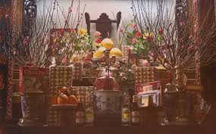 | Our earliest ancestors lived on the Nile Delta.  Tổ tiên của chúng tôi đã sống ở đồng bằng sông Nin
ceremony  /ˈserəˌməni/ | nghi lễ ,lễ kỉ niệm |  | The opening ceremony of the Olympic games will be held tomorrow.  Buổi lễ khai mạc của thế vận hội Olympic sẽ được tổ chức ngày mai.
communal house  /kəˈmju:nl haus/ | nhà cộng đồng | 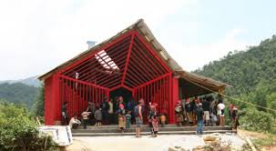 | In some mountainous areas, people often gather in the communal house on special occasions.  Ở một số vùng núi, mọi người thường tụ họp ở nhà cộng đồng vào những dịp đặc biệt.
complicated  /’komplɪkeitid/ (adj) | tinh vi, phức tạp |  | I couldn’t solve this complicated problem.  Tôi không thể giải quyết vấn đề phức tạp này.
costume  /’ kostju:m/ (n) | trang phục |  | Ethnic minority people often wear colourful costumes.  Những người dân tộc thiểu số thường mặc trang phục nhiều màu sắc.
custom /ˈkʌstəm/ | tập quán, phong tục |  | My country has the custom of giving presents at Christmas.  Đất nước tôi có phong tục tặng quà vào Giáng Sinh.
ethnic /ˈeθnik | (thuộc) dân tộc | 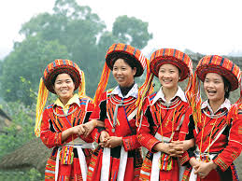 | Vietnamese ethnic minority communities often reside in moutainous areas.  Các cộng đồng dân tộc thiểu số ở Việt Nam thường sống ở vùng núi.
major /ˈmeɪdʒər/ (adj) | lớn, trọng đại, chủ yếu | 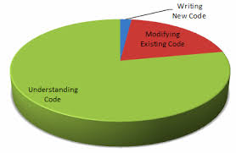 | There have been major changes in our beliefs.  Có nhiều thay đổi lớn trong tín ngưỡng của chúng tôi.
minor /ˈmaɪnər/ (adj) | nhỏ, không quan trọng |  | Women used to play a minor role in the society.  Phụ nữ đã từng có vai trò rất nhỏ trong xã hội.
moutainous /ˈmauntənəs/(adj) | có núi | 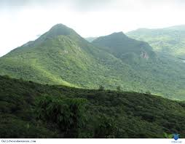 | Visitors are always stunned by the beauty of this moutainous area.  Khách tham quan luôn luôn bị tráng ngợp trước vẻ đẹp của vùng núi này.
poultry /’pəʊltri/(n) | gia cầm | 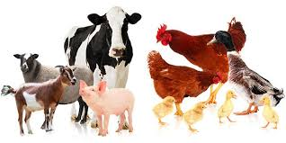 | My family used to raise poultry on the farm.  Gia đình tôi đã từng chăn nuôi gia cầm ở trang trại.
region/ ˈriʤən/ (n) | vùng | 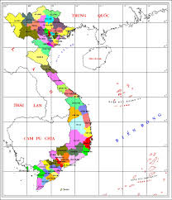 | Ho Chi Minh Cityis in the Southeast region of Vietnam.  Thành phố Hồ Chí Minh nằm ở phía Đông Nam Việt Nam.
specialty /ˈspeʃəlti/(n) | đặc sản | 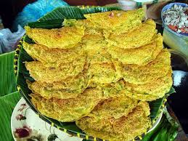 | You should try the local specialties.  Bạn nên thử những đặc sản của địa phương.
terraced field /ˈterəst fi:ld/ | ruộng bậc thang |  | Tourists can see many terraced fields in Sa pa, Vietnam.  Khách du lịch có thể nhìn thấy rất nhiều ruộng bậc thang ở Sa Pa, Việt Nam
unique/ju’ni:k/ | độc đáo ,độc nhất | 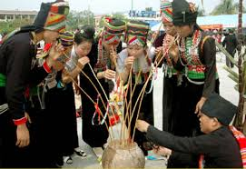 | Every ethnic group of people has their unique customs.  Mỗi nhóm dân tộc đều có những phong tục độc đáo.
worship /‘wərʃip/(v) | thờ phụng |  | People used to worship Sun God in ancient times.  Con người đã từng thờ phụng thần Mặt Trời ở thời kỳ cổ đại

- GRAMMAR.
- ÔN TẬP CÂU HỎI. (QUESTION)
Theo quy tắc ngữ pháp, khi là câu hỏi thì chúng ta cần đảo trợ động từ (auxiliray verbs) lên trước chủ ngữ
- Câu hỏi Yes/No (Yes/No Questions)
Câu hỏi dạng Yes/No Questions là dạng câu hỏi đòi hỏi câu trả lời là Yes (có) hoặc No (không).
Cấu trúc | Ví dụ
Trợ động từ (be/ do/ does) + chủ ngữ (S) + động từ + ….?  Yes, S + trợ động từ / tobe.  Hoặc  No, S + trợ động từ / tobe + not | Isn’t Lan going to school today?  Hôm nay Lan đi học phải không?  Yes, she is. (đúng vậy)  Was Hung sick yesterday?  No, he wasn’t. (không, anh ấy không bệnh)

- Wh-question
Trong tiếng Anh, khi chúng ta cần hỏi rõ ràng và cần có câu trả lời cụ thể, ta dùng câu hỏi với các từ để hỏi. Loại câu hỏi này được gọi là câu hỏi trực tiếp (direct questions)
- Các từ dùng để hỏi trong tiếng Anh
Who (Ai) (chức năng chủ ngữ) | Whom (Ai) (chức năng tân ngữ | What (Cái gì) | Whose (Của ai)
Where (Ở đâu) | Which (cái nào) (để hỏi về sự lựa chọn) | When (Khi nào) | Why (Tại sao)
How (như thế nào) | How much (Bao nhiêu) | How many (Bao nhiêu, số lượng) | How long (Bao lâu)
How far(Bao xa) | How old (Bao nhiêu tuổi) | How often (Bao nhiêu lần) | What time (Mấy giờ)

Các cấu trúc câu hỏi WH thường gặp
- Nguyên tắc đặt câu hỏi
- Nếu chưa có trợ động từ thì phải mượn trợ động từ :do/ does/ did
- Nếu trợ động từ có sẵn (am/is/are/can /will/shall/would/could) thì đảo chúng ra trước chủ ngữ, không mượn do/does/did nữa.
- Cấu trúc thông thường của loại câu hỏi Wh-questions
Từ để hỏi thường được viết ở đầu câu hỏi.Từ để hỏi có thể làm chủ ngữ (subject) hay tân ngữ (object) và bổ ngữ.

Dạng | Cấu trúc | Chú ý
Dạng 1:  Câu hỏi tân ngữ | Wh-word + auxiliary + S + V + object?  Từ để hỏi + trợ động từ + chủ ngữ + động từ chính + (tân ngữ)  Ví dụ:  Where do you live? (Anh sống ở đâu?)  What are you doing? (Ạnh đang làm gì thế?)  Whom do you meet this morning? (Anh gặp lại ai sáng nay?) (Whom là tân ngữ của động từ “meet”)  Who are you going with? (Bạn sẽ đi với ai?) | Object là danh từ, đại từ đứng sau động từ hoặc giới từ.
Dạng 2:  Câu hỏi bổ ngữ | Wh-word + tobe + S + complement?  (Từ để hỏi + động từ tobe + chủ ngữ + bổ ngữ)  Ví dụ.  Where is John? (John ở đâu?)  Who are you? (Bạn là ai?)  Whose is this umbrella? (Cái ô này của ai?)  Who is the head of your school? (Hiệu trưởng của trường anh là ai?) | Bổ ngữ là danh từ hoặc tính từ  Động từ tobe chia theo chủ ngữ
Dạng 3:  Câu hỏi chủ ngữ | Wh-word + V + object?  (Từ để hỏi + động từ chính + tân ngữ)  Ví dụ.  Who lives in London with Daisy? (Ai sống ở London cùng với Daisy vậy?)  Who is opening the door? (Ai đang mở cửa đấy?)  Who teaches you English? (Ai dạy bạn Tiếng Anh?)  Which is better? (Cái/loại nào tốt hơn?)  What caused the accident? (Nguyên nhân gì đã gây ra tai nạn?) | Động từ chính luôn được chia theo ngôi thứ 3 số ít.

C.Trường hợp câu hỏi đặc biệt với WHICH
Cách dùng | Ví dụ
“Which’ được sử dụng thay thế cho What và Who khi ta muốn hỏi ai đó chính xác về người hay vật trong một số lượng nhất định. Người nghe phải chọn trong giới hạn ấy để trả lời. | Which of you can’t do this exercise? (Em nào (trong số các em) không làm được bài tập này?)  Which way to the station, please? (Cho hỏi đường nào đi đến ga ạ?)

B. BÀI TẬP VẬN DỤNG CƠ BẢN.
Bài 1: Khoanh tròn vào đápán đúng.
1. _________ is your cat? It is two months old.
A. How old B. When C. How much
2. ______ did you begin working part-time here? A. How long B. When C. How much
3. ______ people are there in the conference room? A. How B. Howmany C. How much
4. ______time will you spend on your new carpet? A. How long B. Howmany C. How much
5. _______do these shoes cost? A. How long B. Howmany C. How much
6. _______do you go to the gym? A. How B. How often C. How long
7. _____ did you get to work yesterday? I took a taxi because my car was broken. A. How B. Why C. When
8. ______were you late for work yesterday? - Because of the traffic jam A. How B. Why C. When
9. _____does this laptop belong to? It belongs to Jim. A. Who B. Whose C. Which
10. ______ bag was stolen yesterday? A. Who B. Whose C. Which
11. ______will you travel to this summer? I haven’t decided yet. A. Where B. What C. Who
12. _____did you sell yesterday? - Bread and cupcakes. A. What B.Who C. Which
13. ______dress did she buy? -The red or the blue one? A. What B.Whose C. Which
14. ______is playing the piano upstairs? A. Who B. Whose C. Whom
15. To ______should I address the letter? A. Who B. Whose C. Whom
Bài 2: Điền từ thích hợp để hoàn thành các câu sau.
1. ________have you give up smoking? For about two years.
2. _________place is more densely populated – Ha noi or Ho Chi Minh City?
3. _________broken Jane’s favorite vase? Her brother did it.
4. _________ does Mr. Brown do? He’s a reseacher.
5. _________ethnic groups are there in your country?
6. _________ is your grandmother? She’s ninety years old.
7. _________ does your English teacher look like? She’s young and pretty.
8. _________water should we drink every day?
9. _________did you use to go to school? I used to go on foot.
10. _________is it from here to the nearest police station?
11. ________songs is this singer performing? He is performing Trinh Cong Son’s songs.
`12. ________ was Ms Ann born? She was born in a small village.
13. ________did you have for breakfast? - Bread and eggs.
14. ________didn’t you invite Jim to the senior prom?
15. ________do they meet each other? - Almost every day.
Bài3. Nối câu hỏi ở cột A với câu trả lời ở cột B sao cho thích hợp.
A | B
- How much did you pay for that radio? | - For 6 years
- How long have you worked as an engineer? | - About 6 kilomiters
- When did you start your career as a singer? | - It’s near the local park.
- How far is it from here to Tom’s mansion? | - I prefer tea.
- Where isthe vet’s located? | - 10 dollars
- How often do you go travelling? | - It’s mine
- Which do you prefer: tea or coffee? | - 6 years ago
- Whose luggage is it? | - Once or twice a year.

1. _____ 5.______
2. ____ 6. ______
3. _____ 7. ______
4. ____ 8. ______

Bài4. Điền một từ thích hợp vào chỗ trống để hoàn thành những câu hỏi dưới đây
1. _____you like chocolate?
2. When ________ you begin studying here? 2 years ago.
3. Which movie_________ you watch last night?
4. How far __________it from here to the town center?
5. How long ___________Ann and James been friends with each other?
6. What________ you do tomorrow? I will just lie in my bed and read books.
7. Who _________ you pick up yesterday?
8. How old__________ they?
9. How many rooms __________ there in your house?
10. Who___________ sleeping in your room?
11. ___________you found your keys? No, I haven’t found them yet.
12. _________you travel to a mountainous area last summer?
13. How often ___________Ann visit her grandmother?
14. What _________you use to do before your retirement?
15. Where________Jim going to? He is going to the library?
Bài5. Dựa vào từ cho sẵn, viết câu hỏi hoàn chỉnh
1. How many/ groups of people/ there/ in your country? ………………………………………………………………………..
2. How/ your/ party/ last week? ………………………………………………………………………..
3. How/ you/go/ school/ yesterday? …………………………………………………..
4. Whose/ cat/ it? …….…………………………………………………………………..
5. Jim/ learn/ Geography/ at the moment? ………………………………………………………………..
6. You/ ever/ see/ terraced fields? ………………………………………………………………..
7. What/ kind of animal/ the farmers/ raise/ in your country? ………………………………………………………………..
8. What time/ the concert/ start? ………………………………………………………………..
9. How far/ it/ from/ your house/ to the local school? ………………………………………………………………..
10. You/ come/ my birthday party/ tomorrow? ………………………………………………………………..
11. Where/ you/go/ last summer? ………………………………………………………………..
12. How much/ money/ you/spend/on clothes/ last month? ………………………………………………………………..
13. How/ ethnic people/ dress/ in special occasions? ………………………………………………………………..
14. Who/ swim/ in the swimming pool/ now? ………………………………………………………………..
15. How often/ Mr. Smith/ now/ the lawn? ………………………………………………………………..
II. Mạo từ (Articles)
- Định nghĩa
- Mạo từ là từ đứng trước danh từ và cho biết danh từ ấy đề cập đến một đối tượng xác định hay không xác định.
- Mạo từ trong tiếng Anh chỉ gồm ba từ và được phân chia như sau.
Mạo từ xác định (Dedinite article): ‘the” được dùng khi danh từ chỉ đối tượng được cả người nói và người nghe biết rõ đối tượng đó.
Mạo từ bất định (indedinite article): ‘a/an” được dùng khi người nói đề cập đến một đối tượngchung hoặc chưa xác định được.
- Cách dùng mạo từ.
Mạo từ | Cách dùng và vị trí
a | -a đứng trước danh từ đếm được số ít.  -a đứng trước danh từ bắt đầu bằng một phụ âm (consonant) hoặc một nguyên âm (v) nhưng được phát âm như phụ âm.  Ví dụ:  A ruler (cây thước), a pencil (cây bút chì), a pig (con heo), a student (sinh viên), a one way street (đường một chiều)  -a được dùng với ý nghĩa “mỗi, bất cứ”  Ví dụ: A lion lives in the jungle.
an | - an đứng trước danh số ít.  - an đứng trước danh từ bắt đầu bằng một nguyên âm (a, e, I, o, u)  Ví dụ: an orange (quả cam), uncle (chú, cậu)  - an đứng trước một số danh từ bắt đầu bằng “h” và được đọc như nguyên âm.  Ví dụ: an hour (giờ), an honest man (người thật thà)
the | -“the’ đứng trước cả danh từ đếm được (số ít lẫn số nhiều) và danh từ không đếm được.  Ví dụ; The truth (sự thật), The time (thời gian), The bicycle (một chiếc xe đạp), The bicycles (những chiếc xe đạp).  “the” đứng trước bất cứ một danh từ nào khi người nói và người nghe đều biết về danh từ đang được nói tới hoặc được xác định rõ ràng.  Ví dụ: Their Literature teacher is old, but the English teacher is young.  Giảng viên môn Văn của họ thì già rồi nhưng giáo viên tiếng Anh thì trẻ.  “the” đứng trước một danh từ chỉ người hay vật độc nhất.  Ví dụ: the sun (mặt trời), the moon (mặt trăng)  -Trong dạng so sánh hơn nhất (superlatives) với tính từ và trạng từ.  Ví dụ:  This is the youngest student in her class.(Đây là học sinh nhỏ tuổi nhất trong lớp của cô ấy)
BÀI TẬP VẬN DỤNG CƠ BẢN
Bài6. Điền mạo từ ‘a” hoặc “an” trước những danh từ sau:

- _____ aunt
- _____photograph
- _____costume
- _____ custom
- _____honor
- _____ specialty
- _____hour
- _____person
- _____house
- _____region
- _____student
- _____picture
- _____uniform
- _____mountain
- _____university
- _____way

BÀI 7: Điền mạo từ ‘a’, ‘an’ hoặc 0 vào chỗ trống sao cho thích hợp.
- She asked me for ___ information about the meeting.
- They will move to ___ mansion next month.
- I’d like ___ grapefruit and ___ orange juice.
- ___award was given to Jim yesterday.
- We read ___ books and play ___ games when we have free time.
- Jim doesn’t want to borrow ___ money from anyone.
- My friend and I threw ___ party last week.
- It was ___ honor to be invited here today.
- I’ve bought ___ umbrella for my sister.
- My family often have____ eggs for breakfast.
- Would you like______cup of tea?
- My brother doesn’t like ______ cats.
- Is there __________post office here?
- I spend _________hours on my DIY project.
- Mr. Peter used to be ___________famous vet.
BÀI 8: Điền mạo từ “a”, “an” hoặc “the” vào chỗ trống sao cho phù hợp.
- We have __ cat and ____ dog, _____ cat doesn’t get on well with ___ dog.
- You can see ____ moon clearly in the Mid-Autumn festival.
- He is ____famous actor.
- My brother doesn’t like ____ present I gave him.
- Where is ____ book I lent you last week?
- My father works as ___ electrician.
- Have you ever heard about ____ River Thames?
- I want to travel around _____ world when I grow up.
- Yesterday my mother had ______terrible headache.
- Where are ____kids? They are playing outside.
- Peter is ______most hard-working student I’ve ever known.
- It is cold because_______heating systems is broken.
- Did you buy _______pair of shoes yesterday?
- _____Earth orbits around _______Sun.
- She took ______hamburger and ____apple, but she didn’t eat ____apple.
- A boy and a girl is arguing over there, I think I know _____boy.
- My grandfather sent me _____letter and ____gift but I haven’t received________letter.
- My mom is _____best mom in _____world.
- Would you like________glass of water?
- James offered me ________cup of coffee and _____piece of cake. _____cake is delicious.
BÀI 9: Đánh dấu (V) trước câu đúng, đánh dấu (X) trước câu sai và sửa lại cho đúng.
- There is an big apple in the refrigerator. _____
- It took me the hour to finish my homework. _____
- I don’t know a full name of my manager. _____
- They are most beautiful creature on earth. _____
- Mary is studying at a university in Hanoi. _____
- This is an unique custom of this ethnic group. _____
- Did you enjoy a party last night? _____
- The sun is shining brightly. _____
- No one in my family likes drinking a beer. _____
- Peter is a friend of mine. _____

BÀI TẬP TỔNG HỢP NÂNG CAO.
Bài 10. Đặt câu hỏi cho phần gạch chân trong những câu trả lời sau.
- Jim has recently experienced the life of ethnic people in Vietnam. ……………………………………………………………………………..?
- The ethnic minorities in Vietnam often live in mountainous areas. ……………………………………………………………………………..?
- Their costumes are colorful and unique. ……………………………………………………………………………..?
- They often gather together at the communal house in special occasions. ……………………………………………………………………………..?
- The chief of the community often tell tales of heroes to the people at the communal house. ……………………………………………………………………………….?
- Ethnic people often hold festivals in spring. ………………………………………………………………………………?
- Life in the mountainous areas is quite difficult because of the extreme weather. ………………………………………………………………………………?
- In the remote areas, it may take people half a day to travel from their house to the market. ………………………………………………………………………………
- Shortage in electricity and fresh water supply makes life in remote areas so difficult. ………………………………………………………………………………?
- The local authorities try to help the ethnic minorities by teaching them effective farming methods. ………………………………………………………………………………?
BÀI 11: Điền mạo từ “a”, “an”, “the” hoặc 0 vào chỗ trống sao cho phù hợp.
- Farmers in my hometown earn a living by raising ____poultry.
- Some villagers play _____ flute in special occasions.
- Do you know there is _____ local folk festival tonight?
- I like _____colourful costumes of _____ethnic minority people in Vietnam.
- ______cattle are often raised in the rural areas in my country.
- When I travel to _____ foreign country, I always want to try _______local specialities first.
- Have you ever been to _________remote area?
- Ethnic minority people often gather together at __________communal house
- In Tay Nguyen, people sometimes ride ______ elephants.
- _________traditional customs of Vietnam are totally different from________customs of Western countries.

Bài 12: Dựa vào những từ cho sẵn, viết câu hoàn chỉnh.
- When/ bank/ open/ every day? …………………………………………………………………….?
- You/ have/ bread/ and/ boiled egg/ for/ breakfast? …………………………………………………………………….?
- Everyone/ enjoy/ concert/ last night? …………………………………………………………………….?
- When/ you/ start/ working/ as/ officer/ in/ this company? …………………………………………………………………….?
- How much/ money/ you/ spend/ on/ your/ last/ holiday? …………………………………………………………………….?
- What time/ sun/ often/ rise/ in/ summer? …………………………………………………………………….?
- You/ like/ cup/ of/ tea? …………………………………………………………………….?
- Train/ leave/ early/ this morning? …………………………………………………………………….?
- Who/ play/ guitar/ upstairs? …………………………………………………………………….?
- Who/ tallest/ person/ in/ your/ class? …………………………………………………………………….?
Bài 13: Khoanh vào đáp án đúng.
Elephants need help
The elephant is (1) _______ unique cultural symbol of Tay Nguyen and Dak lak is considered the land of (2) ________ elephants in Vietnam. In the past.Tay Nguyen used to have large (3) __________ of elephants living in the mountains. They helped (4) ______locals and they lived in harmony with people. However, the elephants in Tay Nguyen are in (5) _____ now. In recent years, climate changes have decreased the area of natural forests. Illegal deforestation has also threaten the elephants. Besides, illegal hunting for tusks, bones and tail hair has killed many of (6) __________ animals, (7) ________can we protect the elephants? It is important that both the authorities and the local people joined hands to save the elephants from (8) ______.
- A. a B. an C. the D. 0
- A. a B. an C. the D. 0
- A. shoals B. schools C. herds D. flocks
- A. a B. an C. the D. 0
- A. safe B. guard C. danger D. protection
- A. a B. an C. the D. 0
- A. How B. What C. Who D. Why
- A. extinction B. protection C. destruction D. conservation

Bài 14: Đọc bài đọc dưới đây và trả lời câu hỏi.
NGOC LU BRONZE DRUM
Dong Son bronze drums are very famous for its cultural value. They are often used as a musical instrument in festivals and rituals. Of about 200 drums discovered, Ngoc Lu bronze drum is considered the most beautiful drum of the Dong Son culture ever found in Vietnam. It is now preserved at the National Museum of Vietnam History in Hanoi.
This drum has a large size and an ancient look with many decorative patterns. These patterns include a multi-ray star (symbolizing the shining sun) and in between the star rays are designs of stylized peacock feathers. Bands of geometrical patterns with small dots surround the star. The band of human figures presents two people pounding rice, some other standing or sitting inside the house, some beating the drum and many others dancing. In between those human patterns are the curved-roof stilted house, bronze drum, bronze bells, weapons, musical instruments and so on. The bands of animal figures include short –bill birds, the long –bill birds and deer.
The Ngoc Lu bronze drum is the most typical one in the bronze drum system of Vietnam, and at the same time it symbolizes the brilliant peak of the Dong Son culture. The drum represents the scientific knowledge and the artistic talent and mind of the ancient Viet.
- What are Dong Son bronze drums famous for? ………………………………………………………………………………
- Which bronze drum is considered the most beautiful drum of the Dong Son culture? ……………………………………………………………………………….
- Where is the Ngoc Lu bronze drum preserved now? ………………………………………………………………………………..
- What decorative patterns are in between the star rays? ……………………………………………………………………………….
- What does the band of animal figures include? ……………………………………………………………………………….
- What does the Ngoc Lu bronze drum symbolize? ………………………………………………………………………………..
UNIT04. OUR CUSTOMS AND TRADITIONS
(PHONG TỤC VÀ TRUYỀN THỐNG CỦA CHÚNG TÔI)

New words | Meaning | Picture | Example
break with  /breik wið/ | không theo |  | They broke with tradition and went traveling on Tet holiday.  Họ đã không theo truyền thống và đi du lịch trong kì nghỉ tết
conical hat/kɒnɪkl hæt/ | cái nón |  | Visitors to Vietnam often buy conical hats as souvenirs.  Các du khách tới Việt Nam thường mua nón làm quà lưu niệm.
course /kɔːs/ (n) | món ăn | 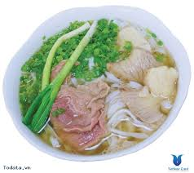 | The main course was noodle.  Món ăn chính là phở.
cutlery /’kʌtləri/ | bộ đồ ăn (gồm thìa, dao, dĩa) |  | In Western countries, people use the cutlery in meals.  Ở những nước phương Tây, mọi người thường dùng bộ đồ ăn trong bữa ăn.
generation / ʤenə’reɪʃn/(n) | thế hệ |  | My grandfather’s generation grew up with the experience of war.  Thế hệ của ông tôi lớn lên với những trải nghiệm về chiến tranh.
honour /’ɒnər/(v) | thể hiện sự tôn trọng |  | They honoured their guests by a welcoming party.  Họ thể hiện sự tôn trọng với các vị khách bằng một bữa tiệc chào đón.
host/ həʊst/(n) | chủ nhà (nam giới) | 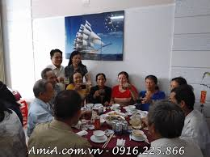 | Our host is introducing us to other guests.  Chủ nhà của chúng tôi đang giới thiệu chúng tôi với những vị khách khác.
hostess /’həʊstəs/(n) | chủ nhà (nữ giới) |  | I was lucky to have Jane as my hostess.  Tôi thật may mắn khi có Jane làm chủ nhà của tôi.
manner /’mænər/(n) | cách ứng xử |  | Different countries in the world often have different table manners.  Những đất nước khác nhau trên thế giới có những cách ứng xử trên bàn ăn khác nhau.
mat/mæt/(n) | cái chiếu | 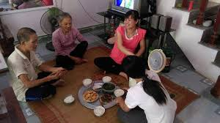 | Vietnamese people often have meals on a mat.  Người Việt Nam thường dùng bữa ở trên một cái chiếu.
reflect /riˈflekt/(v) | phản ánh |  | Her music reflects her passion for traditional music.  Âm nhạc của cô ấy phản ánh niềm đam mê của cô ấy dành cho âm nhạc truyền thống.
respect /riˈspekt/(n,v) | tôn trọng | 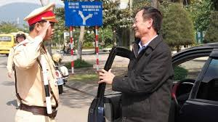 | I always respect Jim for his honesty.  Tôi luôn luôn tôn trọng Jim vì sự trung thực của anh ấy.
reunite/ /ri:ju:’naɪ/(v) | đoàn tụ | 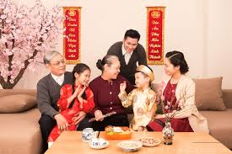 | Myfamily always reunite on Tet holiday.  Gia đình tôi luôn luôn đoàn tụ vào ngày tết.
spirit /’spɪrɪt/ | tinh thần |  | You should try and keep your spirit up.  Bạn nên cố gắng và giữ tinh thần tốt.
tray/treɪ/(n) | cái mâm | 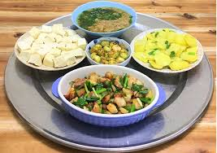 | Vietnamese people often sit around a tray to have meals.  Người Việt Nam thường ngồi xung quanh một cái mâm để dùng bữa.
B. GRAMMAR
- ÔN TẬP SHOULD (NÊN) VÀ SHOULDN’T (KHÔNG NÊN) DÙNG ĐỂ ĐƯA RA LỜI KHUYÊN.
Should là động từ khiếm khuyết, do đó nó không cần chia theo các ngôi và luôn cần môt động từ nguyên thể không có “to” đi đằng sau.
Thể | Thể khẳng định + thể phủ định | Thể nghi vấn
Chức năng | Dùng để diễn tả lời khuyên, hay ý nghĩ điều gì đúng, nên làm hoặc không nên làm. | Dùng để hỏi ý kiến hay yêu cầu một lời khuyên.
Cấu trúc | S + should/ shouldn’t + V + (các thành phần khác | Should + S + V + (các thành phần khác)?  - Yes, S + should  - No, S + shouldn’t
Ví dụ | We should brush our teeth twice a day.  (Chúng ta nên đánh răng hai lần một ngày)  We shouldn’t waste water.  (Chúng ta không nên lãng phí nước) | Should we buy a new car?  (Chúng ta có nên mua một chiếc ô tô mới không?)  Yes, we should.  (Có, chúng ta nên mua.)

BÀI TẬP VẬN DỤNG CƠ BẢN
Bài 1: Hoàn thành những câu sau với động từ khuyết thiếu “should” hoặc “shouldn’t”.
- You ________stay up too late because it’s not good for your health.
- No one ________ be late for school tomorrow because we will have an exam.
- I think there _________ a garbage dump in front of the restaurant.
- You ___________ go for a check-up regularly.
- I think you _________ be more tactful.
- __________you have any questions, please write me an email.
- What ____________ I do to learn better?
- My father thinks that I __________be so into computer games.
- The candidates_________ be here before 10am, or they will be disqualified.
- You _______learn about some cultural features of the country you are going to visit.
- Mary ___________take any pills befor seeing the doctor.
- __________James apply for the job at this company? Yes, he should.
- How much time __________ I spend on this task?
- Old people _______work too hard. They need an abundance of time to relax.
- Parents_________ let their children expose to smartphones at an early age.

Bài 2: Dựa vào những từ cho sẵn, viết câu hoàn chỉnh với “should” hoặc “shouldn’t”.
- You/ go/ to/ see/ doctor/ regularly. …………………………………………………………………………
- Which dress/ I/ wear/ today? …………………………………………………………………………
- The teacher/ think/ Jim/ study/ harder. …………………………………………………………………………
- The boys/ not/ climb up/ the wall. …………………………………………………………………………
- I/ watch TV/ go out/ with/ friends/ now? ………………………………………………………………………...
- If/ Jim/ be/ sick, he/ stay/ home. …………………………………………………………………………
- How much/ water/ we/ drink/ everyday? …………………………………………………………………………
- What/ I/ not/ do/ at/ Chinese restaurant? ………………………………………………………………………….
- You/ inform/ your parents/ before/ you/ go. …………………………………………………………………………..
- Josh/ not/ devote/ all/ his free time/ to/ playing/ games. ……………………………………………………………………………

Bài 3: Chuyển những câu sau thành câu đưa ra lời khuyên với “should” hoặc “shouldn’t”.
Ex: They wear formal clothes when attending the conference.
- They should wear formal clothes when attending the conference.
- Parents instill in their children a respect for their country’s tradition and culture.
…………………………………………………………………………..............
- Everyone goes home for a family reunion regularly.
…………………………………………………………………………………..
- You travel more to broaden your horizon.
…………………………………………………………………………………..
- What does Jim do to study better?
……………………………………………………………………………………
- We don’t go to on our vacation because it’s very far from our location.
………………………………………………………………………………….
- They are never rude to other people.
…………………………………………………………………………………..
- You pay more attention to what your parents say.
………………………………………………………………………………….
- Whenever you go, you pay close attention to the manner and etiquettes there.
…………………………………………………………………………………

- Động từ khuyết thiếu “Must”, “Have to”
Trong tiếng Anh, must và have to đều mang nghĩa là “phải”, dùng để diễn tả sự cưỡng bách, bắt buộc. Tuy nhiên, sự khác biệt về cách dùng của 2 động từ khuyết thiếu này được thể hiện ở dưới bảng sau.
Phân biệt Must và Have to
Thể khẳng định

must + V | have/ has to + V
Mang ý nghĩa của sự bắt buộc đến từ người nói(mang tính chủ quan) | Mang ý nghĩa sự bắt buộc đến từ hoàn cảnh bên ngoài, do luật lệ, quy tắc hay người khác quyết định (mang tính khách quan)
Ví dụ :  I must finish the exercise  (Tôi phải hoàn thành bài tập)  (Situation: I’m going to have a party.)  Câu này có thể được nói trong tình huống người nói sắp có một bữa tiệc, nên cần phải hoàn thành bài tập để đi dự tiệc. | Ví dụ :  I have to finish this exercise.  (Tôi phải hoàn thành bài tập)  (Situation: Tomorrow is the deadline.)  Câu này có thể được nói trong tình huống, ngày mai là hạn cuối cùng để hoàn thành bài tập nên người nói phải hoàn thành bài tập.

Thể phủ định
mustn’t + V | don’t/doesn’t + V
Diễn tả ý cấm đoán | Diễn tả ý không cần thiết phải làm gì
Ví dụ:  You must not eat that.  (Bạn không được phép ăn cái đó)  (Situation: It’s already stale)  Câu có thể được nói trong tình huống thức ăn đã thiu rồi, cho nên người nói cấm đoán người nghe không được ăn món đó. | Ví dụ:  You don’t have to eat that.  (Bạn không cần phải ăn thứ đó)  (Situation: I can see you dislike that.)  Câu này có thể được nói trong tình huống người nói thấy người kia không thích ăn món đó, do vậy không bắt buộc người đó phải ăn.

BÀI TẬP VẬN DỤNG CƠ BẢN
Bài 4: Điền động từ khuyết thiếu “must” hoặc ‘mustn’t” vào chỗ trống để hoàn thành các câu sau.
- I __________do the laundry every2 days
- You __________ stay out too late.
- You ___________ break the class’s rule
- My mother doesn’t want me to arrive home late, so I __________ leave now.
- Those boys ___________ finish their homework before going out.
- Jim ___________ finish his essay today because he’s very busy tomorrow.
- Passengers___________ use phones on the plane.
- You __________ be late for school tomorrow.
- Children _______________ be accompanied by an adult when visiting this dangerous place.
- I ____________ be home before dinner.
- Students_________ talk during the exam.
- You ____________ cheat in a test.
- There _____________ be someone upstairs. I can hear the noise.
- We _____________ give up on what we are doing.
- You __________ let strangers enter the house while I’m not in.
Bài 5: Hoàn thành các câu sau bằng động từ khuyết thiếu “must“hoặc “have to” và động từ trong ngoặc.
- I _________learn Japanese. I need it my job.
- I _________learn Japanese. I love it.
- I _________ wake up early tomorrow.I want to watch the sunrise.
- I ________ wake up early tomorrow. I have a meeting early in the morning
- I ________ wear a black dress because I want to look good.
- I _______wear a black dress because that is the requirement of my company.
- I __________ go home now because it’s too late.
- I __________ go home now because I have a lot to do.
- I _________go to see my friend because I miss her.
- I _________ go to see my classmate because we work on the same project.
- You ________ wear a tie in the company. It‘s one of their rules.
- I ___________ go abroad next week. My boss wants me to sign a contract with our foreign customers.
- I __________ work harder. I want to be successful.
- This room is mess, I _____________ find time to clean it!
- You really ___________ stop driving so fast or you’ll have an accident!

Bài 6: Điền động từ khuyết thiếu “mustn’t” hoặc “don’t have to“ vào chỗ trống để hoàn thành các câu sau.
- You _______________pick me up tomorrow. I will take a taxi.
- Look at that sign! You ___________ walk on the grass.
- You __________ blame anyone for your mistakes. You need to be responsible for yourself.
- You __________ be absent from class tomorrow because the teacher will check your attendance.
- I ____________ prepare dinner because we will eat out tonight.
- You _________ leave any rubbish here. It is forbidden.
- You __________ let anyone know that. It is a big secret.
- You __________ come early tomorrow because the event will start late.
- You __________ park your car here. There is a”No parking sign”
- We don’t have much money left. We _____________ waste anymore.
- They __________ forget their homework at home.
- I ____________ do the housework because I have a maid do it for me.
- They ____________ break the rule that way. It is unacceptable.
- I ____________ use the computer after 11pm because my mother doesn’t allow me to.
- You __________ buy that book. I will lend you mine.
Bài7. Đánh dấu (V) trước câu đúng, đánh dấu (x) trước câu sai và sửa lại cho đúng
- It’s raining outside. Tim has to take his umbrella. ___
………………………………………………………
- I can give you a hand. So you mustn’t do it alone. ___
………………………………………………………..
- They mustn’t be hurry because the film starts late. ___
………………………………………………………..
- You must stop at the red light. ___
……………………………………………………….
- Tomorrow is Monday but I mustn’t go to work. ___
………………………………………………………
- I am short-sighted so I must wear glasses. ___
…………………………………………………………
- You mustn’t smoke here. There are a lot of children around you. ___
………………………………………………………………………
- Everyone have to bey the school’s rules. ____
……………………………………..................
- It is warm today so we mustn’t wear thick coat. ____
………………………………………………….
- My father will buy me a bike so I don’t have to walk to school any more. ___
……………………………………………………………………………….

BÀI TẬP TỔNG HỢP NÂNG CAO.
Bài 8: Hoàn thành các câu sau bằng động từ khuyêt thiếu “should” hoặc “shouldn’t” và những động từ cho sẵn.
talk | discuss | be | be
try | break | wear | thank

- You _________your host for taking care of you when you stayed.
- You _________ with your mouth full.
- Our teacher always reminds that we ____________ punctual.
- You __________ the local specialities when you visit a foreign place.
- It is a tough question. I think we_________ and work out a solution together.
- This year, _________ we ________ with tradition and go travelling on Tet holiday?
- Tourists___________ short clothes when they visit such places as temple or mausoleum.
- I am going to travel by plane next week. My mother says that my luggage __________ so heavy.
Bài 9: Dựa vào thông tin cho sẵn trong bảng, viết câu với động từ khuyết thiếu “should” hoặc “shouldn’t” để diễn tả những điều nên/ không nên làm gì khi sống ở Nhật Bản.
Do’s | Don’ts
- Be on time | - Pass food from one pair of chopsticks to the other.
- Bring your Business Card | - Brings outside food into restaurants
- Say “ itadikimasu” before eating ,especially if you’re being treated | - Use the phone in trains and elevators
- Make loud gulping noises when drinking | - Drink or eat while walking
- Cover your mouth with your other hand when using toothpick. | - Use your chopsticks to point at somebody.

When you are in Japan .
- ……………………………………………………………………………….
- ……………………………………………………………………………….
- ……………………………………………………………………………….
- ………………………………………………………………………………..
- ………………………………………………………………………………..
- ………………………………………………………………………………..
- ………………………………………………………………………………..
- ………………………………………………………………………………..
- ………………………………………………………………………………..
- ……………………………………………………………………………….

Bài 10: Hoàn thành các câu dưới đây với thể khẳng định hoặc phủ định của “must, have to, has to"
- Students___________ look at their notes while they are taking the exam.
- My mother has a terrible headache so she __________ stop working today.
- There is an accident and the traffic is blocked. We _________ to stay here for a while.
- You ____________ do that, Marry, I’ll do it later.
- He __________ wait in line like anyone else
- You __________ light a naked flame near the gas station.
- While operating a motor vehicle, you ___________ drink and drive.
- You __________ skip classes too often or you will not pass the final exam.
- They _________ work hard and earn a lot of money. They want to move to a larger apartment.
- Mr. Smith ____________ drive to work because his company is near his house.

Bài 11: Khoanh tròn vào đáp án đúng
VIETNAMESE CELEBRATION FOR LONGEVITY CUSTOM
In Vietnam, People count each passing year in a person’s life with increasing esteem and respect from their family and neighborhood. Formerly, at the age of 40 one was (1) ________ for being an old man or woman. According to village customs, a man of 50 is to be honored as an old man.Old men stop working and are no longer village officials. (2) _________, they are still invited to festivals and to sears in the communal house. In the festival, they are seated honor ably on the red-bordered (3) ___________. Showing (4) _______ and esteem for the elderly is a (5) ___________that remains today. Nowadays, when grandfathers or parents reach the ages of 70, 80, 90, their children and grandchildren origanize ceremonies for (6) ___________which are generally held on birthdays or during the spring days during Tet.
- A. honor B. honored C. consider D. considered
- A. Moreover B. But C. Although D. However
- A. curtains B. mats C. sofas D. carpets
- A. respects B. respect C. respective D. respectful
- A. tradition B. culture C. custom D. lifestyle
- A. longevity B. length C. age D. life

Bài12. Đọc đoạn văn dưới đây và điền T(True) trước câu có nội dung đúng với nội dung bài đọc, điền F(False) trước câu có nội dung sai với nội dung bài đọc.
Traditional Vietnamese customs and habits have been formed time to time for thousands of years. This creates a long – lasting culture. Despite the domination of Chinese and other powers, Vietnamese people still remains their unique cultural identity.
In the course of development, customs and habits are indipensable spiritual field in Vietnamese culture. It is the original cultural values of the country strongly that define the identity and the long-lastingness of culture in Vietnam. In the entire history of Vietnam, Vietnamese culture is the combination of native culture, cultural exchange with China, Asian region and western countries. However, with a firm native culture, Vietnamese people keep their culture away from being assimilation, and “Vietnamizing” those cultural features instead. Vietnam culture is characterized by a series of unique customs and habits such as worshiping ancestors, chewing betel, and other customs in traditional ceremonies like funeral ceremony, long –life ceremony, etc. These customs and habits are associated with community of villages. Vietnam is a country of festivals, especially in spring. There are several famous festivals featuring Vietnamese culture like Tet Nguyen Dan, Tet Nguyen Tieu, Tet Han Thuc, Tet Doan Ngo, Mid-Autumn Festival, etc. Yet, customs and habits of Vietnamese people vary from region to region, and ethnic group to ethnic group.
- Vietnam has a long –lasting culture. ______
- Due to the invasions of Chinese and other powers, Vietnamese people hardly remain their unique cultural identity. _______
- Vietnamese culture is the combination of many cultural components. ____
- Vietnamese people build their traditions partly by “Vietnamizing “foreign traditions. _________
- Vietnamese customs and habits are related to community of villages. _____
- In Vietnam, festivals are mostly held in spring.
- In Vietnam, customs and habits of people are quite the same throughout the country.

UNIT 05

A. VOCABULARY
New words | Meaning | Picture | Example
Archway  /'ɑ:tʃwei/  (n) | Mái vòm | 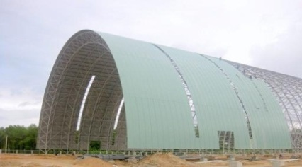 | We will enter the yard after going through an archway.  Chúng ta sẽ tiến vào sân sau khi đi qua mái vòm.
Bamboo  /bæm'bu:/  (n) | Cây tre | 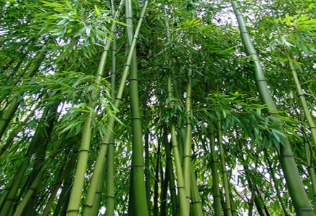 | Local craftsmen can make many things from bamboos.  Những người thợ thủ công địa phương có thể tạo ra nhiều thứ từ cây tre.
Carnival  /'kɑ:nivəl/  (n) | Lễ hội(hoá trang) |  | Will you join in the carnival tomorrow?  Bạn sẽ tham gia vào lễ hội hoá trang ngày mai chứ?
Coconut  /'koukənʌt/  (n) | Quả dừa | 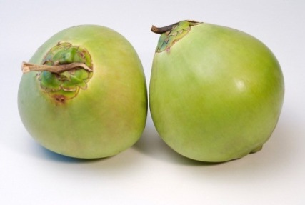 | Coconut candy is a. speciality of Ben Tre Province.  Kẹo dừa là một đặc sản của tỉnh Bến Tre.
Commemorate  /kə'memə'reiʃn/  (v) | Kỉ niệm | 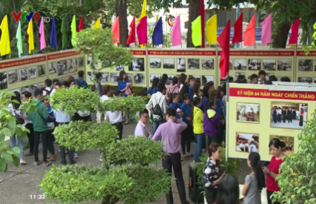 | An exhibiton will be held to commemorate his death.  Một buổi triển lãm sẽ được tổ chức kỉ niệm cái chết của ông ấy.

Fortune  /'fɔ:tʃn/  (n) | Vận may |  | I had good fortune of working with a brilliant coworker.  Tôi có may mắn làm việc với một đồng nghiệp xuất sắc
Green rice flake  /gri:n rais fleik/ | Cốm | 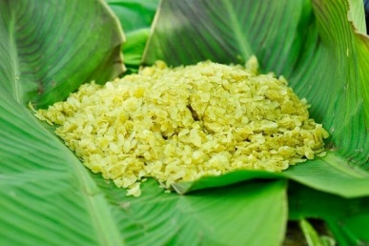 | Green rice flake is a special dish of Viet Nam.  Cốm là một món ăn đặc biệt của Việt Nam.
Hero  /'hiərou/  (n) | Người anh hung |  | He was one of the national heroes.  Ông là một trong những người anh hùng dân tộc.
Incense  /'insens/  (n) | Hương | 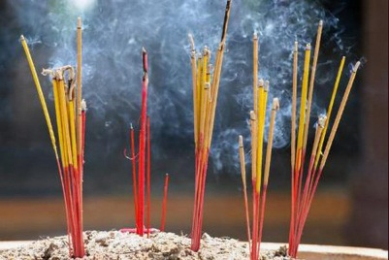 | People burnt incense to honour and commemorate the victims of war.  Mọi người thắp hương để thể hiện sự tôn trọng và tưởng nhớ những nạn nhân của chiến tranh.
Invader  /in'veidə/  (n) | Kẻ xâm lược | 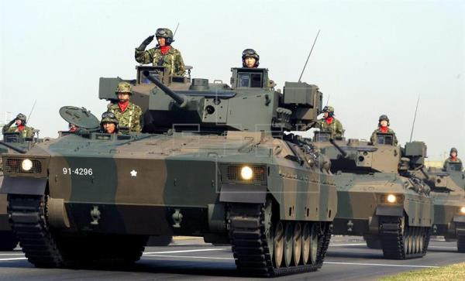 | They was about to rebel the invaders.  Họ đã chuẩn bị chống lại kẻ xâm lược.
Lantern  /'læntən/  (n) | Đèn lồng,đèn trời,đèn thả sông |  | You can see many floating lanterns along this river on special occasions.  Bạn có thể nhìn thấy nhiều đèn lồng trôi dọc theo dòng song này vào những dịp đặc biệt.
Preserve  /pri'zə:v/  (v) | Giữu gìn,bảo tồn | 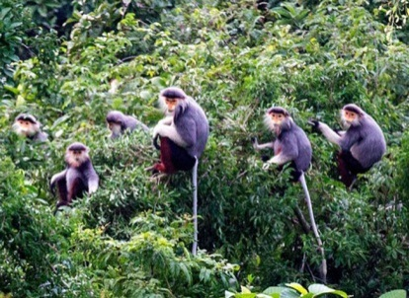 | People should preserve their traditional customs.  Mọi người nên giữ gìn những phong tục truyền thống.
Procession  /procession/  (n) | Đám rước,đoàn người | 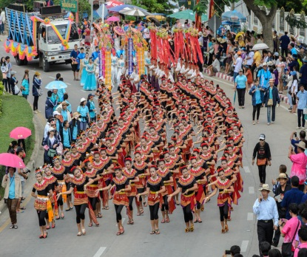 | A procession of visitors came into the building.  Một đoàn khách tham quan đã tiến vào toà nhà.
Reunion  /'ri:'ju:njən/  (n) | Sự đoàn tụ |  | I really long for the family reunion on Tet holiday.  Tôi thực sự trông đợi gia đình đoàn tụ vào dịp Tết.
Wrestler  /'reslə/  (v) | Đô vật | 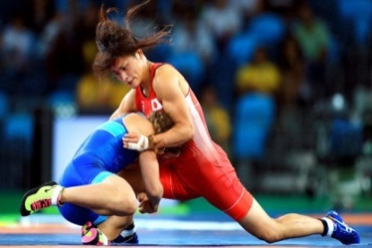 | The two wrestlers are trying to beat the other.  Hai đô vật đang cố gắng để đánh bại đối thủ.
B GRAMMAR
I. ÔN TẬP CÂU ĐƠN (SIMPLE SENTENCES)
Định nghĩa | Câu đơn là câu chỉ có 1 mệnh đề chính, gồm có 1 chủ ngữ và 1 động từ.  Hoặc câu có thể có chủ ngữ là 2 danh từ nối bằng ‘and’ hoặc có 2 động từ nối bằng ‘and’ nhưng vẫn là 1 câu đơn.
Ví dụ | I went to the supermarker yesterday. (Tôi đã đi đến siêu thị ngày hôm qua.)  Mary and Tom are playing tenis.(Mary và Tom đang chơi tenis.)  My broather ate a sandwich and drank beer. (Anh trai tôi đã ăn sandwich và uống bia.)
II. ÔN TẬP CÂU GHÉP (COMPOUND SENTENCES)
1.Định nghĩa và cấu trúc câu ghép
Định nghĩa | -Là câu có 2 hay nhiều mệnh đề độc lập về ý nghĩa.  -Được kết nối với nhau bởi một liên từ kết hợp hay còn gọi là lien từ đẳng lập như: and,or,but,so…
Cấu trúc | Mệnh đề 1 + (,) + liên từ + mệnh đề 2.  Ví dụ:  You should eat less fast or you can put on weight. (Bạn nên ăn ít đồ ăn nhanh hơn hoặc bạn có thể tang cân đấy.)  I wasn’t very hungry, but I ate a lot. (Tớ không đói lắm, nhưng tớ đã ăn rất nhiều.)  My mother does exercise every day, so she looks very young and fit. (Mẹ tớ tập thể dục hang ngày, vì vậy mà trông mẹ rất trẻ và khoẻ.)
Lưu ý | Chúng ta cần phải sử dụng dấu “,” trước lien từ so, con với các lien từ and/or/but thì có thể có dấu phẩy hoặc không.
2. Các liên từ kết hợp thường gặp
Liên từ | Ví dụ
And(và): dùng để bổ sung thêm thông tin | (The Japanese eat a lot of fish, and they eat a lot of tofu too.( Người Nhật ăn rất nhiều cá, và họ cũng ăn rất nhiều đậu phụ nữa.)
Or(hoặc): dung khi có sự lựa chọn | You can take this medicine, or you can drink hot ginger tea. (Con có thể uống thuốc này hoặc con có thể uống trà gừng nóng.)
But (nhưng): dung dể nói 2 mệnh đề mag ý nghĩa trái ngược, đối lập nhau. | She doesn’t eat much, but she’s still fat. (Cô ấy không ăn nhiều, những cô ấy vẫn béo.)
So (nên/vì vậy mà/vậy nên): dung để nói về một kết quả của sự việc được nhắc đến trước đó. | My mother eats healthily, so she is very strong.  (Mẹ tớ ăn uống rất lành mạnh, nên bà ấy rất khoẻ.)
III CÂU PHỨC (COMPLEX SENTENCES)
1.Định nghĩa
Định nghĩa | -Câu phức là câu bao gồm một mệnh đề độc lập (independent clause) và ít nhất 1 mệnh đề phụ thuộc (dependent clause) liên kết với nhau.Hai mệnh đề thường được nối với njau bởi dấu phẩy hoặc các liên từ phụ thuộc (Subordinating Conjuntions).

Ví dụ | He always takes time to play with his daughter even though he is extremely busy.  Mệnh đề độc lập Mệnh đề phụ thuộc  (Anh ấy luôn dành thời gian để chơi với con gái mặc dù anh ấy rất bận rộn.)  Even though he is busy,he always takes time to play with his daughter.  Mệnh đề phụ thuộc Mệnh đề độc lập  (Mặc dù anh ấy bận rộn,nhưng anh ấy vẫn dành thời gian để chơi với con gái.)  You should think about money saving from now if you want to study abroad.  Mệnh đề độc lập Mệnh đề phụ thuộc  (Bạn nên nghĩ về việc tiết kiệm tiền từ bây giờ nếu bạn muốn đi du học.)  If you want to study abroad, you should think about money saving from now.  Mệnh đề phụ thuộc Mệnh đề độc lập  (Nếu bạn muốn đi du học,bạn nên nghĩ về việc tiết kiệm tiền từ bây giờ.)
Lưu ý | -Mệnh đề đi liền với liên từ trong câu phức chính là mệnh đề phụ thuộc (dependent clause).  -Nếu mệnh đề phụ thuộc(dependent clause) nằm phía trược mệnh đề độc lập (independent clause) thì giữa hai mệnh đề phải có dấu phẩy còn lại thì không.
2. Một số lien từ phụ thuộc thường gặp
After  (sau khi) | Although  (mặc dù) | As  (bởi vì/khi) | As if  (như thế là) | As long as  (miễn là) | In oder to  (cốt để mà)
Before  (trước khi) | Even if  (mặc dù) | Because  (bởi vì) | As though  (như thế là) | As much as | So that  (cốt để mà)
Once  (một khi) | Even though  (mặc dù) | Whereas  (trong khi đó) | If  (nếu) | As soon as  (ngay khi) | Unless  (trừ phi)
Since  (kể từ khi/bởi vì) | Though  (mặc dù) | While  (trong khi đó) | In case  (phòng khi) | When  (khi) | Until  (cho đến khi)
■ BÀI TẬP VẬN DỤNG CƠ BẢN
Bài 1: Điền S (Simple) trước những câu đơn, điền C (compound) trước những câu ghép và CC (Complex) trước những câu phức.
______ 1. My bike is broken, so I have to walk to school.
______2. My mother bought me a new pair of shoes and made me a cake on my birthday.
_____ 3. I didn’t expect Jim to come to the meeting yesterday.
_____ 4. Peter had an accident last week but now he is fine.
_____ 5. When I came home, my sister was watching TV.
_____ 6. If you want to succeed in life, you have to work harder.
_____ 7. My sister fancies rock music and she always wants to go to a rock concert.
_____ 8. My grandfather and my grandmother fist met each other when they were very young.
_____ 9. I didn’t know his address until Mary told me.
_____ 10. Although she tried her best, she didn’t get the job.
_____ 11. In spring, there are various festival throughout country.
_____ 12. Jame never eats junk food because it’s bad for his healthy.
_____ 13. There are several parks around the city.
_____ 14. You may have a sore throat if you drink cold water.
_____ 15. They are going to hold a party to celebrate their wedding anniversary.
Bài 2: Khonh tròn vào liên từ thích hợp để hoàn thành những câu ghép dưới đây.(and,or,but,so)
1. My father is an engineer,_____ he often has to work away from home.
A.and B. or C.but D.so
2.This year the Mid-Autumn Festival falls on the next Sunday,_____ I can go home and reunite with my family.
A.and B. or C.but D.so
3.I have never joined in a carnival,_____ I am very curious about it.
A.and B. or C.but D.so
4.My mother is occupied in her job,_____ she tries to make time for me.
A.and B. or C.but D.so
5.Do you wwant to join us_____ do you want to leave now?
A.and B. or C.but D.so
6.I loves cats,_____ my mother doesn’t allow me to have one.
A.and B.or C.but D.so
7.Mary wants to go abroad,_____ she saves money from now.
A.and B.or C.but D.so
8.They used to be friends,_____ now they are not.
A.and B.or C.but D.so
9.This event is help to commemorate the national heroes,_____ it teacher children to respect and be grateful to the heroes.
A.and B.or C.but D.so
10.You can take a seat,_____ you can go around and take a look.It’s up to you.
A.and B.or C.but D.so
Bài 3: Điền một liên từ thích hợp để hoàn thành những câu ghép sau.
1. My father wants me to become a doctor,_____ I want to become a designer.
2. It is a challenging task ____ it takes me a lot of time to do it.
3. Should I stay in and watch TV ____ should I hang out with friends today?
4. There are many festival in Vietnam_____ many of them are held in the spring.
5. Did you stay at home last night_____ did you go out with your friends?
6. I broke my glasses yesterday,_____ I didn’t see things clearly.
7. My brother doesn’t socialize much, ____ he has very few friends.
8. A new camera is all I want now,_____ I don’t have enough money.
9. Mary looks small and thin,_____ she owns great strength.
10.I have many things to do tonight,_____ I reject my friend’s invitation to her party.
11. My computer is brand new,_____ I en counter some problems when I use it.
12. This is a complex problem,_____ we need to work together to find the solution.
13. Peter doesn’t feel today,____ he is absent from school.
14. They thought they won the match,_____ it turned out that they were losers.
15. My siblings and I don’t share many similarities,_____ we are in harmony with each other.
Bài 4: Nối hai câu đơn sau thành câu ghép.
1. My best friend is studying abroad. It is impossible for us to meet each other now.
2. They are going to build a new bridge across this rive. Traveling will be much more convenient.
3. It has been ages since our last encounter. I still remember him clearly.
4. I went down with flu last week. I had to postpone my work.
5. I think the festival will be full of fun. Many people will enjoy it.
6. Students can choose to carry out a project on environmental issues. They can conduct research on the topic of renewable energy.
7. My mother started a business trip last week. She hasn’t returned home yet.
8. My brother has grown up into an adult. He still enjoys playing with Lego.
Bài 5: Khoanh tròn vào liên từ thích hợp để hoàn thành những câu phức dưới đây.
1. It will be a great fortune (if/unless) I can join upcoming carnival.
2. I will lend you my book (as long as/as soon as) you promise to keep it clean.
3. I will call you (as long as/as soon as) I arrive there.
4. (When/While) I came, Jim was having dinner.
5. Catherine was shocked (when/until) she found out the truth.
6. They have worked at this company (when/since) they graduated.
7. At 8 pm last night, I was doing my homework (when/while) my sister was playing with her toys.
8. (Before/After) I had eaten my breakfast, I went to school by bus.
9. (Although/Despite) Mary looks thinner than me, she is much stronger than me.
10. They didn’t come to the party (since/as soon as) they were too busy.
11. You should bring your raincoat (unless/in case) it rains.
12.I didn’t realize her new hair (when/until) she told me.
13.I won’t accept this job (even if/if) the offer me high salary.
14.My father will buy me a book (even though/as long as) I pass the exam.
15.I like her (when/even though) she’s annoying sometimes.
Bài 6: Nối những mệnh đề ở cột A với cột B để tạo thành một câu ghép hoàn chỉnh.
A | B
1.They won’t let you in | a.he failed to persuade her.
2.They were having a small talk | b.once I have enough money to buy one.
3.Even though he tried his best, | c.until I pointed it out for him.
4.Jame didn’t realize his fault | d.unless you have the invitation letter.
5.Although Sarah can sing very well , | e.when I came in the room.
6.Today Peter doesn’t attend class | f.when you visit temples or pagodas.
7.I will move to a bigger apartment | g.as he is suffering from a headache.
8.You shouldn’t wear short skirts | h.she rarely performs in front of people.
1-_____ 2-_____ 3-_____ 4-_____
5-_____ 6-_____ 7-_____ 8-_____
Bài 7: Điền những liên từ cho sẵn vào chỗ trống để hoàn thành những câu phức dưới đây.
whereas | unless x2 | since | before x2 | if x2
even though |  | while
1.______ Jame is my friend, I can’t accept his arrogance.
2. My brother is a bookworm, ____ I don’t like reading books.
3. At midnight, my parents were sleeping_ ____ I was cramming for exams.
4._____ you have any questions, you ask me after the lesson.
5. We won’t go camping_____ the weather is fine.
6. You shouldn’t skip classes_____ you really have to.
7. What did you do_____ you went to bed last night?
8. In some cultures, you have to pray_____ you eat.
9. We are very familiar with this areas_____ we moved here 15 years ago.
10._____ you travel from the North to the South of Vietnam, you will experience many interesting customs.
Bài 8: Viết lại hai câu đơn thành một câu phức.
1. Dog is my favorite animal. They are good companions of people.
2. I don’t like jazz . A friend of mine is a fan of it.
3. They were stuck in the traffic for hours. They managed to get there on time.
4. I came to the party. Everyone was leaving.
5. This time Jane works very hard . She doesn’t want to fail the exam again.
6. I seldom do exercises. I doing exercises is good for health.
7. My computer is old-fashioned. It functions very smoothly.
8. I didn’t know her real name. People always called her by her nickname.
■ BÀI TẬP TỔNG HỢP NÂNG CAO
Bài 9: Đánh dấu [V] trước câu đúng.Đánh dấu [X] trước câu trả lời sai và sửa lại cho đúng.
_____ 1.I love th Mid-Auturn festival. Since there are a variety of interesting activities during the festival.
_____________________________________________________
_____________________________________________________
_____ 2.While the Mid-Autumn festival is also called “Children’s festival” in Vietnam, it is ẹnjoyed by people of all ages.
_____________________________________________________
_____________________________________________________
_____ 3.On this special occasion, family members often reunite and celebrate the festival.
_____________________________________________________
_____________________________________________________
_____ 4.Many people choose to go out and enjoy the exciting atmosphere, however others want to stay in and have time with their family.
_____________________________________________________
_____________________________________________________
_____ 5.The festival is help on the 15th day of the 8th month of the lunar calendar when the full moon.
_____________________________________________________
_____________________________________________________
_____ 6.Moon cakes are very important as if making and sharing moon cakes is the hallmark tradition of this festival.
____________________________________________________
____________________________________________________
_____ 7.In Chinese culture, a round shape symbolizes completeness and reunion so the eating of round moon cakes among family members signifies the unity of families.
___________________________________________________________
___________________________________________________________
_____ 8.Unless you visit Vietnam in autumn, you should join in this special festival.
___________________________________________________________
Bài 10: Dựa vào những từ cho sẵn, viết câu ghép hoàn chỉnh với các liên từ “and,so,but”.
1.I/visit/my neighbors/yesterday/no one/be/home.
___________________________________________________________
2.They/recently/buy/new/house/they/throw/party/tomorrow.
___________________________________________________________
3.You/face/a lot of/difficulties/in thefuture/career/you/should/never/give/up.
___________________________________________________________
4.You/like/cup/of/coffee/you/like/glass/of/water?
___________________________________________________________
5.Mr.Smith/seem/nice/man/he/be/selfish.
___________________________________________________________
6.Mr.Brown/be/dedicated/teacher/many people/respect/him.
___________________________________________________________
7.My students/be/hard-working/and/well-behaved/I not/have to/worry/much/about/them.
___________________________________________________________
8.Ann/want/lose/weight/she/go/the gym/regularly.
___________________________________________________________
9.The new radio/cost/me/a lot of/money/its/quality/br/poor.
___________________________________________________________
10.This movie/be/praised/by/critics/I/not/realy/like/it.
___________________________________________________________
Bài 11: Điền liên từ thích hợp vào ô trống để hoàn thành những câu sau:
1.They haven’t eaten anything since the morning_____ they were too busy to eat.
2.James is very excited now_____ he is going abroad next month.
3. _____ it may be very challenging for you to do it, you can give it a try.
4.I was going home yesterday_____ I came across my old friend.
5. _____ you offtenan apology to Jane, she won’t forgive you.
6_____ Mr.Smith doesn’t like traditional folk songs, he rarely listen to them.
7.Will you hang out with your friends_____ will you reunite with your family on the Mid-Autumn festival?
8. _____ you want to visit a foreign country, you have to apply for a visa first.
9.Tony has lived in Vietnam for 2years, _____ he doesn’t know much about the countries festival.
10.Normally our family prefers staying at home and having dinner together on weekends, _____ this week we want to do something else.
Bài 12: Khoanh tròn đáp án đúng.
Nghinh Ong Festival
In Vietnam, there are many unique fastivals The Nghinh Ong Festival opened in Lai Son commune, Kien Hai district, the Mekong Delta province of Kien Giang on November14 as part of the “National Tourism Year 2016 - Phu Quoc – Mekong Delta”. The Nghinh Ong Festival aims to (1)_____ the solidarity of fishermen at sea (2) _____ they fish and safeguard the country’s sovereignty over sea and islands.The festival is a (3) _____ identity of the coastal locality,which has been preserved and passed through generation.It (4) _____ to enriching the country’s culture (5) _____ it allows Kien Hai district to introduce cultural values,natural resources and typical tourism products.Through the festival, Kien Hai district expects to leave a strong impress on tourists (6) _____ encouraging local people to join hands in developing tourism.
1.A. honor B.show C. comemorate D. celebrate
2.A. When B. because C. if D. in case
3.A. cultural B. customary C. traditional D. historical
4.A. helps B. contributes C. makes D. continues
5.A. or B. and C. but D. so
6.A. while B. when C. although D. but
Bài 13: Đọc đoạn văn sau và trả lời câu hỏi.
Huong Pagoda Festival
Together with Bai Dinh and Yen Tu Pagoda Festival, Huong Pagoda Festival is among the greatest Buddhist festivals in northern Vietnam. Huong Pagoda Festival plays an important role in the spiritual life of Vietnamese people in general and Vietnamese Buddhists in particular.
Huong Pagoda is located in My Duc District, 70 kilometers away from Hanoi to the south, This festival lasts for three months from the first to the third month in Lunar Calendar. In fact, the official opening day for the festival is on the 6th day of the first Lunar month. As other festivals in Vietnam, Huong Pagoda Festival is divided into two parts: The ceremonies and the entertaining activities. Ceremonial rituals consist of incense offering procession and Zen ceremony. In this ceremony, Monks and Buddists offer incense, flowers, candles and fruits. During the ceremony, two monks perform beautiful and flexible dances. There are also entertaining activities. Visitours can enjoy boat cruise along Yen Stream for watching picturesque scenery, climb mountain and explore holy caves. It is believed that climbing up the top of Huong Tich Mountain will bring you fulfillment and great success in life. Coming to Huong Pagoda Festival, touists have chance to taste three famous delicacies which are bamboo shoot, Sang vegetables and grinding roots. Coming at the beginning of Huong Pagoda Festival, tourists will be overwhelmed by the white color of apricot flowers covering the entire area of Huong Son mountain; and at the end of festival, you will have chance to taste the fresh flavor of apricot juice.
The Huong pagoda festival is imbued with national identity in which people are oriented towards Truth, Beauty, and Goodness.
- Where is Huong Pagoda located?

- How long does Huong Pagoda festival last?

- What happens during the Zen ceremony?

- What are some entertaining activities in Huong Pagoda Festival?

- What is believed to bring you fulfillment and great success in life?

- When will tourists have chance to taste the fresh flavor of apricot juice?

UNIT
06
- VOCABULARY
New words | Meaning | Picture | Example
Cheerful  /'tʃjəful/  (adj) | Vui mừng |  | She welcomed her guests with a cheerful smile.  Cô ấy chào đón khách hang bằng một nụ cười vui vẻ.
Cruel  /'kruili/  (adj) | Độc ác | 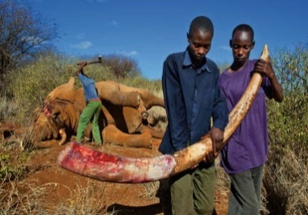 | Some people are very cruel to animals.  Một vài người rất độc ác với động vật.
Cunning  /'kʌniɳ/  (adj) | Xảo quyệt,gian xảo | 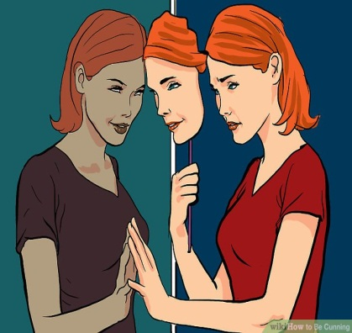 | Josh was as cunning as a fox.  Josh xảo quyệt như một con cáo.
Eagle  /'i:gl/  (n) | Đại bàng |  | Eagles are birds of prey.  Đại bàng là loài chim săn mồi.

Emperor  /'empərə/  (n) | Hoàng đế | 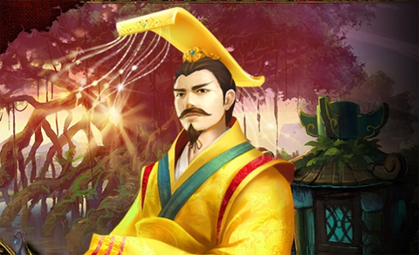 | The country suffered from poverty because of that emperor.  Đất nước đã phải chịu sự ngèo đói bởi vì vị Hoàng đế đó.
Evil  /'i:vl/  (adj) | Độc ác,xấu xa về mặt đạo đức |  | I was frightened of his evil smile.  Tôi sợ nụ cười độc ác của anh ta.
Fable  /'feibl/  (n) | Truyện ngụ ngôn | 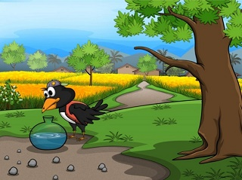 | My country is a land rich in fable.  Quê hương tôi là một vùng đất có nhiều câu truyện ngụ ngôn.
Fierce  /fiəs/  (adj) | Dữ dằn | 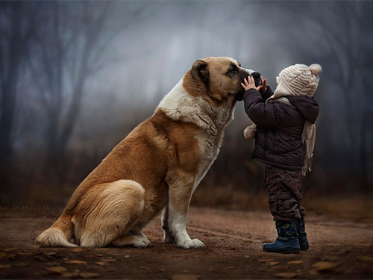 | This dog isn’t as fierce as its look.  Con chó không dữ dằn như vẻ bên ngoài của nó.
Folk tale  /fouk teil/  (n) | Truyện dân gian |  | Folk tales were passed from people to people in aspoken form.  Truyện dân gian được truyền từ người này sang người khác dưới dạng nói.
Genre  /ʤỴ:ɳr/  (n) | Thể loại | 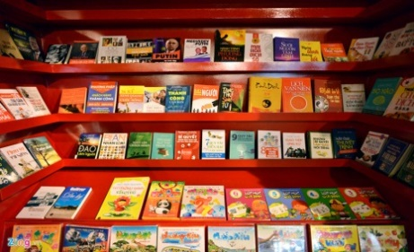 | Which genre of book do you like?  Bạn thích thể loại sách nào.

Giant  /'dʤaiənt/  (n,adj) | Khổng lồ |  | In stories, the giants are often cruel and stupid.  Ở những câu chuyện, người khổng lồ thường độc ác và ngốc nghếch.
Greedy  /'gri:di/  (adj) | Tham lam |  | They stared at the treasure with greedy eyses.  Họ nhìn chằm chằm vào kho báu với ánh mắt tham lam.
Hare  /heə/  (n) | Con thỏ rừng |  | Have you ever seen a hare?  Bạn đã bao giờ nhìn thấy con thỏ rừng chưa?
Imaginary  /i'mædʤinəri/  (adj) | Tưởng tượng |  | I used to have an imaginary friend when I was a child.  Tôi đã từng có một người bạn tưởng tượng khi tôi còn bé.
Knight  /nait/  (n) | Hiệp sĩ | 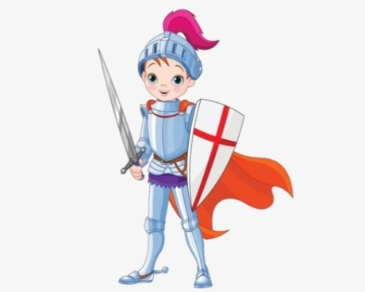 | My grandmother told me tales about brave knights.  Bà của tôi đã kể cho tôi câu chuyện về những hiệp sĩ dũng cảm.
Legend  /'ledʤənd/  (n) | Huyền thoại |  | He is a legend in the world of music  Anh ấy là một huyền thoại trong thế giới âm nhạc.

Mean  /mi:n/  (adj) | Bủn xỉn,bần tiện |  | Don’t be so mean with your friends.  Đừng quá bủn xỉn với bạn của bạn.
Moral  /'mɔrəl/  (adj) | Thuộc về đạo đức | 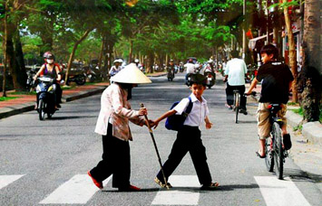 | Our ancestors taught us moral lessons via fables.  Tổ tiên của chúng ta dạy chúng ta những bài học đạo đức qua truyện ngụ ngôn.
Ogre  /'ougə/  (n) | Yêu tinh | 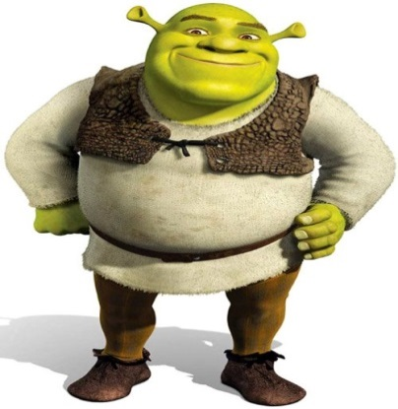 | Orges are just imaginary characters in stories.  Yêu tinh chỉ là những nhân vật tưởng tượng trong truyện.
Plot  /plɔt/  (n) | Cốt truyện | 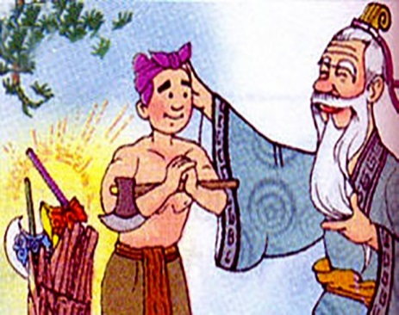 | Folk tales don’t often have complicated plots.  Truyện dân gian không thường có cốt truyện phức tạp.
Tortoise  /'tɔ:təs/  (n) | Con rùa |  | Do you know a story of a hare and a tortoise?  Bạn có biết câu về một con thỏ rừng và một con rùa không?
Wicked  /'wikid/  (n) | Xấu xa,độc ác |  | That was a wicked thing to do!  Đó là một điều độc á để làm.
Witch  /'wit /  (n) | Phù thuỷ |  | He was turned into a frog by a with.  Anh ấy bị biến thành một con ếch bởi một phù thuỷ.
Woodcutter  /'wud,kʌtə/  (n) | Tiều phu | 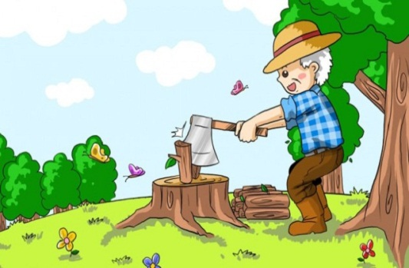 | There is a woodcutter in that village.  Có một người tiều phu trong ngôi làng đó.
B GRAMMAR
I ÔN TẬP THÌ QUÁ KHỨ ĐƠN(THE PAST SIMPLE)
1.Cách dùng
Cách dung | Ví dụ
Diễn tả hành động hay sự việc đã xảy ra và kết thúc tại một thời điểm xác định trong quá khứ. | I met her last summer. (Tôi đã gặp cô ấy vào mùa hè năm ngoái.)
Diễn tả hành động thường làm hay quen làm trong quá khứ | She often went swimming every day last year. (Năm ngoái mỗi ngày cô ấy thường đi bơi.)
2.Cấu trúc của thì quá khứ đơn
a.Với động từ ‘to be” (was/were)
Thể khẳng định |  |  | Thể phủ định
I/He/She/It/  Danh từ số ít | Was | +danh từ/tính từ | I/He/She/It/  Danh từ số ít | Was not/wasn’t | +danh từ/tính từ
You/We/They/  Danh từ số nhiều | Were |  | You/We/They/  Danh từ số nhiều | Were not/weren’t
Ví dụ:  -He was tired. (Anh ấy đã rất mệt.)  -They were in the room. (Họ đã ở trong phòng.) |  |  | Ví dụ:  -He wasn’t at school yesterday. (Hôm qua anh ấy đã không ở trường.)  -They weren’t in the park. (Họ đã không ở trong công viên.)
- Lưu ý: khi chủ ngữ trong câu hỏi là “ you “ ( bạn ) thì câu trả lời phải dùng “I“ ( tôi ) để đáp lại.
b, với động từ thường ( Verb/V )
Thể khẳng định |  |  |  | Thể phủ định
I/you/we/they  Danh từ số nhiều |  | + V-ed |  | I/you/we/they  Danh từ số nhiều |  | + did not/ didn’t |  | + V nguyên mẫu
He/she/it  Danh từ số it |  |  |  | He/she/it  Danh từ số ít
Ví dụ:  -She went to school yesterday. ( Hôm qua cô ấy đã đi học. )  -He worked in this bank last year. ( Năm ngoái anh ấy đã làm việc ở ngân hàng này. ) |  |  |  | Ví dụ:  -My mother didn’t buy me a new computer last year. ( Năm ngoái mẹ tôi đã không mua cho tôi một chiếu máy tính mới. )  -He didn’t meet me last night. ( Anh ta đã không tới gặp tôi tối qua. )  -Mr.Nam didn’t watch TV with me. ( Ông nam đã không xem TV với tôi. )
Thể nghi vấn |  |  |  |  | Câu trả lời ngắn
Did | I/you/we/they/ danh từ số nhiều  He/she/it/ danh từ số ít |  | + V nguyên mẫu? |  | Yes, |  | I/you/we/they/ danh từ số nhiều  He/she/it danh từ số ít |  | Did.
 |  |  |  |  | No, |  |  |  | Didn’t.
Ví dụ:
- Did she work there? ( Có phải cô ấy làm việc ở đó không? )
- Yes, she did/ No, she didn’t.
- Did you go to Ha Noi last month? ( Có phải bạn đã đi Hà Nội tháng trước không? )
- Yes,I did/ No,I didn’t.
3. Dấu hiệu nhận biết:
Trong câu ở thì quá khứ đơn thường có sự xuất hiện của các trạng từ chỉ thời gian như:
- yesterday ( hôm qua)
- last night/ week/ month ….
- ago ( cách đây)
- in + thời gian trong quá khứ ( in 1990)
- when ( khi) trong câu kể
BÀI TẬP VẬN DỤNG CƠ BẢN :
Bài 1: Chia động từ trong ngoặc ở thì quá khứ đơn để hoàn thành câu chuyện ngụ ngôn:
THE FOX AND THE GRAPES
Long, long year ago there (1. Live) ____ a fox who loved to eat. He lived close to a vineyard and he used to stare at the lovely grapes that hung there.
“ How juice they look. Oh I am sure these are stuff that metl in the mouth when you have them. If only I could reach them.” On sunny day, the fox (2. Wake)_________ up and (3.see)_______ the grapes glistening by the sunlight. The vineyard (4.look)__________ heavenly and the grapes looked so luscious that the famished fox could no longer control itself. He (5.jump)________ to reach them but fell down.
He jumped again. No, they (6.be)____ much higher.
He jumped even more. But they were still out of reach.
He jumped and (7.stretch)______ and (8.hop)_______but no avail. Those yummy grapes (9.hang)____higher than the fox could reach. No matter hard he (10.try)_______, the fox could not reach the grapes. He (11.pant)______and (12.begin)_____ to sweat out of exhaustion. Giving up finally, he looked up in contempt and (13.say)______ as he (14.walk)______away, “ those grapes surely must be sour. I wouldn’t eat them even if they were served to me on a golden dish.”
It’s easy to despisewhat you cannot have.
Baì 2: sắp xếp từ cho trước thành câu hoàn chỉnh:
1. year/ did/ you/ Where/ travel/ last/ to ?
_____________________________________________________________________
2. me/ difficult/ for/ it/ learn/ to/ was/ English.
_____________________________________________________________________
3. small/ When/ I/ ,/ mother/ me/ was/ reads/ often/ to/ my.

4. well-behaved/ be/ He/ to/ used/ a/ child.

5. local/ at/ school/ the/ they/ Were/ students/ secondary?

6. age/ Daisy/ to/ the/ an/ piano/ early/ at/ learnt.

7. cars/ streets/ 10/ ago/ There/ not/ year/ were/ so/ many/ in.

8. friends/ ,/ Last/ my/ and/ to/ cinema/ the/ went/ week.
9. didn’t /me/ use/ allow/ knife/ My/ to/ father.

10. Did/ leave/ you/ party/ the/ early/ night/ last?

Đánh dấu [V] trước câu đúng, đánh dấu [X] trước câu sai và viết lại câu đúng.
- Was you give me a ring yesterday?
- Who did the first person to come to the class?
- Jim hurted himself when he prepared the dinner.
- Last week, there was a folk music concert at the lock park.
- When Iwas small, I am the naughtiest child in my village.
- Did he used to be a renowned author?
- I didn’t know who broke the vase.
- Did you wwere born in Japan?
- The first time I met him were 2 years ago.
- They didn’t came to class yesterday.
2. Cấu trúc thì quá khứ tiếp diễn.
Cấu trúc | Ví dụ
Thể khẳng định  I/He/She/It+ was+ V-ing  We/You/They+ were+ V-ing | I was thinking about him last night.  We were just talking about it before you arrived.
Thể phủ định  I/He/She/It+ was not/wasn’t+ V-ing  We/You/They+ were not/ weren’t+ V-ing | I wasn’t thinking about him last night.  We were not talking about it before you arrived.
Thể nghi vấn  Was+ I/he/She/it + V-ing?  Were + We/You/They + V-ing?  Câu trả lời:  (+) Yes, I/He/She/It was.  Yes,We/You/They were.  (-) No, I/he/she/it wasn’t.  No, we/you/they weren’t. | Were you thinking him last night?  What were you just talking about before I arrived.
3. Dấu hiệu nhận biết.
Trong câu có các trạng từ chỉ thời gian trong quá khứ kèm theo thời điểm xác định.
- at + giờ + thời gian trong quá khứ ( at 12 o’clock last night, ….)
- at this time + thời gian trong quá khứ ( at this time two week ago,…)
- in + năm (in 2000, in 2005)
- in the past (trong quá khứ)
-trong câu có “ when ” khi diễn tả một hành động đang xảy ra và một hành động khác xen vào.
-while (trong quá khứ)
BÀI TẬP VẬN DỤNG CƠ BẢN

Chia động từ trong ngoặc ở thì quá khứ tiếp diễn để hoàn thành câu sau.
1. When I called my mother, she (drive) .
2. Yesterday at six I (prepare) dinner.
3. The Smiths (eat) dinner in the restaurant when I saw them.
4. Nina (look) for a job at this time last year
5. My friends (wait) for the bus I saw them.
6. (Tim /write) a letter when you came in his room?
7. What (Mary and peter)?
8. The children (play) in the playground when it suddenly began to rain.
9. What (you/do) at this time yesterday?
10. I (play) video game when my father came home.
11. We (sleep) all day.
12. While Aaron (work) in his room, his friends (play) in the garden.
13. I tried to tell them the truth but they (not listen) .
14. Where (they/go) at 5pm yesterday?
15. Most of the time we (sit) in the room and (talk) with others.

Dựa vào các từ cho sẵn, viết thành câu hoàn chỉnh.
- They/ work/ their/ project/ at 2pm/ yesterday.

2. We/ study/ English/ at this time/ last week.

- Which/ dress/ she/ wear/ at the party/ last night?

- No one/ sleep/ at/ this time/ yesterday.

- Some girls/ argue/ outside/ the shop/ yesterday.

- Jim/ read/ book/ or/ he/ watch/ TV/ at 4pm yesterday?

- My parents / look/ forward/ to/ a vacation/ at this time/ last year.

- My bother/ and/ I/ build/ tree house/ this time/ last year.

Hoàn thành câu, sử dụng quá khứ tiếp diễn của các động từ cho sẵn.

Enjoy | Paint | rest | read | study
Play | Walk | speak | take | vacuum
1. We saw a lot of rubbish when we along that street.
2. I the meal when I spotted a fly in my shop.
3. Jim a shower when his brother came home.
4. They badminton from 4pm till 6pm yesterday.
5. Mrs. Brown the stairs when her husband came home.
6. My neighbors the windows when I visited them.
7. he all day yesterday? I didn’t see him anything.
8. My father a newspaper when I entered
9. Jane to her classmates but they didn’t listen.
10. The student very hard when the teacher entered.

Viết câu hỏi cho phần gạch chân trong các câu dưới đây.
- Mary was making a birthday cake for her grandmother.
- He found s silver coin when he was digging his garden.
- When you telephoned, I was looking after my sister.
- They were talking with Josh’s wife.
- The kids were listening to the radio when I saw them.
- Peter was mowing the lawn while his wife was watering the trees.
- Jane was singing a folk song at this time yesterday.
- Josh was walking slowly when he was hit by a motorbike.
- BÀI TẬP TỔNG HỢP NÂNG CAO.

Gạch chân lỗi sai và sửa lại cho đúng.

An ant and the grasshopper
In a field one summer’s day a Grasshopper was hopping about, chirping and sang to its heart’s. An Ant was passing by and he bearing along with toil an ear of corn he was taking to the nest. “Why not come and chat with me,” saying the Grasshopper, “instead of toiling and moiling in that way?”
“I am helping to lay up food for the winner,” said the Ant, “and the recommend you to do the same.”
“Why bother about winner?” said the Grasshopper; “We have got plenty of food at present.” But the Ant went on its way and was continuing its toil.
When the winner was coming the Grasshopper was having no found itself dying of hunger- while it was seeing the ants distributing every day corn and grain from the stores they had collected in the summer. Then the Grasshopper was knowing : It is best to prepare for days of need.
Lỗi sai | Sửa | Lỗi sai | Sửa

Chia động từ trong ngoặc ở thì quá khứ đơn hoặc thì quá khứ tiếp diễn sao
- I got to the supermarket just before it closed and (buy) milk.
- We invited Sarah to the party, but she (not come)

- Jack lost his job because he (be) too irresponsible for his work.

- Ted (listen) to music at half past seven yesterday night.

- Everyone (know) that it was Bill’s fault, but nobody said anything.

- Karen (take) the key from the coffee table and stormed out of the door.

- At midnight, I (sleep) , but Jane (do) her assignment.

- Luke (stand) outside the bank when suddenly two robbers (run) past him.

- I was bored, so Mum (take) me to a drama workshop with her.

- Do you remember the time we (go) to England on holiday?

- When we (be) in Canada, we (go) skiing almost every day.

- About four years ago, I (decide) to become a chef.
BÀI 10: Dựa vào những từ cho sẵn, viết thành câu hoàn chỉnh.
1.We/ have/ breakfast/ when/ the mailman/ arrive.

2. While/ everyone/ sleep/ Paul/ watch/TV.

3. I/ dream/ about/ long/ vacation/ when/ the alarm clock/ go/ off.

4. While/ I/ practice/ the piano/ late/ last night,i/ hear/ strange/ noise.

5. The sheep/ graze/ in/ the/ filed/ when/ they/ be/ scared/ by/ the/ noise.

6. What/ you/ do/ when/ the earthquake/ happen/ yesterday?

7. I/ run/ to/ catch/ the bus/ when/ I/ see/ Jim.

8. When/ you/ meet/ James/ last night/ ,/ what/ he/ wear?

9. Some people/ chat/ while/ others/ play/ games/ at/ the party/ last/ night.

10. It/ rain/ at this time/ yesterday/ so/ we/ cancel/ the barbecue

Khoanh tròn đáp án đúng.

A beautiful day
Yesterday was so nice a day. Jane (1)_________ up so early. The sun (2) _______ brightly and the bids (3) ___________ on the tree. Jane was so happy because today she went to meet her old friend. Jane’s friend invited her to his new apartment with some other friends. When Jane came, everyone was sitting in the living room and (4)_________ passionately with each other. As she walked in, she (5)
by her friend. They had a lot to tell the other (6)________they had not met for ages. Jane came home with a smile on her face since her friend (7)_________ to contact regularly.
1. A. woke B. was waking C. stayed D. was staying
2. A. shone B. was shining C. was shone D. shined
3. A. twitters B. twittered C. was twittering D. were twittering
4. A. talked B. talking C. talks D. was talked
5. A. welcomed B. was welcoming C. welcomes D. was welcomed
6. A. although B. because C. however D. so
7. A. promised B. was promising C. promise D. was promised
Đọc bài đọc dưới đây và điền T (True) trước câu trả lời đúng với nội dung bài đọc, điên F (False) trước câu trả lời không đúng với nội dung bài đọc.

What are myths, legends and folk tales
Once upon a time, long, long ago, there lived some really great storytellers. Their stories have been passed down, retold, translated, adapted and, more recently, written down, because everyone loves a good stories. These stories probably include, myths and folktales.
A legend is usually based on a true event in the past. Legend usually have a real hero at the centre of the story and they are often set in fantastic place. The story will have been passed on from person to person, sometimes over a very long period of time.
A myth is not quite the same as a legend. Sometimes a myth is loosely based on a real event but, more often than not, it is a story that has been created to teach people about something very important and meaningful. Myths are often used to explain the world and major events, which, at the time, people were not able to understand- earthquakes, floods, volcanic, eruptions, the rising and setting of the sun, illness and death.
Folktales are usually stories that have been passed down from generation to generation in spoken from. Often we do not know who was the original author and it is possible that some stories might have been concocted author a campfire by a whole group of people. It is quite normal to discover that are many version of the tale, some very similar but others may have only one or two characters in common and take place in totally different settings.
_____ 1.In legends, heroes are set in fantastic places.
_____ 2.Amongst legends, myths and folktales, only legends are based on true event in the past.
_____ 3.Myths are created only for entertainment.
_____ 4.Earthquakes, floods and volcanic eruptions are explained in myths.
_____ 5.Folktales may be invented around a campfire by a whole group of people.
_____ 6.Folk tales have only one version.
_____ 7.Folktales are usually passed in written form.

Unit 7. pullution
A. VOCABULARY
News words | Meaning | Picture | Example
Aquatic  /əˈkwætɪk/  (adj) | Dưới nước |  | The aquatic ecosystem is threatened by water pollution.  Hệ sinh thái dưới nước đang bị đe dọa bởi ô nhiễm nước.
Chemical  /ˈkemɪkl/  (n) | Chất hóa học |  | Chemical substances from factories are harmful to the environment.  Những chất hóa học từ nhà máy có hại đối với môi trường.
Contaminant  /kənˈtæmɪnənt  (n) | Chất gây ô nhiễm | 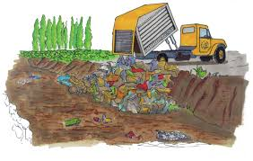 | They are trying to remove contaminants from the lake.  Họ đang cố gắng loại bỏ những chất gây ô nhiễm ra khỏi hồ.
Damage  /ˈdæmɪdʒ/  (v,n) | Phá hủy | 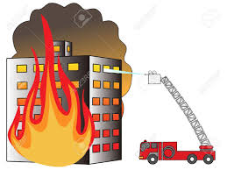 | The fire badly damaged the building.  Ngọn lửa đá phá hủy trầm trọng ngôi nhà.
Dead  /ded/  (adj) | Chết | 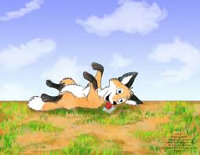 | Some animals escape danger by playing dead.  Một vài loài động vật trốn thoát nguy hiểm bằng cách giả chết.
Dirty  /ˈdɜːrti/  (adj) | Bẩn |  | Everything in his room was so dirty.  Mọi thứ trong phòng của anh ấy đều bẩn.
Dump  /dʌmp/  (v) | Đổ rác, vứt bỏ | 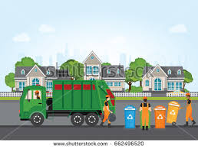 | People mustn’t dump waste into the sea.  Mọi người không được đổ rác xuống biển.
Environmental  /ɪnˌvaɪrənˈmentl/  (adj) | Thuộc về môi trường |  | We are facing many environmental problems these days.  Ngày nay chúng ta đang đối mặt với nhiều vấn đề môi trường.
Groundwater  /ˈgraʊndwɔːtər/ (n) | Nước ngầm | 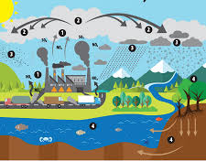 | People dig well to use groundwater.  Mọi người đào giếng để sử dụng nguồn nước ngầm.
Herbicide  /ˈhɜːrbɪsaɪd/  (n) | Thuốc diệt cỏ |  | Herbicide can pollute the groundwater.  Thuốc diệt cỏ có thể gây ra ô nhiễm nguồn nước ngầm.
Industrial  /ɪnˈdʌstriəl/  (adj) | Thuộc về công nghiệp |  | Industrial chemicals cause air, water and land pollution.  Những chất hóa học công nghiệp gây ra ô nhiễm không khí, nước và đất.
Litter  /ˈlɪtər/  (n,v) | Đổ rác, làm bừa bộn | 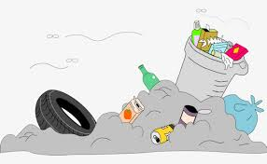 | The street are littered with rubbish.  Những con đường bị đổ đầy rác.
Poison  /ˈpɔɪzn/  (n) | Chất độc |  | Some kinds of mushrooms contain poison.  Một vài loại nấm có chứa chất độc.
Radioactive  /ˌreɪdioʊˈæktɪv/  (adj) | Phóng xạ | 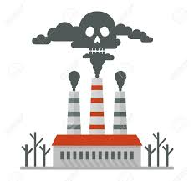 | Radioactive pollution is not a pollution of our city.  Ô nhiễm phóng xạ không phải là vấn đề của thành phố chúng tôi.
Stream  /striːm/  (n) | Dòng suối | 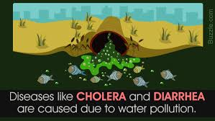 | Some mountain streams are polluted by acid rain.  Một vài dòng suối trên núi đá bị ô nhiễm bởi mưa a-xít.
Thermal  /ˈθɜːrml/  (adj) | Nhiệt | 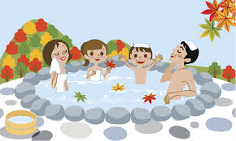 | Are there any thermal springs in your country?  Có suối nước nóng ở đất nước bạn không?
Visual  /ˈvɪʒuəl/  (adj) | Thuộc về thị giác |  | Jane has a good visual memory.  Jane có một trí nhớ hình ảnh tốt.

B. GRAMMAR
1. ĐỊNH NGHĨA CÂU ĐIỀU KIỆN.
Định nghĩa | Ví dụ
Câu điều kiện gồm có hai phần: mệnh đề chỉ điều kiện (if-clause) và mệnh đề chỉ kết quả (result clause) | If the weather is fine, I will go campingwith my friends tomorrow.  (Nếu thời tiết đẹp thì ngày mai tôi đi sẽ đi cắm trại với bạn của tôi.)  -> “If the weather is fine” là mệnh đề chỉ điều kiện: “I will go camping with my friends tomorrow” là mệnh đề chỉ kết quả (mệnh đề chính)
Mệnh đề IF và mệnh đề chính có thể đứng trước hay sau đều được. | I will go camping with my friends tomorrow if the weather is fine.

II. ÔN TẬP CÂU ĐIỀU KIỆN LOẠI 1 (CONDITIONAL SENENCES TYPE 1)
Chức năng | Dùng để diễn tả điều kiện có thể xảy ra ở hiện tại hoặc tương lai.
Cấu trúc | If + S+ V _{(s/es)} + (bổ ngữ) S will +V _{nguyên mẫu} + (bổ ngữ)  (thì hiện tại đơn) (thì tương mai đơn)  -> Mệnh đề IF dùng thì hiện tại đơn, mệnh đề chính dùng thì tương lai.
Ví dụ | If I have enough money, I will buy a new computer. (Nếu tôi có đủ tiền thì tôi sẽ mua một chiếc máy tính mới.)  - If you work hard, you will make a lot of money. (Nếu bạn làm việc chăm chỉ thì bạn sẽ kiếm được nhiều tiền.)
Lưu ý | - Unless= If not  - If= Unless + not  Ví dụ:  - If he doesn’t do his homework, his mother will complain.  -> Unless he does homework, his mother will complain.  - If you don’t send to the hospital, she will die.  -> Unless you send her to the hospital, she will die.  Có thể dùng các động từ must, have to, can, may, should thay cho will trong mệnh đề chính.  Ví dụ:  Is It rains heavily, you can stay here. (Nếu trời mưa bạn có thể ở lại đây.)  - If you want to see that film, you must buy a ticket. (Nếu bạn muốn xem bộ phim đó thì bạn phải mua vé.)

BÀI TẬP VẬN DUNG CƠ BẢN
Bài 1. Khoanh tròn phương án đúng để hoàn thành các câu sau.
1. If the weather is fine, we (goes/ will go) camping tomorrow.
2. My parents will give me a gift if I (will pass/ pass) the final exam.
3. If you are polite to others, they (will be/ are nice to you).
4. Unless James (studies/ will study) hard, he will fail the exam.
5. My parents won’t allow me to go out if I (don’t finish/ won’t finish) my homework.
6. If the cable TV (doesn’t/ won’t) work, we will rent a DVD.
7. If you don’t want to stay at home, you (go/ can go) with me to the supermarket.
8. If you (will be/ are) a good listener, you will gain many friends.
9. James won’t attend the meeting if he (won’t/doesn’t) want to.
10. You can’t have this job unless you (have/will have) long working experience.
11. What (you will do/ will you do) if it snows tomorrow?
12. You (will be/ are) able to understand it you practice every day.
13. We will eat out today if there (will be/ is) nothing left in the fridge.
14. If it (will be/ is) too cold outside, we will stay home.
15. If she (isn’t/ won’t) careful, she will make many mistakes.
Bài 2. Hoàn thành các câu sau sử dụng dạng đúng của động từ trong ngoặc.
1. The manager (be) ________________ very angry if I am late for work.
2. You will have to work very hard if you (take)______ this course.
3. I (go) ________ to see the doctor if I don’t feel well tomorrow.
4. They can’t hear you unless you (speak) ______ louder.
5. If Peter (forget) _____________ to write his essay, the teacher (give) _____________ him a low mark.
6. If they (win) ___________ this match, they will ne the champions.
7. We (have) _________ plenty of time if we (arrive) ______ there early.
8. The zookeeper (punish) ____________ you if you (feed) ___________ the animal.
9. What ________ (Jane/ say) if Jim (tell0 _______ her the truth.
10. The boys (shiver) _____________ with cold if they (swim) ________ in this lake.
11. The door (not lock) ____________- unless you (press) ____ the green button.
12. Jim won’t be late if he (take) _______________ the bus at 6 o’clock .
13. Mary isn’t home, but if you (want) _____ to leave her a message, I (give) ________ it to her.
14. If jack (clean) ________ the floor, I (do) __________ the washing.
15. the children (be) _____ happy if you (give) _______ them some sweets.
Bài 3.Nối cột A với cột B để tạo thành câu hoàn chỉnh.
A | B
1. If people keep dumping rubbish into the lake, | a. the groundwater will be poisoned.
2. If the farmers overuse pesticide, | b. if our surrounding environment is polluted
3. Soil erosion won’t happen in an area, | c. they will disappear in the future.
4. if we don’t converse the rainforests, | d. unless we join hands to protect it.
5. Our health will be badly affected | e. the aquatic life will be afflicted.
6. Our environment will be damaged | f. floods will be more and more severe.
7. Is we don’t protect the frontier forests, | g. if people use more public transportation.
8. The amount of carbon dioxide in the atmosphere will be reduced | h. if people practice sustainable agricultural mad use.
1. ____ 2. __________ 3. _______ 4. ____________
5. ____ 6. __________ 7. _______ 8. ____________
Bài 4. Dựa vào từ cho sẵn, viết câu hoàn chỉnh.
1. If/people/ not/ stop/ dumping/ waste/ into/ rivers/,/pollution/ increase/.
_____________________________________________________________________________
2. If/ polar/ ice caps/ melt/ ,/huge landmasses/ be/ under/ water.
_____________________________________________________________________________
3. If the air/ in/ city/ be/polluted/ ,it/can/ cause/ people’s/ respiratory/ problems.
_____________________________________________________________________________
4. If/smog/ be/ frequently/ formed/ in/ city/,/it/ cause/ difficulty/ in/ breathing/ headache/ even/ lung cancer.
_____________________________________________________________________________
5. If/ carbon monoxide/ concentrate/ in/ great/ amounts/, /it/ be/ harmful/.
_____________________________________________________________________________
6. The climate/ change/ if/ more trees/ be/ cut/ down/ for/ hardwood/.
_____________________________________________________________________________
7. If/ we/ not/ control/ pollution/ soon/,/it/ be/ too/ late/.
_____________________________________________________________________________
8. If/we/ not/ protect/ frontier/,/we/ suffer/ many/ from/ natural/ disasters.
_____________________________________________________________________________
Bài 5. Viết lại câu với “” if/unless” sao cho nghĩa của câu không thay đổi.
1. I can’t finish this task you don’t give me a hand.
-> _____________________________________________________________________________
2. You will run out of money if you don’t stop wasting it.
-> _____________________________________________________________________________
3. Don’t call me unless it is an emergency.
-> _____________________________________________________________________________
4. James will not pass the test unless he studies harder.
-> _____________________________________________________________________________
5. If Jane finishes her work before 6 pm, she will dine out with her friends.
-> _____________________________________________________________________________
6. My brother won’t go travelling this summer if he doesn’t find a companion.
-> _____________________________________________________________________________
7. It is not easy to do these exercises unless you listen attentively to the teacher.
-> _____________________________________________________________________________
8. If Jim doesn’t submit his essay before Tuesday, he will be punished by the teacher.
-> _____________________________________________________________________________
III. CÂU ĐIỀU KIỆN LOẠI 2 (CONDITIONAL SENTENCES TYPE 2)
Chức năng | - Dùng để diễn tả điều kiện không thể xảy ra ở hiện tại hoặc tương lai, điều kiện chỉ là một giả thiết, mọt ước muốn trái ngược với thực trạng hiện tại.  - Dùng để đưa ra lời khuyên.
Cấu trúc | If+ S+ V-ed + (bổ ngữ), S+ would + V nguyên mẫu + (bổ ngữ).  (thì quá khứ đơn)  -> Mệnh đề IF dùng thì quá khứ đơn, mệnh đề chính dùng động từ khuyết thiếu “would +V”
Ví dụ | If we were a bird, I wou;d be very happy.  (Nếu tôi là một con chim tôi sẽ rất hạnh phúc)  -> Tôi không thể là chim được.  If I had a million USD, I would buy that cả. (Nếu tôi có một triệu đo la, tôi sẽ mua chiếc xe đó.)  -> hiện tại không có.
Lưu ý | - Trong câu điều kiện loại 2, ở mệnh đề ‘IF’, với chủ ngữ “ I/he/she/it” ta có thể dùng “were ” hoặc “was” đều được.  - Ta cũng có thể dùng “could” hoặc “might” trong mệnh đề chính.  WOULD= sẽ (dạng quá khứ của WILL)  COULD = có thể (dạng quá khứ của CAN)  MIGHT = có thể (dạng quá khứ của MAY)

BÀI TẬP VẬN DỤNG CƠ BẢN
Bài 6. Khoanh tròn vảo phương án đúng.
1. I (would buy/ bought) a new house if I had enough money.
2. If he (would try/ tried) his best, he might be successful.
3. If I (lived/ would live) in Japan, I could speak Japanese well.
4. If someone gave you a dress, which color (would you want/ you would want) it to be?
5. I would repaired the roof myself if I (would have/ had) a longer ladder.
6. You would be more comfortable now if you (didn’t/ wouldn’t) wear high heels.
7. I (wouldn’t/didn’t) buy things on the Internet if I were you.
8. If you (met/ would meet) your favorite author Mark Twain, what wouldn’t you ask him?
9. His parents would be very proud if he (wouldn’t be/ weren’t) so naughty.
10. If Jane had more money, she (would treat/ treated) herself to a decent meal.
11. If you were a billionaire, what (would you do/ did you do)/
12. If Kate owned a computer, she (would spend/ spent) most of her free time on it.
13. If I (would know/ knew) his address, I would give it to you.
14. She would look much better if her hair (didn’t look/ wouldn’t look) so unkempt.
15. If I were in your situation, I (would/ will) let the nature take its course.
Bài 7. Hoàn thành các câu sau, sử dụng dạng đúng của động từ trong ngoặc.
1. More tourists would come to our country if we (provide) ______________ better services.
2. If I studies abroad, _____________ (we/keep) in touch with each other?
3. If someone (give) ______________ you a camera, what would you do with it?
4. If I (win) _________________ a big prize in a lottery, I (donate) _______________ apart of it and (spend) _______________ the rest for myself.
5. What ___________ (you/do) if you found a wallet in the street?
6. I could watch foreign TV program without subtitles if I (know) _________ English.
7. He might be obese if he (not stop) __________________ taking in fat and sugar.
8. If he knew that it was dangerous, he (not do) _______________ it.
9. If you (see) ________________ someone drowning, ________________ (you/save) him?
10. She (be) __________________ happier if her parents (not get) ________________ divorced.
11. If you (sleep) _____________ under a mosquito net you (not be) _______________ bitten so often.
12. I (get) _________________ a job easily if I (have) ______________________ a degree.
13. If whe (have) _________ another hair style, she (look) ___________ younger.
14. if the weather (not be) _______________________ severe, out crops (grow) _______________ faster.
15. I (keep) _____________ a horse if I could afford it.
Bài 8. Viết câu điều kiện loại 2 cho các trường hợp sau.
0/ They don’t have enough money. They cannot buy a new car.
->If they had enough money, they could buy a new car.
1. There isn’t a library in my neighborhood. I cannot borrow books.
__________________________________________________________________________________
2. My health is not good. I don’t play extreme sports.
__________________________________________________________________________________
3. We cannot go for a picnic because it is pouring with rain.
__________________________________________________________________________________
4. I don’t have much free time. I cannot come to your party.
__________________________________________________________________________________
5. Jim doesn’t have any siblings. He feels lonely sometimes.
__________________________________________________________________________________
6. My father is very busy at work. He rarely has time for me.
__________________________________________________________________________________
7. This camera is expensive. I can’t buy it.
__________________________________________________________________________________
8. You don’t try your best. Your result will not be good.
__________________________________________________________________________________
BÀI TẬP TỔNG HỢP NÂNG CAO.
Bài 9. Hoàn thành các câu sau, cho dạng đúng của động từ trong ngoặc.
1. We (be) ____________ happy if air pollution were the only problem.
2. They would be disappointed if you (not go) _____________ to their party.
3. If we (use) _______ this kind of light bulb, we can save energy.
4. Peter should go to sleep early if he (not want) ____________ to be tired the next morning.
5. If you (take) _______________ more exercises, you would be more resistant to diseases.
6. You may have car accident unless you (drive) ________________ more carefully.
7. If I travel to London, I (visit) ____________ its museum.
8. If they offer me the job, I think I (accept) _________________ it.
9. Many people (be) ____________ out of work if the local factory closed down.
10. What (happen) _________________ if that red button was pressed?
11. I’d be absolutely astonished if Mary and James (get) _____________ married.
12. They won’t let you in unless you (show) _____________them your identity card.
13. My best friend gave me this book. She (be) ________________ very upset if I lost it.
14. Would you mind if I (turn) ________________ up the radio.
15. I’m sure she (forgive) ______________ you if you sincerely apologize to her.
Bài 10. Đánh dấu trước câu đúng, đánh dấu x trước câu sai và viết lại cho đúng.
______ 1. Pollution can be reduced if we joined hands to prevent it.
_________________________________________________________________
______ 2. If farmers would make use of pesticide more wisely, the soil would not be poisoned.
_________________________________________________________________
______ 3. I won’t believe it unless you showed me the evidence.
_________________________________________________________________
_____ 4. Unless you don’t tell me the truth, I won’t help you.
_________________________________________________________________
_____ 5. If James is more outgoing, he would have more friends.
_________________________________________________________________
_____ 6. I think the show would be successful if he were one of the organizers.
_________________________________________________________________
______ 7. If you paid more attention to what I said, you didn’t make so many mistakes.
_________________________________________________________________
______ 8. If children are taught about environmental issues, they might change their attitudes towards pollution.
_________________________________________________________________
______ 9. You would be punished if you park your car here.
_________________________________________________________________
_____ 10. If you could win the competition, we will have a celebration.
_________________________________________________________________
Bài 11. Hoàn thành các câu sau, chọn và cho dạng đúng của các độn từ cho sẵn.
happen | Reduce | save | suffer | Cause
throw | Take | be | change | See
1. If we use less vehicles, we _________ the amount of carbon dioxide into the air.
2. If you __________ the president, what you do to prevent air pollution.
3. If there were no fresh water left, what ____?
4. If people (not) ________________ rubbish in the street, it would look better.
5. if there wasn’t so much light in the cities at night, we __________ the starts more clearly.
6. If the water is contaminated, people ________ from many diseases.
7. If chemicals from factories are dumped into rivers and lakes, they ______ water pollution.
8. If people want to protect their planet, they should ________ their habit of using plastic bag for convenience.
9. If we recycle paper, we ________ 1000 trees a day.
10. If people were more aware of the negative consequences of pollution, they might ______ actions to prevent it.
Bài 12. Khoanh tròn phương án đúng.
Consequences of water pollution
Water pollution is a matter of concern nowadays because of its negative effects on the environment and human. The first problem is that water pollution kills (1) ________ organism. Dead fish, crabs, birds and sea gulls, dolphins, and many other animals have been killed by (2) ____________ in their habitat. Moreover, pollution (3) _______ the natural food chain as well. Pollutants such as lead and cadmium are eaten by tiny animals. Later, these animals are consumed by fish and shellfish, and the food chain continues to be disrupted at all high levels. Eventually, humans are (4) ___________ by this process as well. People can get (5) ______ such as hepatitis by eating seafood that has been (6) ______________. In many poor nations, there is always outbreak of cholera and diseases as a (7) ______ of poor drinking water treatment from contaminated water. (8) ________ people don’t prevent pollution, not only the environment but also their health will be put at risk.
1. A. aquatic B. atmosphere C. underground D. soil
2. A. pollutes B. Pollution C. polluted D. pollutants
3. A. changes B. disrupts C. pollutes D. clears
4. A. affect B. affected C. affecting D. effect
5. A. illness B. sickness C. diseases D. healthiness
6. A. cleaned B. poisoned C. processes D. prepared
7. A. outcome B. effect C. way D. result
8. A. If B. Unless C. When D. In case
Bài 13. Đọc đoạn văn sau và trả lời câu hỏi.
Light pollution
Most of us are familiar with air, water, and land pollution, but did you know that light can also be a pollutant? Not many people know about this kind of pollution. Light pollution is the inappropriate or excessive use of artificial light and it can have serious environmental consequences for humans, wildlife, and our climate. Light pollution is a side effect of industrial civilization. Its sources include building exterior and interior lighting, advertising, commercial properties, offices, factories, streetlights, and illuminates sporting venues.
The fact is that much outdoor lighting used at night is inefficient, overly bright and, in many cases, completely unnecessary. This light, and the electricity used to create it, is being wasted by spilling into the sky, rather than focusing on the actual objects and areas that people want illuminated. For three billion years, life on Earth in a rhythm of light and dark that was created solely by the illumination of the Sun, Moon, and Stars. Now, artificial lights overpower the darkness and our cities glow at night. It disrupts the natural day-night pattern and shifts the delicate balance of our environment. Light pollution has negative impacts. It increases energy consumption, disrupts the ecosystem and wildlife and harms human health. Fortunately, concern about light pollution is rising dramatically. A growing number of sciences, homeowners, environmental groups and civic leaders are taking actions to restore the natural night.
1. What source of light does not contribute to light pollution?
A. moonlight B. streetlight
C. offices D. advertising
2. What is NOT true about light pollution according to the passage?
A. People are so familiar with it.
B. Is has many bad effects on humans and the environment.
C. It is the inappropriate or excessive use of natural light.
D. It is a side effect of industrial civilization.
3. What disrupts the natural day-night pattern as mentioned in the passage?
A. artificial light B. darkness
C. our city D. night
4. Which is NOT mentioned as the negative impact of light pollution?
A. increasing the use of energy
B. disrupting the ecosystem.
C. badly affect human health
D. balancing the ecosystem

UNIT 8. ENGLISH-SPEAKING COUNTRIES
CÁC QUỐC GIA NÓI TIẾNG ANH
A. VOCABULARY
New words | Meaning | Picture | Example
Accent  /ˈæksent/  (n) | Giọng |  | She has a Southern accent.  Cô ấy có giọng miền Nam.
Diverse  /daɪˈvɜːrs/  (adj) | Đa dạng | 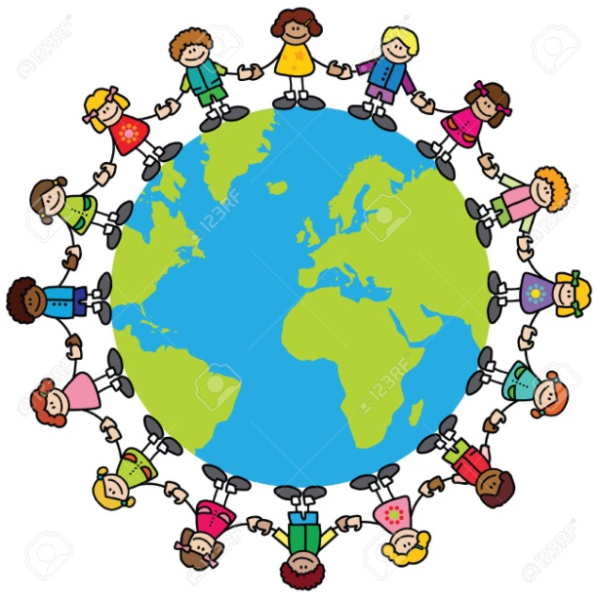 | In the United States, you can meet people from diverse cultures.  Ơ Mỹ, bạn có thể gặp nhiều người từ các nền văn hóa đa dạng.
Endless  /ˈendləs/  (adj) | Vô tận |  | I have an endless list if things to do.  Tôi có một danh sách vô tận các việc phải làm.
Excursion  (n) | Cuộc du ngoạn | 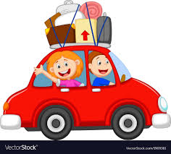 | I will go on an excursion with my friends next month.  Tôi sẽ đi du ngoạn với bạn tôi tháng tới.
Exhibition  /ˌeksɪˈbɪʃn/  (n) | Triển lãm | 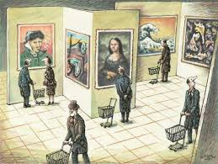 | Jane is interested on exhibitions of old photos.  Jane thích triển lãm những bức ảnh cũ.
Garment  (n) | Trang phục | 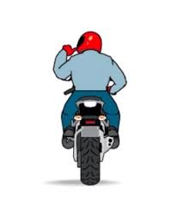 | He put on his outer garment and went out.  Anh ta mặc áo khoác và đi ra ngoài.
International  /ˌɪntərˈnæʃnəl/  (adj) | Thuộc về quốc tế | 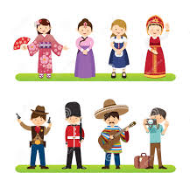 | It is an international sport event.  Đó là một sự kiện thể thao tầm quốc tế.
Loch  /lɒk/  (n) | Hồ | 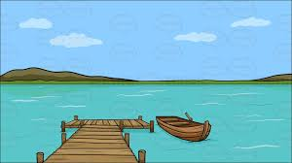 | There are many species of salmon on this loch.  Có rất nhiều loại cá hồi ở hồ này.
Monument  /ˈmɑːnjumənt/  (n) | Đài tưởng niệm | 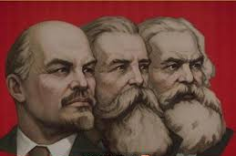 | There is a monument to the national hero in the city square.  Có một đài tưởng niệm anh hùng quốc gia ở quảng trường thành phố.
Mother tongue  /ˌmʌðər ˈtʌŋ/  (n) | Tiếng mẹ đẻ |  | My mother tongue is Vietnamese.  Tiếng mẹ đẻ của tôi là tiếng Việt.
Native  /ˈneɪtɪv/  (n) | Bản xứ | 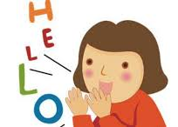 | Jim wants to speak English as a native speaker.  Jane muốn nói tiếng Anh như người bản xứ.
Spectacular  /spekˈtækjələ(r)/  (adj) | Hùng vĩ, ngoạn mục |  | You can enjoy spectacular scenery from here.  Bạn có thể thưởng thức cảnh đẹp hùng vĩ từ đây.
Summer camp  /ˈsʌmə kæmp/  (n) | Trại hè | 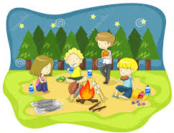 | Have you ever taken part in a summer camp?  Bạn đã bao giờ tham gia vào trại hè chưa?
Territory  /ˈterətri/  (n) | Lãnh thổ |  | The territory was controlled by invaders for many years.  Lãnh thổ này được kiểm soát bởi kẻ xâm lược trong nhiều năm.

B. GRAMMAR
I. CÁC THÌ HIỆN TẠI (PRESENT TENSES)
Thì | Cấu trúc | Dấu hiệu nhận biết
Hiện tại đơn | * Động từ thường  (+) S + V_s/es + O  (-) S + don’t/ doesn’t + V + O  (?) Do/Does + S + V + O?  * Động từ Tobe  (+) S + am/is/are +O  (-) S + am/ is/ are not + O  (?) Am/ Is/ Are + S + O? | Everyday/week/month/year…, in the morning/ afternoon/ evening/ always; usually; often; sometimes; seldom; rarely; frequently; …
Hiện tại tiếp diễn | (+) S + am/ is/ are + V_ing + O.  (-)S + am/ is/ are + not V_ing + O  (?) Am/ Is/ Are + S + V_ing + O? | Now, at the moment, at the present, Look! Listen! At this time, right now, now,…
Hiện tại hoàn thành | (+) S+ have/ has + Vp_{II} +O.  (-)S+ have/ has + not Vp_{II} +O.  (?) Have/ Has + S + Vp_{II} +O? | Just, yet, never, ever, already, so far, up to now, since, for, recently, lately, until now, up to present, …
BÀI TẬP VẬN DỤNG CƠ BẢN
Bài 1: Khoanh tròn đáp án đúng
1. The Smith (is having/ are having) a barbecue in the backyard right now.
2. The train (just leaves/ has just left) for 10 minutes.
3. The police (haven’t caught/ hasn’t caught) the burglars yet.
4. Jim (is still reading/ has still read) the book he borrowed from the local library last week.
5. (Have you ever tried/ Are you ever trying) Indian cuisine before? No, this is my first time.
6. At present, my father (is having/ has) a car and a motorbike.
7. You should arrive at the airport before &:30 because the plane (takes off/ are taking off) at sharp 8.
8. Who (is/are) James talking to?
9. I (have read/read) five science books so far.
10. Coffee (has always been/ is always) my favorite drink since I was 20.
11. Why (are you always talking/ do you always talk) with your mouth full?
12. What (are you doing/ do you do) now? I am a linguist.
13. Look! It (is pouring/ pours) with rain.
14. Have you finished your homework yet? No, actually I (am working/ work) on it.
15. Mr. Brown (is sleeping/ has slept). I can hear his loud snoring.
Bài 2. Điền các trạng từ cho sẵn vào chỗ trống sao cho thích hợp
Always rarely yet for
Since often never now
1. James has ______ tried Japanese food before. This is the first time.
2. My brother is _________ waking up late in the morning.
3. They haven’t seen each other _____________ the last winter.
4. To be honest, I ___________ do morning exercises because I hate getting up early.
5. Have you ever been to a foreign country __________?
6. The Smith have lived in this neighborhood ________ 5 years.
7. My mother _____________ goes shopping with friends when she has free time.
8. _________ Jim is playing the piano while his sister is singing along.
Bài 3. Chia động từ trong ngoặc sao cho thích hợp.
1. Where’s Mary? She (listen) __________________ to a new CD in her room.
2. Don’t forget to take your umbrella with you today. You know it (be) _____________ the raining season now.
3. Jean always (learn) __________ English at this time every day but today she (not study) _______ at the moment.
4. What time _____________ (the meeting/ happen) tomorrow? I (not know) ___________________ it yet. I (wait) _________________ for the announcement.
5. Where _______ (you/live) since you moved from your old house?
6. Look! The sun (rise) __________ over the ocean. This is the most amazing scene I (ever/ see) ______________.
7. He (speak) _________ Japanese so well because He (come) ___________ from Japan.
8. ________ (you/ usually/ go) for Christmas or _________ (you/stay) at home?
9. Look! Your friend (hold) ___________ some roses. They (look) ____________ lovely.
10. _____________ (you/ finish) your assignment yet? No, I ________________.
11. My father usually (walk) __________ to work but now hw (drive) __________________ his car.
12. I (not think) _________ Mary (sleep) __________ because I can hear some noise from her room.
13. My grandparents (bring) ____________ me up since I was very small.
14. How long ____________ (Peter/ work) in his firm?
15. James (always/ complain) __________. It (be) ________ hard to please him.
16. I (just/ realize) _______ that there are only four weeks to the end of them.
17. This is the second time I (be) _____ to London.
18. Now the children (not want) _______ to go to sleep. They (prefer) ___________ their mother to tell them bedtime stories.
19. _____ (they. Want) a horror movie before? Yes, they (watch) __________ a plenty of such movies before.
20. Jim (cook) __________ so tired now. He (work) ______________________ non-stop since the morning.
Bài 4. Đặt câu hỏi cho phần gạch châ của những câu dưới đây.
1. Mary has moved to her new house for 4 months.
________________________________________________________________________________
2. The airplane takes off at 6pm tomorrow.
________________________________________________________________________________
3. James and Jane are helping an old man cross the road.
________________________________________________________________________________
4. The children visit their grandparents every two months.
________________________________________________________________________________
5. This dress costs me $100 to buy.
________________________________________________________________________________
6. The couple has sent a letter to their daughter.
________________________________________________________________________________
7. Many people are queuing in front of the shop because a hot item is on sale.
________________________________________________________________________________
8. They have watched this movie three times.
________________________________________________________________________________
9. My mother is always complaining about my untidiness.
________________________________________________________________________________
10. I often learn a new word by making sentences with it.
________________________________________________________________________________
B. THÌ HIỆN TẠI ĐƠN VÀ HIỆN TẠI TIẾP DIỄN DIỄN TẢ TƯƠNG LAI
(PRESENT SIPLE AND PRESENT CONTINUOUS FOR FUTURE)
Cách dùng | Ví dụ
Thì hiện tại đơn diễn tả tương lai khi nói về lịch làm việc, thời gian biểu, lịch trình tàu xe… (như giao thông công cộng, lịch chiếu phim, lịch phát sóng chương trình truyền hình…) | - The train leaves Plymouth at 11:30 and arrives in London at 14:45 (Đoàn tàu sẽ rời Plymouth lúc 11h30 và sẽ đến Luân Đôn lúc 14h45.)  - It’s Friday tomorrow. (Ngày mai là thứ 6)  - The final exam is in May. (Bài kiểm tra cuối cùng diễn ra vào tháng 5.)
Thì hiện tại tiếp diễn được sử dụng với nghĩa tương lai khi diễn tả một kế hoạch trong tương lai gần (có dự định trước) | - What are you doing on Saturday evening?(Bạn sẽ làm gì vào tối thứ 7?)  - I’m not working tomorrow, so we can go out somewhere.(Ngày mai tôi sẽ không làm việc vì vậy chúng ta có thể đi chơi đâu đó.)
BÀI TẬP VẬN DỤNG CƠ BẢN
Bài 5. Khoanh tròn vào phương án đúng, thì hiện tại đơn hoặc thì hiện tại tiếp diễn.
1. Tomorrow the sun (rises/is rising) at 6.44 and it (sets/ is setting) at 18.33.
2. I (don’t do anything/ am not doing anything) tonight. I want to relax.
3. What time (do you meet/ are you meeting) John on Sunday?
4. This year the school (ends/ is ending) on 28 June.
5. After the reconstruction the supermarket (opens/ is opening) on Monday again.
6. I can’t help you. I (see/ am seeing) the doctor this afternoon.
7. We’ve already booked our holiday. We (go/ are going) to Rome in May.
8. Could you meet us at the airport tomorrow morning? The plane (lands/ is landing) at 10.15.
9. The piano concert (doesn’t start/ is not starting) at 8 o’clock. It’s cancelled.
10. (Do you have/ Are you having) your birthday party this week or next week? I forgot.
Bài 6. Sửa lại lỗi sai được gạch chân trong mỗi câu sau.
1. Mike and Fred is leaving tomorrow morning.
Mike and Fred ________________ tomorrow morning.
2. Look, the concert is beginning at 6 o’clock.
Look, the concert __________________ at 6 o’clock.
3. Do you do anything tonight?
___________________ anything tonight?
4. Excuse me, what time the ship lands?
Excuse me, what time ________________________ ?
5. I see my doctor this afternoon.
I ______________________ my doctor this afternoon.
6. Where do you go on your holiday next summer?
Where ______________________ on your holiday next summer?
7. The train is not leaving at 10.15. it is arriving at 10.15.
. The train _________________ at 10.15. It __________________ at 10.15.
8. Do you give Jill anything for her birthday this year?
_____________________ Jill anything for her birthday this year?
9. This winter term classes are ending on 8 March.
This winter term classes ________________________ on 8 March.
Bài 7. Gạch chân dưới các cum từ chỉ thời gian. Sau đó cho dạng đúng của động từ trong ngoặc ở thì Hiện tại đơn hoặc Hiền tại tiếp diễn.
1. I __________________ Peter tonight. He __________________ us to a restaurant. (meet/ take)
2. The ferry ________________ at 9.00 from Dover and _______________ at 10.45 in Calais. (leave, land)
3. My parents _______________ their wedding anniversary next Sunday. They _____________ to Paris (celebrate, go)
4. I ________________________ a lecture this afternoon. And I _________ tomorrow either. (not give, not teach)
5. Why ______ the exhibition ___________ tomorrow? When _____ it _____________ place instead? (not open, take)
6. How _________ you ____________to the party tonight? _____________ you _____________ a bus? (get, catch)
Bài 8. Dựa vào từ cho sẵn, sắp xếp lại các từ và viết thành câu hoàn chỉnh ở thì Hiện tại đơn hoặc thì Hiện tại tiếp diễn sao cho phù hợp.
1. to the dentist/ go/ I/ tomorrow.
__________________________________________________________________________________
2. tonight/ with/ have/ our business partner/ we/ dinner.
__________________________________________________________________________________
3. on/ my holiday/ July/ begin/ 10th
__________________________________________________________________________________
4. depart/ the train/ at 11.30/ platform 5/ from/.
__________________________________________________________________________________
5. to Africa/ you. When exactly/ fly/.
__________________________________________________________________________________
6. end/ when/ the art exhibition/.
__________________________________________________________________________________
7. go/ to the garden/ Miss Pitt/ on Sunday/.
__________________________________________________________________________________
8. at 9.45/as usual/ the plane/ take off/.
__________________________________________________________________________________
BÀI TẬP TỔNG HỢP NÂNG CAO
Bài 9. Chia động từ trong ngoặc sao cho thích hợp
Jim: Hello there, Daisy! Long time no see! It (1. Be) _____________________ great to see you again.
Daisy: Oh, Jim! Hello! What a coincidence! (2. Not see) _________________ you for ages! It is great to see you. What (3. You do) _____________ in London now or (4. You/ just visit) __________________ ?
Jim: Well, an engineering company (5.just offer) ______________ me a job, so I decided to rent a small apartment near my company. Now I (6.look) ___________________ for one with high standard but reasonable price.
Daisy: Oh, I think it (7.be) ________________________ very difficult to find that perfect apartment. You should lower your standard if you (8.want) ______________ to find a cheap place to live.
Jim: Yeah, you (9.be) ___________ right. Hey, Daisy, let’s talk about you recently. (10.You still/work) ___________ at the restaurant near your house?
Daisy: No, Jim. I quitted it three months ago. I couldn’t get on well with my manager. He (11.always shout) ___________ even when my co-workers and I (12.make) ______________ just a small mistakes. Now I am employed by a restaurant in the city center.
Jim: (13. It/be) _____________________ very far from your house?
Daisy: It is. Every day I (14.have) ________________ to take the earliest train to commute to work. It (15.set) ________________ off at 5am and it (16.often take) __________________ me half an hour to travel to work.
Jim: You must wake up early in the morning.
Daisy: It was hard for me in the first few weeks but things (17.get) _________________ better and better now. I (18.be) _______________ quite satisfied with my job now.
Bài 10. Dựa vào các từ cho sẵn, viết câu hoàn chỉnh.
1. They/not/want/ to/ buy/ new/ car/ now/ because/ they/not/ have/ enough/ money/ yet/.
________________________________________________________________________________
2. You/ever/ speak/ to/ foreigner/ before?
__________________________________________________________________________________
3. I/ not/ know/ when/ the/ train/ leave/.
__________________________________________________________________________________
4. Rose/ often/ walk/ school/ but/ today/ she/ ride/ new/ bike/ at/ present/.
__________________________________________________________________________________
5. How much/ time/ you/ often/ spend/ on/ self-studying?
__________________________________________________________________________________
6. Who/ Jane/ talk/ to over/ there?
__________________________________________________________________________________
7. I/ not/ find/ my car key/ yet/. I/ call/ my husband/ to/ ask/ him/ about/ it/.
__________________________________________________________________________________
8. No one/ heard/ news/ about/ accident/ this morning/.
__________________________________________________________________________________
9. Everyone/ sleep/ now/ but/ I/ be/ awake.
__________________________________________________________________________________
10. How long/ it/ usually/ take/ you/ to/ finish/ your breakfast?
__________________________________________________________________________________
Bài 11. Hoàn thành đoạn hội thoại với những động từ cho sẵn dưới đây ở thì Hiện tại đơn hoặc thì Hiện tại tiếp diễn sao cho phù hợp.
Take (x2) start (x2) leave go do depart get come
The big day
A: Have you heard of Brad and Mimi?
B: Brad and Mimi? What’s happened?
A: They (1) ______________ married on Saturday?
B: You’re joking. I didn’t know that Mimi fancied Brad. When (2) _________________ the wedding __________ place?
A: It (3) ___________ place on Saturday. Didn’t you listen to me?
B: Of course I did. But what time (4) ____ it __________?
A: The wedding ceremony (5) ___________ at 11 o’clock in the All Saints church.
B: (6) _______ you ____________?
A: Yes, I am. They’ve invited me.
B: Do you think I could join you?
A: Why not? I’m sure the church is going to be full. But I (7) ______________ early in the morning because my dad (8) ___________________ to work by car on Saturday and he can take me to the All Saints.
B: If your dad doesn’t mind _________________
A: No problem. The more, the merrier, he always says. By the ways, (9) ______ you _________- anything tomorrow morning? We could buy some present for them.
B: Good idea. We can get the bus to the Macy’s shopping Gallery. It (10) ____________________ at 9.35.
A: All right. See you at the bus stop. Bye.
A: Bye-bye.
Bài 12. Cho dạng đúng của độngt từ trong ngoặc ở thì hiện tại đơn hoặc thì Hiện tại tiếp diễn để diễn tả tương lại.
1. The train ____________ at 9 at night. (arrive)
2. Giovanni ___________ to spend the weekend with us. (come)
3. What time _______ you _______ to the doctor’s on Wednesday? (go)
4. What time __________________ the film _________________ ? (start)
5. ____________ the concert _______________ at 7 or 8? (begin)
6. We _______________ a dinner party on Friday and you’re invited. (have)
7. Most shops in Spain __________ until 10 am. (not open)
8. What time ______________ the corner shop ________________? (shut)
9. Where ________________ you ____________________ in Bangkok? (stay)
10. My tai chi classes __________________ next week? (start)
11. Out flight ____________ in London at4 o’clock in the afternoon. (land)
12. Everything’s arranged. We ______________ house this Saturday. (move)
13. We _____________ at Litith’s Café this afternoon at four. (meet)
14. I’m sorry. I can’t meet up this weekend. We _________ to Wales. (go)
15. Our ferry ___________ for lbiza at 6 tomorrow morning. (depart).
Bài 13. Gạch chân lỗi sai trong đoạn văn sau đây và sửa lại cho đúng.
Mary and I am best friends and we have learned English with each other since half a year. Both of us is highly interested in learning this language due to a number of factors. First of all, learning English enable us to understand masterpieces from English speaking countries such as books, movies and music. Although Mary is always complain that some English grammar structures are too difficult to remember, she is always making great effort to learn the language. She often goes to the library to borrow English written books. By now, Mary is reading up to 5 books in English. I am preferring watching movies to reading books. Sometimes, we are talking with each other in English and share about the books or movies we have just enjoy.

1. _________________ -> _____________
2. _________________ -> _____________
3. _________________ -> _____________
4. _________________ -> _____________
5. _________________ -> _____________
6. _________________ -> _____________
7. _________________ -> _____________
8. _________________ -> _____________
9. _________________ -> _____________
10. _________________ -> _____________

Bài 14. Khoanh tròn vào đáp án đúng
Why is it necessary to learn English?
English is the most commonly used language among foreign language (1) ___________. Nowadays, when people from different nationalities (2) ______________ to communicate, they commonly use English language. If you can speak English fluently, you have more chances of making friends with foreigners. It helps you connect with and (3) _________ from people of different cultures. In (4) __________ of career aspects, knowing English (5) _____________ up job opportunities. Being able to communicate with foreign clients and business partners (6) _______________ you a more challenging position in your career. (7) _________ English is the language of the Film industry and learning it (8) _______________ you will no longer have to rely on subtitles or dubbed versions. You will also be able to read books written by English-speaking authors in their original version. Last but not least, music is much better if you can understand the meaning. We are sure that you will be satisfied to enjoy English-language music morel.
1. A. speakers B. tellers C. talkers D. chatters
2. A. wants B. want C. is wanting D. are wanting
3. A. learn B. learns C. is learning D. are learning
4. A. ways B. means C. terms D. references
5. A. opens B. is opening C. has opened D. opened
6. A. provide B. provides C. is providing D. had provided
7. A. Moreover B. Therefore C. However D. Instead
8. A. means B. meaning C. mean D. meant
Bài 15. Đọc đoạn văn và điền T (true) hoặc F (false)
English as a global language
English is the third largest language by number of native speakers, after Mandarin and Spanish.
Is has often been referred to as a “world language, the lingua franca of the modern era. English is not an official language in most countries and it is often taught as a foreign language. It is, by international treaty, the official language for aeronautical and maritime communications. English is one of the official languages of the United Nations and many other international organizations, including the International Olympic Committee.
Books, magazines and newspaper written in English are available in many countries around the world, and English is the most commonly uses language in the science. Science Citation Index reported as early as 1997that 95% of its articles were written in English, even though only half of them came from authors in English-speaking countries. In publishing, English literature predominates considerably with 28 percent of all books published in the world and 30 percent of web content in 2011(from 50 percent in 200). English is also the global language of many businesses, even outside of the UK, Canada and the USA. If you have an international meeting in France, for example, odds are that you will be asked to speak English, Daimler-Chrysler, Nokia, Renault, Samsung, Technicolor, and Microsoft in Beijing have all said that English is their common corporate language, to name just a few of the largest international companies, but many smaller companies have the same policy.
_____ 1. English is amongst the largest language of the number of native speakers.
______ 2. English is often taught as a second language in most countries.
______ 3. English is the only official language of the United Nations and many other international organizations.
_______ 4. Most of the science works were written in English.
_______ 5. It was reported that as early as 1997, 95% of Science Citation Index’s articles came from authors in English-speaking countries.
_______ 6. English is not used in business outside of the UK, Canada and the USA.
UNIT 9 – NATURAL DISASTERS (THẢM HỌA THIÊN NHIÊN)
A- VOCABULARY
New words | Meaning | Picture | Example
accurate  /ˈækjərət /  (adj) | chính xác |  | It is not easy to make accurate weather forecast.  Nó không dễ để dự báo thời tiết chính xác.
collapse  /kəˈlæps/  (v) | sụp đổ |  | Many buildings collapsed after the earthquake.  Rất nhiều tòa nhà sụp đổ sau trận động đất.
debris  /ˈdebriː/  (n) | mảnh vỡ |  | Be careful of the flying debris in the storm.  Hãy cẩn thận với những mảnh vỡ bay trong cơn bão.
disaster  / dɪˈzɑːstə(r)/  (n) | thảm họa |  | Thousands of people died in the disater.  Hàng ngàn người đã chết trong thảm họa đó.
drought  /draʊt/  (n) | hạn hán |  | We have suffered three years of drought.  Chúng tôi vừa trải qua 3 năm hạn hán.
eruption  /ɪˈrʌpʃn/  (n) | Sự phun trào |  | Vocanic eruptions arevery dangerous.  Sự phun trào của núi lửa rất nguy hiểm.
evacuate  /ɪˈvækjʊeɪt/  (v) | sơ tán |  | The locals were evacuated to escape the storm.  Người dân địa phương được sơ tán để tránh bão.
injured  /ˈɪnʤəd/  (adj) | bị thương |  | Several people were injured in the tornado.  Nhiều người đã bị thương trong cơn lốc xoáy.
relief  /rɪˈliːf/  (n) | đồ cứu tế, cứu trợ |  | They have found a relief organization.  Họ vừa mới thành lập một tổ chức cứu hộ.
rescue  /ˈreskjuː/  (v) | giải cứu |  | Two children were rescued from the flood yesterday.  Hai đứa trẻ đã được cứu thoát khỏi cơn lũ hôm qua.
severe  /sɪˈvɪə(r)/  (adj) | khốc liệt, khắc nghiệt |  | We experienced a severe winter last year.  Chúng tôi đã trải qua một mùa đông khắc nghiệt năm ngoái.
shelter  /ˈʃel.tə (r)/  (n) | nơi trú ẩn |  | The local authorities built night shelters for homeless people.  Chính quyền địa phương đã xây nơi trú ẩn vào ban đêm cho người vô gia cư.
survivor  /səˈvaɪvə(r)/  (n) | người sống sót |  | He is the only survivor of the shipwreck.  Anh ta là người sống sót duy nhất trong vụ đắm tàu.
temporary  /ˈtemprəri/  (adj) | tạm thời |  | It is just a temporary solution to this problem.  Nó chỉ là một giải pháp tạm thời cho vấn đề này.
tornado  /tɔːˈneɪdəʊ/  (n) | lốc xoáy |  | The tornado destroyed all the buildings on its way.  Lốc xoáy đã phá hủy tất cả những ngôi nhà trên đường đi của nó.
tsunami  /tsuːˈnɑːmi/  (n) | sóng thần |  | The tsunami caused severe damage.  Sóng thần đã gây ra sự tàn phá nghiêm trọng.
typhoon  /taɪˈfuːn/  (n) | bão, lốc xoáy |  | Their house was destroyed during the typhoon.  Nhà của họ đã bị phá hủy trong cơn bão.
Wreak havoc  /riːk ˈhævək/ | tàn phá, phá hủy |  | Natural disasters wreak havor on people’s lives and property.  Thảm họa thiên nhiên tàn phá con người và của cải.

B-GRAMMAR
I-ÔN TẬP CÂU BỊ ĐỘNG (PASSIVE VOICE)
Thì | Cấu trúc câu chủ động | Cấu trúc câu bị động
Hiện tại đơn | S + V (s/es)  People speak English here. | S + am/is/are + VpII  English is spoken here.
Hiện tại tiếp diễn | S + am/is/are + V-ing  They are building a new house. | S + am/is/are + being + VpII  A new house is being built
Hiện tại hoàn thành | S + have/has + VpII  We have cleaned our car. | S + have/has been + VpII  Our car has been cleaned.
Quá khứ đơn | S + Ved/V2  Someone cleaned the room yesterday. | S + was/were + VpII  The room was cleaned yesterday.
Quá khứ tiếp diễn | S + was/were + V-ing  They were making a cake when I arrived. | S + was/were being + VpII  A cake was being made when I arrived.
Tương lai đơn | S + will + V-inf  The government will pass the new law next month. | S + will be + VpII  The new law will be passed next month.
Tương lai tiếp diễn | S + will be + V-ing  She will be singing a song when the prime minister comes in. | S + will be being + VpII  The song will be being sung when the prime minister comes in.
BÀI TẬP VẬN DỤNG CƠ BẢN
Bài 1: Khoanh tròn vào đáp án đúng.
1. Yesterday my brother (bought/was bought me) a new T-shirt.
2. Who (was broken/broke) the vase?
3. Yesterday I was having dinner when my door (was knocked/was knocking).
4. At the moment my car (is polishing/is being polished) by my brother.
5. This car (has been used/has used) by Mr. Smith for 5 years.
6. The early train to Manchester city (leaves/is left) at 6 am tomorrow.
7. No one (has heard/has been heard) about the accident last night.
8. If you work hard, you (will reward/will be rewarded).
9. (Have the police caught/Have the poloce been caught) the thieves yet?
10. Which dress (chose/was chosen) to wear by Jane last night?
11. At this time next month, I (will be visiting/will be visited) London with my family.
12. The children (are looking/are being looked) after by a babysister.
13. You (will be receive/ will receive) a lot of compliments if you win the contest.
14. Jim didn’t realize that his wallet (stole/was stolen) until he came home.
15. (Was you brought/Was you bringing) by your grandparents when you were small?
Bài 2: Hoàn thành các câu sau với thể bị động của động từ trong ngoặc ở thì thích hợp.
1. I (usually take) ______________to the cinema by my parents every month.
2. _____________(Jim/inform) of the exact date of the conference? No, he wasn’t.
3. The concert (broadcast)_____________live tomorrow.
4. Yesterday, temparature (forecast) _____________to reach 40⁰C.
5. At this time tomorrow, a birthday cake (make)________ for our best friend Jessy.
6. Who___________(rob) of all the properties last week?
7. All the members ___________(treat) equally in our organization.
8. Nothing (do)_________so far to prepare for the coming storm.
9. When I was small, I often (call) __________by my nickname.
10. Yesterday, Jim was playing with his dog when the doorbell (ring)_____________.
11. What______________(do) so far to lessen the impact of natural disasters?
12. At 8 o’clock yesterday, my brother (feed) __________by my mother while I (look) ____________after by my father.
13. This film (never show) _______________on television before.
14. If you submit your assignment late, you (punish)___________by your teacher.
15. I think more attempts (make) ____________in the future to protect people from natura catastrophes.
16. No feasible solutions to this problem (put)______________forward yet.
17. I don’t think that black café (prefer)_____________by many people.
18. Last week, everyone in my class (snow) _____________under.
19. _______________(these sheep raise) by the local people?
20. Every student (anticipate)______________to finish their essay before the deadline.
Bài 3: Chuyển những câu chủ động sau đây thành câu bị động.
1. Jim will pick me to the airport tomorrow.
_____________________________________________________________________
2. Peter wrote his report last week.
_____________________________________________________________________
3. They will replace the old equipment with new one.
_____________________________________________________________________
4. What will they do to prevent natural disasters?
_____________________________________________________________________
5. I think we will soon use up the natural resourses.
_____________________________________________________________________
6. The children water the trees every two days.
_____________________________________________________________________
7. They never mentioned Jim in their conversation.
_____________________________________________________________________
8. At this time next month I will be sitting an English text.
_____________________________________________________________________
9. When will they sell their new products?
_____________________________________________________________________
10. At midnight, my brother and I was making a wish list.
_____________________________________________________________________
11. My mother is preparing dinner at the moment.
_____________________________________________________________________
12. No one will buy products with poor quality.
_____________________________________________________________________
13. They will not allow your dog to enter the museum.
_____________________________________________________________________
14. Have anyone heard of Jim and Jane’s luxury wedding?
_____________________________________________________________________
15. The boys are using the computer to look up information.
_____________________________________________________________________
Bài 4: Chuyển những câu bị động dưới đây thành câu chủ động.
1. A gift was sent to me by my old students.
_____________________________________________________________________
2. You are not allow by the teacher to cheat in the exam.
_____________________________________________________________________
3. My table is being fixed by my father.
_____________________________________________________________________
4. How long has this fax machine been used by Mr. Green?
_____________________________________________________________________
5. The singer was not recognized by his fan when he was at the restaurant.
_____________________________________________________________________
6. He will be disqualified from the competition by the judges if he uses drugs.
_____________________________________________________________________
7. All the unnecessary lights will be turned off to save energy.
_____________________________________________________________________
8. Jane was prevented from staying up too late by her mother.
_____________________________________________________________________
9. Was this document typed by Mr. Brown?
_____________________________________________________________________
10. Many dead people were found by the recuers after the earthquake.
_____________________________________________________________________
Bài 5: Sắp xếp các từ đã cho thành câu hoàn chỉnh.
1. Jim/one/preferred/Which/ - /tea/is/coffee/by/or?
_____________________________________________________________________
2. been/Many/caused/problems/that/storm/fierce/have/by.
_____________________________________________________________________
3. Many/tornado/were/buildings/by/the/destroyed/last/night.
_____________________________________________________________________
4. caused/Numerous/diseases/are/lack/by/of/water/fresh/the.
_____________________________________________________________________
5. At/extra/the/moment/atentions/,/paid/to/are/storm/upcoming/the.
_____________________________________________________________________
6. person/a/was/left/Not/behind/single/the/flood/in.
_____________________________________________________________________
7. are/All/victims/flood/the/helped/local/the/by authorities/being.
_____________________________________________________________________
8. Shelters/be/to/provided/will/homeless/in/next/few/people/months/the.
_____________________________________________________________________
9. No/severely/was/one/tornado/yesterday/injured/in/the.
_____________________________________________________________________
10. a/scientists/now/A/is/speech/delivered/being/by/renowed.
_____________________________________________________________________
II- THÌ QUÁ KHỨ HOÀN THÀNH (PAST PERFECT)
Cấu trúc | (+) S + had + VpII (past participle)  (-) S + had not/hadn’t + VpII.  (?) Had+ S + VpII?  Yes, S + had./No, S + hadn’t.
Ví dụ | (+) I had left when they came. (Khi họ đến thì tôi đã rời đi rồi).  (-) I hadn’t left when they came. (Khi họ đến thì tôi đã không rời đi).  (?) Had you left when they came? (Khi họ đến, bạn đã rời đi rồi à?)  Had you not left when they came? (Khi họ đến, bạn đã không rời đi à?)  Hadn’t you left when they came? (Khi họ đến, bạn đã không rời đi à?)
Cách dùng | - Diễn tả một hành động đã được hoàn tất trước một hành động khác trong quá khứ.  Ví dụ: He had left the house before she came.  - Diễn tả một hành động đã được hoàn tất trước một thời điểm xác định trong quá khứ.  Ví dụ: We had had lunch by two o’clock yesterday.  By the age of 25, he had written two famous novels.
Dấu hiệu nhận biết | by + thời gian trong quá khứ  before, after, when, by the time, as soon as, as…….
BÀI TẬP VẬN DỤNG CƠ BẢN
Bài 6: Hoàn thành những câu sau, sử dụng thì quá khứ hoàn thành của động từ.
1. When I arrived at the station, the train (leave)_________________.
2. My friend (live)___________in China before she moved to American.
3. They (never been) _______________ here before.
4. After I (finish) __________ my breakfast, I went to work.
5. The student (not finish) __________their assignments so they were in great troubles.
6. After the couple (eat) ____________seafood at a seaside restauran, they felt sick.
7. If you (listen) __________to my advice, you wouldn’t have made that silly mistake.
8. What did Jim do after he (finish)__________his homework?
9. The trees were dead because it (be)_____________dry all the summer.
10. _____________(you/meet) Jane anywhere before?
11. Yesterday I was late for the train becase I (forget) _____________my ticket home.
12. Peter told me that he (prepare) __________every thing for his party.
13. The grass was yellow as it (not rain) _________all summer.
14. The electricity was cut off because we (not pay)___________our hydro bill on time.
15. We (not eat) ___________all the morning sowe felt very hungry.
Bài 7: Khoanh tròn vào đáp án đúng.
1. My co-worker (had not used/didn’t use) email before, so I showed him how to use it.
2. Because I (hadn’t studied/didn’t study) for the test, I was very nervous.
3. The wave (had destroyed/ destroyed) the sandcastle that we had built yesterday.
4. When shewent out to meet her friends, she (had already done/ already did) all the chores.
5. The waitress brought a drink that I (didn’t order/ hadn’t ordered) before.
6. (Had you given/ did you give) James a ring before you dropped by his apartment?
7. Susan (took/had taken) a rest after she had washed all the dishes.
8. When Jim came to the meeting, everyone (had left/left).
9. Before she had dinner, she (had washed/washed) her hands carefully.
10. Before I (had gone/went) out, I asked my parents for permissions.
11. I could not remember the name of the man we (met/had met) the week before.
12. We (ate/had eaten) all the cakes mymom had made.
13. Before she (came/had come) home, she had met some of her old friends.
14. Before Jane (started/ had started) to make the cake, she had prepared all the ingredients.
15. I (had fed/fed) my cat before I left home.
Bài 8: Dựa vào những từ cho trước, viết câu hoàn chỉnh.
1. By/age/of/twelve/Jim/be/able/to/speak/English/fluently.
_____________________________________________________________________
2. She/gain/a lot of/working/experience/before/she/apply/for/that/job.
_____________________________________________________________________
3. We/be/great/troubles/because/we/spend/all/the/money.
_____________________________________________________________________
4. My father/know/well/about/London/because/he/be/there/many/times.
_____________________________________________________________________
5. My friend/study/Japanese/before/she/move/to/Japan.
_____________________________________________________________________
6. Peter/own/a/big/house/for/10 years/before/he/move/to/countryside.
_____________________________________________________________________
7. Where/you/live/before/1954?
_____________________________________________________________________
8. Our team/encounter/many/obstacles/before/we/succeed.
_____________________________________________________________________
9. Cindy/be/sick/until/she/stop/eating/junk food.
_____________________________________________________________________
10. I/be/in/Canada/for/7 years/before/I/move/to/America.
_____________________________________________________________________
BÀI TẬP TỔNG HỢP NÂNG CAO
Bài 9: Đánh dấu [] trước câu đúng, đánh dấu [x] trước câu có lỗi sai và sửa lại cho đúng.
______ 1. The tallest building in our city was collapsed last week.
_______________________________________________________________
______ 2. All the people in my village have already evacuated before the food.
_______________________________________________________________
______ 3. How many people were the rescuers found yesterday?
_______________________________________________________________
______ 4. Temporary shelters will be providing to the food victims.
_______________________________________________________________
______ 5. Their houses swept away in the storm.
_______________________________________________________________
______ 6. Were anyone injured by the flying debris in the storm.
_______________________________________________________________

______ 7. Natural disasters are wreaked havoc on human and the environment.
_______________________________________________________________
______ 8.What has done to support the people in the flooded area?
_______________________________________________________________
______ 9. Many people havedonated money to build houses for poor people.
_______________________________________________________________
______ 10. They were informed about upcoming storm by the local authorities.
_______________________________________________________________
Bài 10: Dựa vào những từ cho trước, viết thành câu hoàn chỉnh.
1. After/the storm/pass/people/come/back/to/their/ normal/ life.
_____________________________________________________________________
2. A decent meal/prepare/by/my mother/after/ she/ come/ home/ after/ work.
_____________________________________________________________________
3. By 1990, my family/ settle down/ in New Jersey/ for 10 years.
_____________________________________________________________________
4. Jim/ have/ a/ shower/ when/ doorbell/ ring/ by/ his wife.
_____________________________________________________________________
5. At this time last year/ a project/ on/ environmental/ issues/ carry/ by Dr.Brown.
_____________________________________________________________________
6. They/ prepare/ carefully/ for/ the hurricane/ before/ it/ arrive.
_____________________________________________________________________
7. Many people/ live/ in temporary shelters/ until/ the/ storm/ pass.
_____________________________________________________________________
8. Earthquakes/ in Japan/ cause/ devastating/ effects/ on/ human/ and/ environment/ recently.
_____________________________________________________________________
Bài 11: Cho dạng đúng của từ trong ngoặc để hoàn thành các câu dưới đây.
1. I (tell) __________by Jim that he (paint) __________the entire house.
2. Japanese children (teach) _________how to escape an earthquake at an early age.
3. When we (arrive)___________, we (find)________that the bus (leave)__________.
4. The police (evacuate) _______the building before it (collapse)_____________.
5. When she (call) _________me last night, I (go) _________to sleep, so I could’t answer her.
6. I (never meet)________________Peter before the party last night.
7. Food and shelters (provide)_________________to the local people at the moment.
8. What (do)____________so far to minimize the impacts of natural disasters in our country.
9. I (prepare) __________carefully before I (give) the _____________the presentation about the impacts of natural disasters.
10. My friend (save)________ a lot of money before he (decide) ______to buy a new house.
11. I hope that financial aids (offer)__________to the poor people in the drought area.
12. Peter and Jane (eat)__________before they (come) _________to see me.
13. So far, hundreds of the temporary shelters (provide)__________to the earthquake victims.
14. A relief agency (just found)____________to lessen the effects of the flood on human’s property.
15. Survivors of the earthquake (receive)_____________help from the authorities before they could get back to their normal life.
Bài 12: Hoàn thành những câu sau với dạng đúng của những động từ cho sẳn.
evacuate injure rescue provide
forecast destroy suffer cause
1. Many people_____________from waterborne diseases after the severe flood last year.
2. The locals_____________from their village to escape the earthquake already.
3. Free food and fresh water ___________to the victims of natural disaster every year.
4. Five people_____________from drowning in the rushing stream so far.
5. The tornado _____________many houses before it stopped.
6. Some people _____________after the earthquake.
7. A hurricane_____________by the meteorologists to reach our area next week.
8. Every year, natural disasters_____________loss of human life, damage to property and deterioration of the environment.
Bài 13: Khoanh tròn vào đáp án đúng.
Throughout its history, Japan (1)________from the destructive sea surges, known as tsunami. Tsunamis (2)________by earthquakes, hundreds of which strike Japan each year. It is of utmost importance that Japan is always ready for this chain of natural disasters. In Japan, high-rise buildings in major cities (3)________so that they (4)_______rather than shake during earthquakes, making them safer. Besides, new regualtions for quake-proofing buildings came into force, and some local governments (5)_____citizens a structural health check on their homes. Some coastal areas have tsunamis (6)_______, while others (7)________built floodgates to withstand inflows of water from tsunamis. And if an earthquake above a certain magnitude (8)_________, the bullet train will stop and nuclear and other plants will automatically go into temporary shut-down.
1. A.had suffered B. has suffered C. had been suffered D. has been suffered
2. A.trigger B. are triggered C. triggered D. were triggered
3. A.design B. are designed C. designed D. were designed
4. A.sway B. are swaying C. are swayed D. have swayed
5. A. offer B. are offering C. are offered D. offered
6. A.home B. house C. shelter D. habitat
7. A.build B. are building C. are built D. have built
8. A.strikes B. is striking C. has struck D. is struck
Bài 14: Đọc bài đọc dưới đây và trả lời câu hỏi.
Flood stands amongst the most devastating natural catastrophes. Almost everyone is well aware of its negative impacts on human such as loss of human life, damage to property, destruction of crops, loss of livestocks, and deterioration of health conditions owing to waterborne diseases.
However, flood can also have some positive impacts on the environment. In many natural systems, floods play the key role in maintaining the ecosystem functions and biodiversity. They link the river with the land surrounding it, recharge ground water systems and fill wetlands. Moreover, floodwater often carries both sediment and nutrients, so it helps enrich the land. For many species, flood trigger breeding events, migration, and dispesal. The environmental benefits of flooding can also help the economy through things such as increased fish production, recharge of groundwater resourses, and maintainance of recreational environments.
While cycling of sediments and nutrients is essential to a healthy ecosystem, too much sediment and nutrient in a waterway lowers the downstream water quality. Other negative effects include loss of habitat, dispersal of weed species and the release of pollutants such as chemicals, heavy metals and debris. These can degrade aquatic habitats, lower water quality, reduce coastal production, and contaminate coastal food resources.
1. What does the passage mainly discuss?
A. Negative impacts of flood on human.
B. Negative impacts of flood on the ecosystem.
C. Effects of flood on the environment.
2. What does the word “catastrophes” mean?
A. disasters
B. phenomena
C. sources
3. In which way does flood affect human health as mentioned in the first paragraph?
A. waterborne diseases
B. loss of property
C. loss of liverstock
4. Which is not mentioned as a way flood helps maintain the ecosystem functions and biodiversity?
A. It recharges ground water systems.
B. It carries both sediment and nutrients.
C. It maintains recreational environments.
5. What happens if there is too much sediment and nutrient in a waterway?
A. Breeding events are triggered.
B. The quality of downstream water is lowered.
C. It maintains a healthy ecosystem.

UNIT 10 – COMMUNICATION (GIAO TIẾP)
A- VOCABULARY
New words | Meaning | Picture | Example
channel  /ˈʧænl/  (n) | kênh |  | What’s on Channel 2 tonight?  Có gì ở kênh 2 tối nay?
communicate  /kəˈmjuːnɪkeɪt/  (v) | giao tiếp |  | My foreign friend and I communicate by email.  Bạn nước ngoài của tôi và tôi giao tiếp qua thư điện tử.
cyber-  /ˈsaɪbə/ | thuộc về internet |  | Cyberbullying is a hot issue these days.  Bắt nạt qua mạng internet là một vấn đề nóng hiện nay.
digital  /ˈdɪʤɪtl/  (adj) | kỹ thuật số |  | Do you have a digital camera?  Bạn có một chiếc máy ảnh kỹ thuật số đúng không?
face-to-face  /feɪs-tuː-/feɪs/  (adj) | trực diện |  | They rarely have face-to-face communication with each other.  Họ hiếm khi giao tiếp trực tiếp với nhau.
instantly  /ˈɪnstəntli/  (adv) | ngay lập tức |  | Nowadays, we can send and receive message instantly via internet.  Ngày nay, chúng ta có thể gửi và nhận tin nhắn ngay tức khắc thông qua mạng internet.
interact  /ˌɪntərˈækt/  (v) | tương tác |  | She interacts well with other classmates.  Cô ấy tương tác tốt với bạn cùng lớp.
lLanguage barrier  /ˈlæŋgwɪʤ/ /ˈbærɪə/ | rào cản ngôn ngữ |  | The language barrier is a problem when I go abroad.  Rào cản ngôn ngữ là một vấn đề khi tôi đi nước ngoài.
oversleep  /ˌəʊvəˈsliːp/  (v) | ngủ quên |  | I overslept and went to school late.  Tôi ngủ quên và đến trường muộn.
react  /riːˈækt/  (v) | phản ứng |  | How did the teacher react to his misbehavour?  Cô giáo đã phản ứng như thế nào trước hành vi sai trái của anh ấy?
signal  /ˈsɪgnl/  (n) | tín hiệu |  | There aren’t any TV signals at the moment.  Không có tín hiệu TV vào thời điểm này.
telepathy  /tɪˈlɛpəθi/  (n) | thần giao cách cảm |  | I don’t believe in telepathy.  Tôi không tin vào thần giao cách cảm.
transmission  /trænzˈmɪʃən/  (n) | sự truyền tín hiệu |  | There was a break in transmission because of the storm.  Đã có sự ngắt đường truyền tín hiệu do cơn bão.
visible  /ˈvɪzəbl/  (adj) | có thể nhìn thấy được |  | The moon and stars are visible tonight.  Mặt trăng và những ngôi sao có thể nhìn thấy được tối nay.
B GRAMMAR
I-ÔN TẬP THÌ TƯƠNG LAI TIẾP DIỄN (FUTURE CONTINUOUS)
1. Cách dùng
Cách dùng | Ví dụ
Diễn tả hành động sẽ đang diễn ra tại một thời điểm cụ thể trong tương lai. | Tonight at 11pm, we will be dancing at the party.  (Tối nay lúc 11 giờ, chúng tôi sẽ đang nhảy múa tại bữa tiệc.)
Để hoạch định cho những việc được trông thấy đang xảy ra trong tương lai. | You’ll recognize me when you get there. I’ll be wearing jeans and a white T-shirt. I’ll besitting at a table at the corner and reading a newspaper.
Hành động có dự định trước trong tương lai gần. | He will be leaving in a few days.  Will you be going away this summer?
2. Dạng thức của thì tương lai tiếp diễn
Thể khẳng định |  | Thể phủ định
I | will be + V-ing | I | will not/won’t be + V-ing
He/She/It/Danh từ số ít/ Danh từ không đếm được |  | He/She/It/Danh từ số ít/ Danh từ không đếm được
You/We/They/Danh từ số nhiều |  | You/We/They/Danh từ số nhiều
Ví dụ:  At this time tomorrow, he will be doing his homework. (Giờ này ngày mai, anh ấy sẽ đang làm bài tập về nhà.)  At this time next week, I will be going to France.  (Giờ này tuần sau, tôi sẽ đang đi Pháp) |  | Ví dụ:  At 9pm tomorrow, they won’t be cleaning thei house. (Lúc 9 giờ tối mai, họ sẽ không đang lau dọn nhà đâu.)  At this time next month, she won’t be working for this company. (Giờ này tháng sau, cô ấy sẽ không đang làm việc cho công ty này nữa.)

Thể nghi vấn |  |  | Câu trả lời ngắn
Will | I | be + V-ing | Yes, | I  He/She/It/Danh từ số ít/ Danh từ không đếm được  You/We/They/Danh từ số nhiều | will.
 | He/She/It/Danh từ số ít/ Danh từ không đếm được
 | You/We/They/Danh từ số nhiều |  | No, |  | won’t
Ví dụ:
* Will she be singing at this time tomorrow? (Cô ấy sẽ đang hát vào giờ này ngày mai chứ?)
Yes, she will./No, she won’t.
* Will you be having dinner at 6pm tomorrow? (Bạn sẽ đang ăn tối lúc 6 giờ tối mai à?)
Yes, I will./No, I won’t.
Dấu hiệu nhận biết
Trong câu có các trạng từ chỉ thời gian như: An hour from now (1 tiếng nữa), tonight at … (tối nay lúc…giờ), at this time tomorrow (giờ này ngày mai), at this time next week/month/year (giờ này tuần/tháng/năm sau)…
BÀI TẬP VẬN DỤNG CƠ BẢN
Bài 1: Viết các câu dưới đây theo cấu trúc thì Tương lai tiếp diễn.
1. I’m going to watch television from 9 until 10 o’clock this evening.
So at 9.30 I ___________________________________________________
2. Tomorrow afternoon I’m going to play tennis from 3 o’clock until 4.30.
So at 4 o’clock tomorrow I _______________________________________
3. Jim is going to study from 7 o’clock until 10 o’clock this evening.
So at 8.30 this evening he ________________________________________
4. We are going to clean the flat tomorrow. It will take from 9 until 11 o’clock.
So at 10 o’clock tomorrow morning _________________________________
5. Tom is a football fan and there is a football match on television this evening. The match begins at 7.30 and ends at 9.15.
So at 8.30 this evening __________________________________________
6. Don’t phone me between 7 and 8 ________________(we/have) dinner.
7. A: Can we meet tomorrow afternoon?
B: Not in the afternoon______________________________( I/work).
8. Do you think _________________________________(you/still/do) the same job in ten years’ time?
9. If you need to contact me, ____________________________(I/stay) at the Hilton Hotel until Friday.
10. _____________________________(I/meet) Laura at 9 tomorrow.
Bài 2: Đặt câu hỏi dưới đây theo cấu trúc thì Tương lai tiếp diễn.
1. You want to borrow your friend’s bicycle this evening.
(you/ use/ your bicycle this evening?)
_____________________________________________________________
2. You want your friend to give Tom a message this afternoon.
(you/ see/ Tom this afternoon?)
_____________________________________________________________
3. You want to use your friend’s typewriter tomorrow evening.
(you/ use/ your typewriter tomorrow evening?)
_____________________________________________________________
4. Your friend is going shopping. You want him/her to buy some stampsfor you at the post office.
(you/ pass/ the post office when you’re in town?)
_____________________________________________________________
Bài 3: Dùng cấu trúc thì tương lai tiếp diễn, hoàn thành những câu sau.
1. This time next week Helen_____________(travel) to Brazil with her husband.
2. My aunt _____________(open) her new restaurant in town.
3. They _________________(swim) in the sea before the end of the month.
4. _________________your friend ______________(wait) for you at the airport?
5. My grandmother_________________(have) an operation very soon.
6. Jackeline_____________(interview) the candidates for the post.
7. I know you won’t be asleep at 12.00. You______________(play) computer games.
8. Next Saturday night Sonia ______________(have) dinner with some friends.
9. The mechanic_________________(repair) my car in the garage.
10. Joana ______________(live) in Greece happily with her family.
11. My mom_______________(decorate) our new flat.
12. The tennis player _____________(compete) for the World Cup.
13. The police______________(investigate) the kipnapping of the kid.
14. We__________________(celebrate) Christmas in a month’s time.
15. Why_____________you____________(write) these novels in a short period of time?
16. By half past seven your father__________________(arrive) in Berlin.
17. I ______________(not wash) all my summer clothes by ten o’clock.
18. You__________________(answer) all my questions for the survey.
19. My grandparents ____________________(spend) next month in Spain.
20. The gardener_______________(cut) the old trees in aweek.
21. Barbara____________________(do) the shopping in two hours.
22. Your teacher__________________(correct) the final exams right now.
23. The woman ___________________(talk) with her friend on the phone.
24. My alarm clock_______________(ring) tomorrow morning at 7.15.
II- VERBS + TO-INFINITIVES
-Nếu muốn theo sau một động từ là một hành động khác, ta phải dùng danh động từ (V-ing) hoặc động từ nguyên thể có “to” (to V).
-Một số động từ thường được theo sau bởi động từ nguyên thể có TO:
want (muốn) | try (cố gắng) | need (cần)
plan (dự định) | hope (hi vọng) | promise (hứa)
decide (quyết định) | expect (mong mỏi) | learn (học)
choose (chọn) | forget (quên) | refuse (từ chối)
agree (đồng ý) | seem (dường như) | deserve (xứng đáng)
help (giúp đỡ) | manage (xoay sở được) | afford (có đủ khả năng)
appear (tỏ ra) | arrange (thu xếp) | pretend (giả vờ)
fail (thất bại) | hesitate (lưỡng lự) | prepare (chuẩn bị)
Ví dụ:
- What do you want to do this evening? (Tối nay bạn muốn làm gì?)
- Mai has decided to sell her car. (Mai đã quyết định bán xe hơi của cô ấy.)
- I can’t affordto buy it. (Tôi không đủ khả năng để mua nó.)
- They agreed to help us. (Họ đồng ý giúp đỡ chúng tôi.)
- She appeared to be tired. (Cô ấy xem ra trông mệt mỏi.)
- We arranged tomeet atten. (Chúng tôi thu xếp gặp nhau lúc 10 giờ.)
* LƯU Ý
- Một vài động từ như love, hate, prefer có thể theo sau bởi cả V-ing và to V mà không có sự thay đổi về nghĩa.
BÀI TẬP VẬN DỤNG CƠ BẢN
Bài 4: Cho dạng đúng của động từ trong ngoặc, gerund (V-ing) hoặc to-infinitive (to V)
1. Jim loves__________________in Thailand. (to work)
2. I hate __________________the shopping on Saturday. (to do)
3. Blast! I forgot ________________milk. (to buy)
4. In the end we decided_______________in. (to stay)
5. I need __________________some information about Portugal. (to find)
6. My parents like________________ for long walks at the weekend. (to go)
7. Tony gave up______________years ago. (to smoke)
8. I wanted__________________and see Troy but no one else was interested. (to go)
9. Mrs. Leith offered________________us to the airport. (to take)
10. Clare refused______________clean up after the party. (to help)
11. I tried_______________him to come but it was no use. (to persuade)
12. Do you mind not_______________? (to smoke)
13. Everybody really enjoys ______________the cha-cha-cha. (to dance)
14. Lionel admitted_____________my chocolate mousse. (to eat)
15. We arranged_______________under the station clock at half nine. (to meet)
16. The firemen managed_________________the fire pretty quickly. (to put out)
17. I always try to avoid _______________him whenever I can. (to see)
18. My brother denied______________my chocolate mousse. Maybe his hamster ate it. (to eat)
Bài 5: Dựa vào đáp án của Bài 4, đặt động từ in đậm vào cáccột bên trái sao cho thích hợp. Sau đó dịch nghĩa của động từ sang tiếng Việt.
VERB + GERUND VERB + TO + INFINITIVE
Translation Translation
1. _____________ ………………… 1. _____________ …………………
2. _____________ ………………… 2. _____________ …………………
3. _____________ ………………… 3. _____________ …………………
4. _____________ ………………… 4. _____________ …………………
5. _____________ ………………… 5. _____________ …………………
6. _____________ ………………… 6. _____________ …………………
7. _____________ ………………… 7. _____________ …………………
8. _____________ ………………… 8. _____________ …………………
9. _____________ ………………… 9. _____________ …………………
Bài 6: Đọc đoạn văn dưới đây. Hoàn thành các câu bằng cách cho dạng đúng của động từ trong ngoặc ở dạng V-ing hoặc to V.
Minutes of the English Club Meeting
End of term gathering
Eric said that we should begin (1)______________(plan) the End of Term Gathering of the English Club as he had promised (2)______________________(give) the details to Mrs. Clean by next week. Mark suggested (3)_______________(book) a room at the Golden Dragon Restaurant. However, Susan felt that most members could’t afford (4)______________(pay) for an expensive dinner. Ellen offered (5)________________(let) us use her parens’home in Kowloon Tong on Saturday afternoon. She said that she liked (6)________________(have) big parties and she didn’t mind (7)_________________(organize) it by herself. However, Donald hated (8)_______________ (make) one person do all the work. He wanted (9)________________ (get)more members involved. Simon considered (10)_______________(hold) the gathering at the Beachside Café in Sai Kung. He thought most members would enjoy (11)_______________(go) to Sai Kung. Maggie said a lot of members would hesitate (12)_______________(travel) all the way to Sai Kung because of the distance.
The members continue (13)________________(discuss) the suggestions for time but no decision was reached.
BÀI TẬP TỔNG HỢP NÂNG CAO
Bài 7: Dựa vào các từ cho sẳn, viết câu ở thì Tương lai tiếp diễn.
1. (I/not travel/next week) ____________________________________________
2. (Sam/study/at two o’clock) __________________________________________
3. (you/work/tonight) ________________________________________________
4. A: (she/study) ______________________________? B: No,she_____________
5. (they/not drive/tomorrow) __________________________________________
6. A: (you/sleep?) ______________________________B: Yes, I _____________
7. we/watch/TV/tonight) ______________________________________________
8. (Mr.Smith/fly to Italy/soon) _________________________________________
9. (the sun/set/at seven o’clock) _________________________________________
10. A: (we/eat/soon?) ______________________________B: Yes, we __________
11. (where/you/stay?) _______________________________________________
12. (I/do/my homework/tonight) _______________________________________
13. (how/they/get to work?) ___________________________________________
14. A: (she/play?) ______________________________B: No, she ____________
15. (I/get a haircut/this afternoon) _______________________________________
Bài 8: Khoanh tròn vào phương án đúng.
1. We don’t want coming/to come last in the league.
2. It’s best to avoid eating/to eat too much sugar.
3. You have to practice to kick/kicking the ball.
4. You might choose not coming/to come.
5. She’s learning to play/playing the guitar.
6. He refused to listen/listening to them.
7. We agreed being/to be there at six.
8. I can’t imagine not living/to live in Spain.
9. They expect being/to be about half an hour late.
10. It seems to be/being working well.
11. You promised to come/coming to the match.
12. They’ve decided to cooperate/ coorperating with us.
13. He denies planning/to plan the robbery.
14. They deserve being/to be proud.
15. When will you finish to cook/cooking?
16. Can you help me to write/writing this essay?
17. They admitted to steal/stealing the car.
18. I’ll consider giving/to give up next year.
19. Eveyone enjoys relaxing/to relax on the beach.
20. I hope to stay/staying for at least a week.
21. We like swimming/to swim in the sea.
22. They prefer to dance/dancing to singing.
23. I think I’ll manage to do/doing it by myself.
24. I’ll try to finish/finishing this before Monday.
Bài 9: Đọc đoạn văn dưới đây và chọn phương án trả lời đúng.
Communication in Groups
The sheer number of people in a group affects the amount of communication. Consider the difference between communication between two friends and communication in a group of five people. When friends talk, there are two people sending and receiving messages. In a group of five, there are five people doing the same thing. Each idea that is expressed must be understood by four others, who may also choose to respond. Consequently, the greater number of people in a group, the fewer contributions any individual may make. Because there are disadvantages to large groups, you might assume that small groups would be the most effective. However, groups can’t be too small as well as too large. With too few members, a group has limited resources, which eliminates a primary advantage of group for decision making. Also, in very small groups, members may be unwilling to disagree or critisize each other’s ideas. I believe that five to seven members is the ideal size for a small group.
1. We can conclude from the reading that in large groups___________________
A. there is always a chaos at the end of each discussion
B. no one critisizes each other’s ideas
C. before a decision is made everyone has to express their ideas individually.
D. everyone is free to express their ideas as much as they can.
E. there is less opportunity for each person to speak
2. According to the passage, small groups___________________
A. are always more successful than large groups in terms of decision making
B. can have some disadvantages as well
C. express their criticism more freely than large groups
D. have always infinite resources
E. are unable to make a decision at the end of discussions
3. The author of the article suggests that___________________
A. the number of people in a small group must not be more than five
B. large groups are always superior to small groups
C. the ideal size for a small group should be five to seven
D. small groups are better as members of them have a chance to critisize each other
E. everyone should listen to each other’s ideas no matter how large the group is

UNIT 11: SCIENCE AND TECHNOLOGY
(KHOA HỌC VÀ CÔNG NGHỆ)
A. VOCABULARY
New words | Meaning | Picture | Example
archaeology  [,ɑ:ki'ɔlədʒi] (n) | khảo cổ học |  | Josh is interested in archaeology.  Josh có hứng thú với khảo cổ học
discover  [dis'kʌvə] (v) | khám phá | 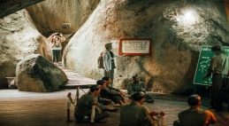 | You will be fascinated to discover about the city’s history.  Bạn sẽ thấy thích thú khi khám phá lịch sử thành phố này.
enormous  [i'nɔ:məs] (adj) | to lớn, khổng lồ |  | He spent an enormous amount of time on that project.  Anh ấy dành một lượng lớn thời gian cho dự án đó.
explorer  [iks'plɔ:rə] | người thám hiểm |  | Jim dreams of becoming an explorer in the future.  Jim mơ ước trở thành một nhà thám hiểm trong tương lai.
field  [fi:ld] (n) | ngành, khía cạnh |  | She is well-known in the field of music.  Cô ấy nổi tiếng trong lĩnh vực âm nhạc.
invent  [in'vent] (v) | phát minh, sáng chế |  | The light bulb was invented by Thomas Edison.  Bóng đèn được phát minh bởi Thomas Edison.
patent  ['peitnt] (n) | bằng sang chế |  | He obtained a patent on his new product last year.  Anh ấy đã lấy được bằng sáng chế cho sản phẩm mới năm ngoái.
precise  [pri'sais] (adj) | rõ ràng và chính xác. | 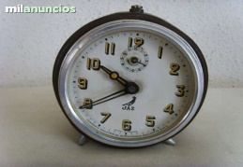 | Can you tell me the precise time of the meeting?  Bạn có thể nói cho tôi biết thời gian chính xác của buổi họp được không?
role  [rəul] (n) | vai trò |  | Jane plays an important role in her club.  Jane có vai trò quan trọng trong câu lạc bộ của cô ấy.
science  ['saiəns] (n) | khoa học |  | John wants to become a science student.  John muốn trở thành một sinh viên ngành khoa học.
steam engine  [ ˈsti:m endʒɪn ] | đầu máy hơi nước | 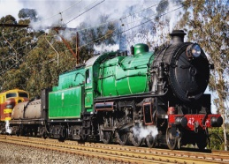 | Who invented the steam engine?  Ai đã phát minh ra đầu máy xe lửa?
technique  [tek'ni:k] (n) | kỹ thuật | 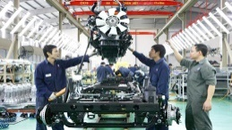 | His technique has improved a lot.  Kĩ thuật của anh ấy đã tiến bộ rất nhiều.
transform  [træns'fɔ:m] (v) | biến đổi |  | My village has transformed into a modern city.  Làng tôi đã biến đổi thành một thành phố hiện đại.
yield  [ji:ld] (n,v) | sản lượng | 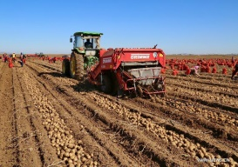 | This year we have a high crop yield.  Năm nay chúng ta có sản lượng vụ mùa cao.
B. GRAMMAR.
I. ÔN TẬP CÁC THÌ TƯƠNG LAI (FUTURE TESES)
Thì | Cấu trúc | Dấu hiệu nhận biết
Tương lai đơn | (+) S + will + V(infinitve) + O  (-) S + won’t+ V(infinitve) + O  (?) Will + S + V(infinitve) + O ? | tomorrow  next week/month/year  in the future  in + thời gian trong tương lai
Tương lai tiếp diễn | (+) S + will + be + V-ing + O  (-) S + won’t + be + V-ing + O  (+) Will + S +be + V-ing + O ? | At this time tomorrow/next week  At 10 o’clock tomorrow  Thời gian xác định tại một thời điểm trong tương lai
Bài 1: Viết lại cụm từ gạch chân trong mỗi câu dưới đây ở dạng thì tương lai đơn (will + V) hoặc thì tương lai tiếp diễn (will be + V-ing) sao cho phù hợp.
1. Don’t call me at 10 o’clock. I am going to fly to Spain.
2. I suppose we are going to stay at a hotel next summer.
3. Come to see me in the afternoon. I work in the garden.
4. Do you think it is snowing at the weekend?
5. Is the coat O.K ?- Yes, I am taking it.
6. This time on Sunday we are going to ski in France.
7. I don’t know if I will stay here. Perhaps I move to a big city one day.
8. Every student is using a computer in the future.
Bài 2: Chia động từ trong ngoặc ở thì tương lai đơn hoặc thì tương lai tiếp diễn sao cho phù hợp.
1. I can buy it for you. I (shop)__________________ in the afternoon anyway.
2. Is Bill at school? – No, he isn’t. I suppose he (come) __________________
3. I hope Simon (be) __________________there.
4. Did you remember to invite Mrs. Oates? – Oh, no! I forgot. But I (call) __________________ her now.
5. I’ll have a holiday next week. I (not get up) __________________ at 6 o’clock as usual.
6. You are so late! Everybody (work) __________________ when you arrive at the office.
7. Be careful or the cars (knock) __________________ you down.
8. We (move) __________________ our house this time tomorrow.
9. He (play) __________________ tennis at 7.30. He usually starts at 7 o’clock. Could you come before that?
10. Your suitcase is so big. I (take) __________________ it for you.
Bài 3: Dựa vào gợi ý, dùng thì tương lai đơn hoặc tương lai tiếp diễn để viết các câu hỏi dưới đây.
1. I am not sure if I can offer this room. ________________________________?
(our guest /like/it)
2. Can I borrow your laptop tonight? ________________________________ ?
(you/use/it/about 9 o’clock)
3. We arrive in Aberdeen at 1 o’clock. ________________________________ ?
(we/have/time/for lunch)
4. The show starts at 8. Please, ________________________________ ? (you/drive me/there)
5. Your journey will be so long. How ________________________________ while you are on the train? (you/spend/your time).
6. I’ve just missed the train. How ________________________________? (I/ get/to school)
7. I’d like to see your project. If I come at 4.30, ________________________________ ? (you/work/on it)
8. If your teacher ask you, ________________________________ ? (you/translate/the text)
9. What ________________________________ while I am cleaning the windows? (you/do)
10. ________________________________ if the coach is booked? (you/take/a taxi)

II. CÂU GIÁN TIẾP (REPORTED SPEECH)
1. Định nghĩa.
Định nghĩa | Ví dụ
- Câu trực tiếp (Direct Speech) là chính xác lời của ai đó. Chúng ta thường dùng dấu “ ” để trích dẫn lời nói trực tiếp.  - Câu tường thuật (hay còn gọi là câu gián tiếp) là câu thuật lại lời nói trực tiếp do một người khác phát biểu. | - They said, “We will visit her”. (Direct Speech)  →They said (that) they would visit her. (Reported Speech/ Indirect Speech)
2. Câu trần thuật gián tiếp (Reported Statement)
Khi muốn thay đổi một câu trần thuật trực tiếp sang 1 câu trần thuật gián tiếp, chúng ta dùng động từ ‘say/tell’ để giới thiệu. Đồng thời cần áp dụng các quy tắc sau:
a. Thay đổi thì của động từ.
* Nếu động từ giới thiệu ở thì hiện tại (say/tell) thì động từ trong câu gián tiếp giữ nguyên thì trong câu trực tiếp.
Ví dụ: “ I always drink coffee in the morning”, she says
→ She says that she always drinks coffee in the morning.
* Nếu động từ giới thiệu ở thì quá khứ (said/told) thì động từ trong câu gián tiếp cần thay đổi như sau:
Thì trong lời nói trực tiếp | Thì trong lời nói gián tiếp
Hiện tại đơn  “I like sciences” | → Quá khứ đơn.  He said (that) he liked sciences
Hiện tại tiếp diễn  “I am staying for a few days” | →Quá khứ tiếp diễn  She said (that) she was staying for a few days.
Hiện tại hoàn thành  “Nick has left” | → Quá khứ hoàn thành  She said (that) Nick had left
Quá khứ đơn  “Nick left this morning” | → Quá khứ hoàn thành  She told me (that) Nick had left that morning
Quá khứ tiếp diễn  “I was doing my homework” | → Quá khứ tiếp diễn/ Quá khứ hoàn thành tiếp diễn  She said (that) she was doing her homework /She had been doing her homework
Will  “Man will travel to Mars” | →Would  He said (that) man would travel to Mars.
Can  “We can swim” | → Could  They told us (that) they could swim.
May  “We may live on the moon” | →Might  He said (that) they might live on the moon.
b. Đổi ngôi của đại từ nhân xưng, tính từ và đại từ sở hữu.
Trong lời nói trực tiếp | Trong lời nói gián tiếp
I | → he/she
we | → they
you | → I/he/she
my | → his/her
our | → their
your | → my/his/her
mine | → his/hers
ours | → theirs
c. Thay đổi các trạng từ chỉ thời gian nơi chốn.
Trạng từ trong câu trực tiếp | Trạng từ trong câu gián tiếp
now | →then
today | →that day
here | →there
this week | →that week
tomorrow | →the following day/the next day
yesterday | →the day before/the previous day
last month | →the month before/the previous month
tonight | →that night
ago | →before
next week | →the following week/the week after
these | →those
Ví dụ:
He said to me, “I and you will go with her father next week”
He told me (that) he and I would go with her father the following week.
BÀI TẬP VẬN DỤNG CƠ BẢN
Bài 4: Chọn từ thích hợp trong hộp dưới đây rồi điền vào chỗ trống.
There | the following day | two hours | before | my | the previous week
then | the day before | that evening | that night | that | her
1. “I like this pair of shoes”. →She said (that) she liked____________ pair of shoes.
2. “Our plane lands tonight”→ They said their plane landed ____________
3. “I saw Jane yesterday”→ He told me that she had seen Jane____________
4. “I have met your father”→ Dan told me that he had met ____________ father
5. “I am going to the cinema this evening”→ Sara told me that she was going to the cinema ____________
6. “Paul took his driving licence last week”→ Paul told me he had taken his driving licence ____________
7. “This girl is my sister”→ She said to me that that girl was ____________sister.
8. “I like the way they cook here”→ Tina said that she liked the way they cooked____________
9. “She won’t arrive tomorrow”→ Sandra said that she wouldn’t arrive ____________
10. “Henry phoned Lara two hours ago”→ Henry told me that Lara had phoned ____________
11. “I am watching TV now”→ Mum said that she was watching TV ____________
Bài 5: Điền vào chỗ trống từ phù hợp “said” hoặc “told”
1. He _______ me a nice story.
2. Sarah _______ to her mum that she was sick.
3. We _______ that we were going to leave that night.
4. Paul _______ his books were missing.
5. She _______ that she would take the dog out that night.
6. Brian _______ that he had moved to Canada the week before.
7. Dan _______ Lara to stop spending so much money.
8. Our teacher _______ us that Christopher Columbus had discovered had discovered America.
9. He _______ they would arrive the following day.
10. They _______her to come early.
11. Fiona _______ to Kate that she had bought a nice skirt the day before.
12. I was sure that he _______ the truth.
Bài 6: Đọc ví dụ và viết các câu gián tiếp ở thì hiện tại cho các câu dưới đây.
Ví dụ: “I am waiting for you”→ Mary says to Peter she is waiting for him.
‘I am asking your help’.
1. Mary says to Peter ________________________________
2. Paul says to Jenny ________________________________
3. I say to you ________________________________
4. You say to me ________________________________
5. Jane says to the boys ________________________________
‘We bought you some books yesterday’
6. They say to us ________________________________
7. Sarah says to the children ________________________________
8. Mary says to Peter ________________________________
9. You say to me ________________________________
10. I say to you ________________________________
Bài 7: Các câu trực tiếp dưới đây đã được chuyển thành câu gián tiếp. Hãy đọc, gạch chân và sửa lỗi sai có trong mỗi câu.
1. “I am not going to tolerate this anymore ”, said Sarah.
Sarah said she was not going to tolerate this anymore.
2. “You have always been my friend”, said Joe.
Joe said I was always his friend.
3. “We never eat meat”, claimed Bill
Bill claimed that they had never eaten meat
4. “I will talk to Sam soon,” she told me on Sunday.
She told me on Sunday she will talk to Sam sonn.
5. “Mary used to exercise everyday,” he said.
He said Mary had used to exercise every day.
6. “I wish I was twenty years younger,”said Linda.
Linda said she wished she had been twenty years younger.
7. “Answer the phone!”he told me.
He told me I answered the phone
8. “Where is Alex?” she asked me.
She asked me where was Alex.
Bài 8: Hoàn thành các câu gián tiếp dưới đây.
1. Mr. Miller said, ‘I can’t come to the meeting on Sunday’
Mr. Miller said (that) ________________________________________________________
2. Mary said, ‘I’m feeling ill’
Mary said (that) ____________________________________________________________
3. Your brother said, ‘I like chocolate’
Your brother said (that) ______________________________________________________
4. My brother said, ‘I’m going to learn to cook’
My brother said (that) ________________________________________________________
5. He said, ‘I’ll learn English online tomorrow’
He said (that) ______________________________________________________________
6. My cousin said, ‘I’m not enjoying my job very much recently’
My cousin said (that) ________________________________________________________
7. My parents said, ‘We’ll phone you when we get back’
My parents said (that) ________________________________________________________
8. Susan said, ‘You don’t know what Bob is doing’
Susan said (that) ____________________________________________________________
9. She said, ‘I’ll tell dad I saw you’
She said (that) ______________________________________________________________
10. He said, ‘I have got a toothache’
He said (that) ______________________________________________________________
11. He said, ‘I have passed the physical test’
He said (that) ______________________________________________________________
12. Safia said, ‘I went to Italy last year’
Safia said (that) ____________________________________________________________
13. Kevin said, ‘I had a great weekend’
Kevin said (that) ____________________________________________________________
14. Mehrzad said, “I’m going to start my own photography business next month.”
Mehrzad said (that) _________________________________________________________
15. Alex said, “I finished university in June”
Alex said (that) _____________________________________________________________
16. Safia said, “I have studied photography”
Safia said (that) ____________________________________________________________
17. Maria said, “I will bring you a scarf from India”
Maria said (that) ____________________________________________________________

BÀI TẬP TỔNG HỢP NÂNG CAO
Bài 9: Chia động từ trong ngoặc ở thì tương lai đơn hoặc thì tương lai tiếp diễn để hoàn thành các câu sau.
1. I’m that next year this city (look)_________________ much better.
2. They (have to) _________________ change their diet if they want to keep fit.
3. I (not do) _________________that if he doesn’t apologize to me.
4. I can’t go out with you, but I (make) _________________ it up to you.
5. At 10 p.m I (go) _________________ to bed to get some rest.
6. I (not do) _________________anything till Monday.
7. You can visit me tomorrow. I (not do) _________________ anything important.
8. Can I borrow your car? Sure, I (not use) _________________ it until Friday.
9. At 11 p.m I (sleep) _________________ .
10. You should recognize her easily. She (wear) _________________ a red skirt.
11. I wish I could visit you, but I (manage) _________________ a very important project.
12. She (not come) _________________ with us, I’m sure.
13. I (help) _________________ you as soon as I finish this project.
14. He (not be able) _________________ to carry such a heavy bag.
15. I think he (find) _________________ this work more interesting when he grows up.
16. This time next month I (enjoy) _________________ the holidays.
17. Hold on, I (give) _________________ you a gift.
18. He (give) _________________ me 20$ a day during my stay.
19. I suppose the weather (be) _________________ good.
20. We (leave) _________________ this house as soon as possible.

Bài 10: Khoanh tròn vào phương án đúng.
1. Customer in restaurant: Waiter, this place is dirty.
Waiter: I’m sorry, sir, I _________________ (bring) you another.
A. will bring | B. will be bringing | C. A &B
2. It’s beginning to get dark; the street lights ________ (go) on in a few minutes.
A. will go | B. will be going | C. A & B
3. Let’s wait here; the swing bridge __________(open) in a minute to let that ship through.
A. will open | B. will be opening | C. A & B
4. Guest: May I use your phone to ring for a taxi?
Hostess: Oh, there’s no need for that; my son __________(drive) you home.
A.will drive | B. will be driving | C. A & B
5. A: Before you leave the office you _________ (hand) the keys of the safe to Mr Pitt. Do you understand?
B: Yes, sir.
A. will hand | B. will be handing | C. A & B
6. Are you nearly ready? Our guests __________ (arrive) any minute.
A. will arrive | B. will be arriving | C. A & B
7. Loudspeaker announcement: The ship __________ (leave) in a few minutes and all persons not travelling are asked to go ashore.
A. will leave | B. will be leaving | C. A & B
8. You ought to try to get a ticket for the Spectators’ Gallery next week; they _______ (debate) international fishing rights.
A. will debate | B. will be debating | C. A & B
9. A: You’ve left the light o.
B: Oh, so I have. I _______ (go) and turn it off.
A. will go | B. will be going | C. A & B
10. I’ve been appointed assistant at the local library. The you ___________ (work) under my sister. She is head librarian there.
A. will work | B. will be working | C. A& B

Bài 11: Đọc đoạn văn và trả lời câu hỏi dưới đây.
Ultralight Airplanes
An ultralight airplane is very different from a conventional airplane. It looks like a lawn chair with wings, weighs no more than 254 pounds, flies up to 60 miles an hour, and carries about 5 gallons of fuel. Most ultralights are sold as kits and take about 40 hours to assemble. Flying an ultralight is so easy that a pilot with no experience can fly one. Accidents are rarely fatal or even serious because the ultralight lands so slowly and gently and carries so little fuel. Some models now have parachutes attached, while others have parachute packs which pilots can wear.
1. According to the passage, pilots_______.
A. prefer to fly with ultralights rather than with regular aircraft.
B. can weigh up to 250 pounds, depending on the model of the ultralight airplane.
C. don’t think that their ultralight airplanes are simple to use.
D. are reluctant to put their ultralights together.
E. don’t need a special training to fly an ultralight airplane.
2. We learn from the passage that an ultralight airplane_________.
A. provides the only opportunity to fly affordably.
B. doesn’t fly very well it it weighs less than 254 pounds.
C. is inexpensive but difficult to fly.
D. can be put together in a short time.
E. is only permitted to be used for private recreational flying.
3. It is pointed out in the reading that _______________
A. there is more risk involved in flying ultralight aeroplanes than in flying general aviation aircraft.
B. ultralight airplanes can remain airborne for more than an hour.
C. the risk of injury to a passenger in an ultralight airplane is very low.
D. the gear an ultralight airplane carries can be more fragile than traditional equipment.
E. people who fly ultralights don’t need a license.
UNIT 12: LIFE ON OTHER PLANETS
(CUỘC SỐNG TRÊN CÁC HÀNH TINH KHÁC)
A. VOCABULARY
New words | Meaning | Picture | Example
aeronautical  [,eərə'nɔ:tikəl] adj | thuộc hàng không | 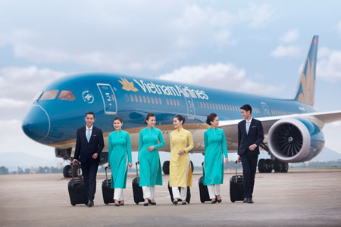 | Mr. Smith is an aeronautical engineer.  Ông Smith là một kĩ sư hàng không.
alien  ['eiljən] (n) | người ngoài hành tinh |  | Do you think that aliens really exist?  Bạn có nghĩ rằng người ngoài hành tinh thực sự tồn tại không?
astronaut  ['æstrənɔ:t] (n) | phi hành gia | 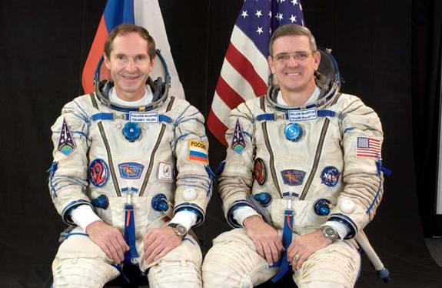 | They will send two astronauts into space this year.  Họ sẽ đưa hai phi hành gia lên vũ trụ năm nay.
captain  ['kæptin](n) | thuyền trưởng, đội trưởng |  | He was the captain of the football team at school.  Anh ấy là đội trưởng đội bóng ở trường.
crew  [kru:] (n) | đoàn, đội | 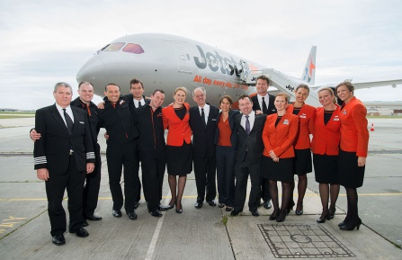 | My sister is one of the flight crew.  Chị tôi là một người trong phi hành đoàn.
Galaxy  ['gæləksi] (n) | Giải Ngân Hà | 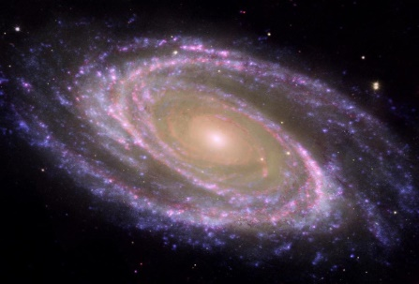 | The galaxy contains our solar system.  Dải Ngân Hà chứa hệ mặt trời.
Jupiter  ['dʒu:pitə] (n) | sao Mộc | 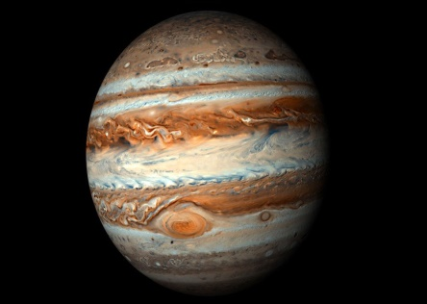 | Jupiter is the largest planet in the solar system.  Sao Mộc là hành tinh lớn nhất trong hệ mặt trời.
launch  [lɔ:nt∫] (v) | phóng, mở, khởi đầu |  | They launched a rocket last year.  Họ đã phóng một quả tên lửa năm ngoái.
Mercury  [ˈmɝːkjəri ] (n) | sao Thủy |  | Jupiter is the smallest planet in the solar system.  Sao Thủy là hành tinh bé nhất hệ mặt trời.
Neptune  ['neptju:n] (n) | sao Hải Vương |  | Neptune is not visible to the naked eye.  Sao Hải Vương không thể nhìn thấy bằng mắt thường.
notable  ['nəutəbl] (adj) | đáng chú ý |  | He made a notable success in the field of business.  Anh ấy làm nên thành công đáng chú ý trong ngành kinh tế.
outer space  [ˈaʊtər speɪs] | vũ trụ |  | Who was the first woman in outer space?  Ai là người phụ nữ đầu tiên trong không gian vũ trụ.
particular  [pə'tikjulə(r)] (adj) | cụ thể, riêng biệt |  | Is there a particular film you like?  Có bộ film cụ thể nào bạn thích không?
solar system  [ˌsəʊlə ˈsɪstəm] | hệ Mặt trời | 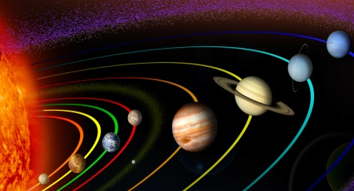 | There are eight planets in the solar system.  Có 8 hành tinh trong hệ Mặt trời.
UFO  [ju:ˌefˈoʊ ] | (Unidentified Flying Object)  vật thể bay không xác định |  | Do you believe in UFOs?  Bạn có tin vào những vật thể bay không xác định không?
Venus  ['vi:nəs] (n) | sao Kim | 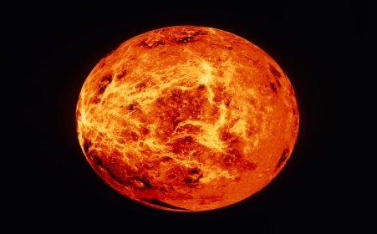 | Venus has the same size as the Earth.  Sao Kim có cùng độ lớn với địa cầu.
weightless  [ˈweɪtləs] (adj) | không trọng lực | 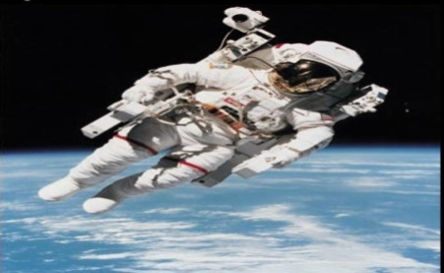 | Astronauts work in weightless conditions.  Phi hành gia làm việc trong môi trường không trọng lực.
witness  [ˈwɪtnəs] (n,v) | nhân chứng, chứng kiến | 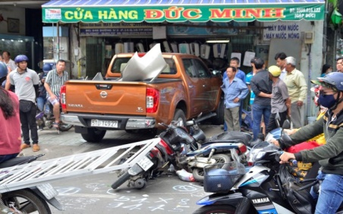 | No one witnessed the accident last night.  Không có ai chứng kiến vụ tai nạn tối qua.
B. GRAMMAR.
I. ÔN TẬP MAY VÀ MIGHT
Cách dùng | Ví dụ
- “May” và “might” được dùng để diễn đạt điều gì có khả năng xảy ra ở hiện tại hoặc tương lai.  - “might” diễn tả sự việc có khả năng xảy ra thấp hơn “may”. | - It may/might be a bomb. (Có thể đó là 1 quả bom)  - Where is Emma? I don’t know. She may/might be out shopping. (Có lẽ cô ấy đi mua sắm)  - I may go to London next month. (khả năng xảy ra 50%)  - I might go to London next month. (khả năng xảy ra 30%)
- “May” và “might” được dùng để xin phép, cho phép (có tính chất lễ phép, trang trọng hơn “can” và “could”).  - “May not” được dùng để từ chối lời xin phép hoặc chỉ sự cấm đoán. | - May I borrow your car? (xin phép lịch sự)  - Yes, of course you may./No, I’m afraid you may not. (từ chối lời xin phép)  - Students may not use the teachers’ car park. (cấm đoán)
- May được dùng trong những lời chúc mừng trang trọng (không dùng might). | May the New Year bring you all your heart desires. (Chúc bạn 1 năm mới vạn sự như ý!)
BÀI TẬP VẬN DỤNG CƠ BẢN
Bài 1: Hãy chỉ ra chức năng của hai động từ khuyết thiếu may và might trong những câu dưới đây. Viết Po vào ô trống bên cạnh nếu nó chỉ khả năng (Possibility), viết AP nếu nó chỉ lời xin phép (Asking for Permission), và viết PE nếu nó chỉ sự cho phép (Permission)
1. I may have lunch early I’m hungry.
2. May I come in now?
3. He might go abroad next month.
4. I may not have time to go out today.
5. May I borrow your book tomorrow?
6. You may not borrow the car until you can be more careful with it.
7. You may go camping with your friends if you get high marks in the next tests.
8. It’s quite bright. It might not rain today.
9. Might we just interrupt for a moment?
10. Jay may be coming to see us tomorrow.
Bài 2: Sắp xếp các từ đã cho thành câu đúng.
1. airport/He/be/the/waiting/us/may/at/for.
2. might/John/your/come/party/to.
3. room/I/the/May/leave?
4. your/I/May/eraser/use/,/please/?/Yes/,you/course/of/may.
5. that/touch/Don’t/ write/it/be/because/dangerous/might.
6. is/No One/to/go/allowed/into/building/that/,/may/go/you/not/inside/.
7. applying/is/for/the/a/He/job/at/university/,/get/he/it/might
8. yesterday/Sheila/go/sick/work/didn’t/,/to/she/be/might/.
9. bomb/may/it/a/be
10. put/I/the/May/on/TV?
Bài 3: Dựa vào những từ gợi ý, dùng might/might not(mighn’t) để viết thành câu hoàn chỉnh.
1. I/go to the party.
....................................................................................................................................................
2. She/not talk to him.
....................................................................................................................................................
3. They/lose the game.
....................................................................................................................................................
4. Everybody/come to my concert
....................................................................................................................................................
5. The government/not win the election
....................................................................................................................................................
6. The school/not win the competition.
....................................................................................................................................................
7. The singer/become famous.
....................................................................................................................................................
8. He/not break a world record
....................................................................................................................................................
9. My father/work in a different country
....................................................................................................................................................
10. I /not become president of a country
....................................................................................................................................................
II.CÂU HỎI GIÁN TIẾP (REPORTED QUESTIONS)
1. Các quy tắc khi chuyển câu hỏi trực tiếp sang câu hỏi gián tiếp
- Động từ tường thuật được sử dụng trong câu hỏi gián tiếp thường là: asked, required, wondered, wanted to know.
- Áp dụng qui tắc đổi đại từ nhân xưng, tính từ sở hữu, đại từ sở hữu giống câu trần thuật gián tiếp.
- Áp dụng qui tắc đổi thì của động từ giống câu trần thuật gián tiếp.
- Áp dụng qui tắc đổi các trạng từ chỉ thời gian, nơi chốn giống câu trần thuật gián tiếp.
- Câu hỏi chuyển sang câu gián tiếp phải được chuyển về dạng khẳng định và lược bỏ dấu hỏi chấm.
2. Các dạng câu hỏi gián tiếp.
Dạng | Cấu trúc
Câu hỏi Wh-Questions (Câu hỏi bắt đầu bằng các từ để hỏi như: What, Where, When, Why, How...) | S + asked/wondered/wanted to know + O + Wh + S + V...  He said to me, “Why did you go with her father last week?”  →He asked me why I had gone with her father the week before.
Câu hỏi Yes/No Questions: Dùng “If hoặc whether” để bắt đầu câu hỏi Yes/No gián tiếp. | S + asked/wondered/wanted to know + O + if/whether + S + V  Ví dụ:  He said to me, “Will you go with her father next week?”  → He asked me if/whether I would go with her father the following week.

BÀI TẬP VẬN DỤNG CƠ BẢN.
Bài 4: Sắp xếp các từ sau để tạo thành câu hỏi gián tiếp hoàn chỉnh.
1. asked/was/how much/that/Tom/computer
Tom ...........................................................................................................................................
2. had/to know/the officer/if/wanted/the keys/I
The officer .................................................................................................................................
3. Ann/hadn’t come/why/to her party/asked/Sam/he
Ann ............................................................................................................................................
4. asked/Jane/for her holidays/she/was going/he/where
He...............................................................................................................................................
5. me/English/asked/I/spoke/He/if
He ..............................................................................................................................................
6. old/asked/He/her/how/was/mother
He ..............................................................................................................................................
7. British/was/asked/whether/He/I/me/American/or
He ..............................................................................................................................................
8. Boy/The asked/the/where/lived/policeman/be
The policeman ...........................................................................................................................
9. Had/Bristol/She/I/been/asked/to/before/if
She..............................................................................................................................................10. The/asked/time/train/She/what/arrived.
She .............................................................................................................................................
Bài 5: Khoanh tròn vào phương án đúng.
1. Tourist: “Where is the post office?” A tourist asked me where ...............................
A. the post office has | B. the post office was
C. is the post office | D. was the post office
2. Mom: “It’s 2 a.m; what are you doing in the kitchen?” Mom wanted to know what ...................... in.
A. was I doing | B. I do | C. I was doing | D. am I doing
3. Dad: “Why did you come home so late last night?” Dad wanted to know ................ home very late the night before.
A.why did I come | B. if I come | C. if I came | D. why I had come
4. Jane: “Have you ever been to Australia?” Jane asked me .......................to Australia
A. if I’m ever going | B. if I’d ever been | C. have I ever been | D. had I ever been
5. Joe: “Could you sing when you were five?” He asked me.................when I was five
A. can I sing | B. if I can sing | C. could I sing | D. if I could sing
6. Mother: “When are you going to do your homework?” Mother asked me when ...........to do my homework.
A. was I going | B. I was going | C. am I going | D. I’ll be going
7. Allen: “How many songs had John Lennon written before he died?” Allen wanted to know how many songs .................. before his death.
A. John Lennon had written | B. John Lennon was writing
C. was John Lennon writing | D. had John Lennon written
8. Janet: “Were you working at 8p.m last night?” Janet asked me ................... at 8p.m the other night.
A. if I’m working | B. if I’d been working
C. was I working | D. had I been working
9. Dad: “Have you been attending classes regularly?” Dad asked me ...................attending classes regularly.
A. if I’d be | B. had I been | C. if I’d been | D. have I ben
10. Mario: “What should I do to improve my English?” Mario asked his teacher what ........... to improve his English.
A. he should do | B. he would do | C. shall he do | D. should he do
11. Jim: “How much does your sister earn?” Jim wanted to know how much.................
A. my sister has earned | B. did my sister earn
C. does my sister earn | D. my sister earned
12. Joe: “Could you sing when you were five?” He asked me ....................when I was five.
A. can I sing | B. if I can sing | C. could I sing | D. if I could sing
13. Mary: “Are you able to swim?” Mary asked me ........................to swim.
A. if I have been able | B. am I able | C. if I was able | D. will be able
14. Tourist: “When was that castle built?” The tourist asked the guide when ...................
A. had the castle been built | B. the castle had been built
C. the castle was being built | D. was the castle built
15. Sue: “May I sleep at Lee’s house overnight?” Sue asked her mother ........................ at her friend’s house overnight
A. if she might sleep | B. could she sleep
C. can she sleep | D. if she had to sleep
Bài 6: Chuyển các câu hỏi trực tiếp dạng Yes-No questions dưới đây thành câu hỏi gián tiếp.
Ví dụ: “Is this my birthday cake?” →Peter asked Mary if that was his birthday cake.
1. “Will you send me an e-mail?” Marty to Kim
....................................................................................................................................................
2. “Were you driving your car when you had an accident?” The police to Mr Lloyd
....................................................................................................................................................
3. “Did you give up smoking last month?” The doctor to Mrs Smith
....................................................................................................................................................
4. “Have you done the washing up?” Mum to me
....................................................................................................................................................
5. “Can’t you phone your mother at home?” The teacher to him
....................................................................................................................................................
6. “Do you like sleeping? ” I to Greg
....................................................................................................................................................
7. “Has your house been redecorated? ” My neighbor to me
....................................................................................................................................................
8. “Were you punished for being late? ” Mum to Ben
....................................................................................................................................................
9. “Do I have to move the lawn in our garden today? ” Tom to his wife
....................................................................................................................................................
10. “Are they taking the dog for a walk now? ” Kate to me
....................................................................................................................................................
Bài 7: Chuyển các câu hỏi trực tiếp dạng Wh-questions dưới đây thành câu hỏi gián tiếp.
Ví dụ: Who is this flower for? →Mary asks Peter who that flower is for.
1. “What’s your name? ” The officer to Sam
....................................................................................................................................................
2. “How could you drive here in this storm?” Linda to the writer
....................................................................................................................................................
3. “Why are you wearing this awful shirt?” The boss to Mr Grey
....................................................................................................................................................
4. “When will the lunch be ready?” Tina to her mum
....................................................................................................................................................
5. “How did you try to cope with this problem? ” The psychologist to Sylvie.
....................................................................................................................................................
6. “When did you find this great book? ” The teacher to Jack
....................................................................................................................................................
7. “Where are you from? ” Mike to Sam
....................................................................................................................................................
8. “How many apples have you eaten today?” Mum to Paul
....................................................................................................................................................
9. “What can I do for you? ” The greengrocer to Mrs Hill
....................................................................................................................................................
10. “Where is my tie? ” Dad to the children.
....................................................................................................................................................
Bài 8: Chuyển các câu hỏi trực tiếp dưới đây thành câu hỏi gián tiếp.
1. “Have you done your homework yet, Peter?”
Mum wanted to know if ............................................................................................................
2. “Where are you going to spend your holiday this summer, Sue?”
Mary asked Sue .........................................................................................................................
3. “Do you know how long it is from London to Cambridge?”
Tom asked me if.........................................................................................................................
4. “Will you phone me as soon as you arrive in Oxford, Carol?”
Cindy asked Carol if ..................................................................................................................
5. “Did the children play football in the park yesterday? ”
Grandma was interested in knowing if ......................................................................................
6. “How much does the ticket for the concert cost? ”
Father wanted to know ..............................................................................................................
7. “Can you help me with the housework tomorrow, Linda?”
He asked Linda if ......................................................................................................................
8. “What time does the new TV series begin tonight?”
Terry asked ................................................................................................................................
9. “Are you going to buy a new computer next month, Lewis?”
I wanted to know if ...................................................................................................................
10. “When has Tim started working this morning?”
Mr. Smith asked his secretary ...................................................................................................
11. “Is Sue coming to the library with you, Paul?”
Tina asked Paul if ......................................................................................................................
12. “Why haven’t you sent me an email while you were in London?”
Dave wanted to know ................................................................................................................
13. “Could you swim when you were six, Tony? ”
The P.E teacher asked Tony if ..................................................................................................
14. “What have you been doing at school this morning, Charles ?”
Dad was interested in knowing .................................................................................................
15. “Are you revising for tomorrow exam?”
The teacher asked the students if ..............................................................................................
16. “How often do you play chess with your brother, Alice?”
Sam wanted to know .................................................................................................................
BÀI TẬP TỔNG HỢP NÂNG CAO.
Bài 9: Chọn phương án đúng nhất.
1. “What has Daddy made for dinner ? ” asked Simon.
A. Simon asked what Daddy had made for dinner.
B. Simon asked what Daddy have made for dinner.
C. Simon asked what Daddy has made for dinner.
2. “Who won the match? ” asked Monica.
A. Monica asked who had won the match.
B. Monica asked who have won the match.
C. Monica asked who has won the match.
3. “Has Sarah ever been to Siena ? ” he asked.
A. He asked whether Sarah had never been to Siena.
B. He asked whether Sarah had ever been to Siena.
C. He asked whether Sarah has never been to Siena.
4. “Do you like fried eggs?”Anne asked David
A. Anne asked David whether he like fried eggs.
B. Anne asked David if he like fried eggs.
C. Anne asked David if he liked fried eggs.
5. “Can they play the piano?” she asked
A. She asked if they could play the piano.
B. She asked if they can play the piano.
C. She asked whether they can play the piano.
6. “Have you ever been to Lisbon? ”Luis asked Paul.
A. Luis asked Paul whether he has ever been to Lisbon.
B. Luis asked Paul whether he had ever been to Lisbon.
C. Luis asked Paul whether he had never been to Lisbon.
7. “Can I use your mobile, John? ” asked Sarah.
A. Sarah asked John if she can use his mobile.
B. Sarah asked John if she could use her mobile.
C. Sarah asked John if she could use his mobile.
8. “Are we going out tonight?” asked Bob.
A. Bob asked if/whether they were going out this night.
B. Bob asked whether they were going out that night.
C. Bob asked whether they are going out that night.
9. “Is the Pope a Catholic?” asked JK
A.JK asked whether the Pope be a Catholic
B. JK asked if the Pope be a Catholic
C. JK asked if the Pope was a Catholic
10. “Where do bears live?” asked George.
A. George asked where bears lived.
B. George asked where bears lives.
C. George asked where lived bears.
Bài 10. Đọc đoạn hội thoại dưới đây và tường thuật lại dưới dạng câu gián tiếp.
Mike: “What are you doing here, Liz? I haven’t seen you since June.”
Liz: “I’ve just come back from my holiday in Ireland”
Mike: “Did you enjoy it?”
Liz: “I love Ireland. And the Irish people were so friendly”
Mike: “Did you go to the Wicklow Mountains?”
Liz: “It was my first trip. I can show you some pictures. Are you doing anything tomorrow?”
Mike: “I must arrange a couple of things. But I am free tonight.”
Liz: “You might come to my place. What time shall we meet?”
Mike: “I’ll be there at eight. Is it all right?”
1. Mike asked Liz ................................................ And he said .................................................
2. Liz explained that ...............................................................
3. Mike wondered ...............................................................
4. Liz told him that .................................................... and that .................................................
5. Mike wanted to know...............................................................
6. Liz said that ............................................... and that she .......................................................
7. And then she asked him if ...............................................................
8. Mike explained that ...............................................................
9. But he added that ...............................................................
10. Liz suggested that .............................................. and asked him .........................................
11. Mike said ...............................................................
12. And then he asked ...............................................................
Bài 11: Chọn dạng động từ đúng trong những câu trực tiếp dưới đây.
1. Helen asked me if I liked visiting old buildings.
‘Do you like/Did you like visiting old buildings?’ asked Helen.
2. Bill asked Mary if she had done anything the previous weekend.
‘Have you done anything/Did you do anything last weekend?’
3. The policeman asked me if the car belong to you me.
‘Does this car belong/Did this car belong to you?’asked the policeman.
4. Fiona asked me if I had seen her umbrella anywhere.
‘Did you see/Have you seen my umbrella anywhere ?’ asked Fiona.
5. Joe asked Tina when she would get back.
‘When will you get /have you got back?’asked Joe.
6. Eddie asked Steve who he had been to the cinema with.
‘Who did you go/had you been to the cinema with?’ asked Eddie.
7. My parents asked me what time I had got home the night before.
‘What time did you get/have you got home last night?’ my parents asked.
8. David asked a passer-by f it was the right road for Hastings.
Is this/Was this the right road for Hastings? Asked David.
Bài 12: Đọc kĩ đoạn văn dưới đây.
People used to think that there were six planets moving in a circle around the Sun. Mercury was the nearest to the Sun and Saturn was the furthest away. Most scientists knew that the Earth was the third nearest planet to the Sun, between Venus and Mars, and that Jupiter was between Mars and Saturn. We have now discovered that there are three more planets – Uranus, Pluto and Neptune. These others are farther from the Sun, and Pluto is the farthest one.
From its time of discovery in 1930 Pluto was considered to be the ninth planet in solar system. In 2006 the IAU (International Astronomical Union) changed the definition of ‘planet’, so that Pluto is not a planet, but the second largest dwarf planet in solar system. So there are eights planets, not six or nine and the largest is in the middle of them, the fifth away from the Sun.
Đánh dấu T (True) nếu câu đúng, F (False) nếu câu sai, NS (Not stated) nếu câu không được nói trong bài.
1. Mercury is the third nearest planet to the Sun. _______
2. Venus is the brightest of the planets. _______
3. Pluto has been considered a planet for 76 years. _______
4. The International Astrological Union changed the definition of ‘planet’. _______
5. There are five dwarf planets in the solar system. _______
6. Jupiter is the largest planet in the solar system. _______

